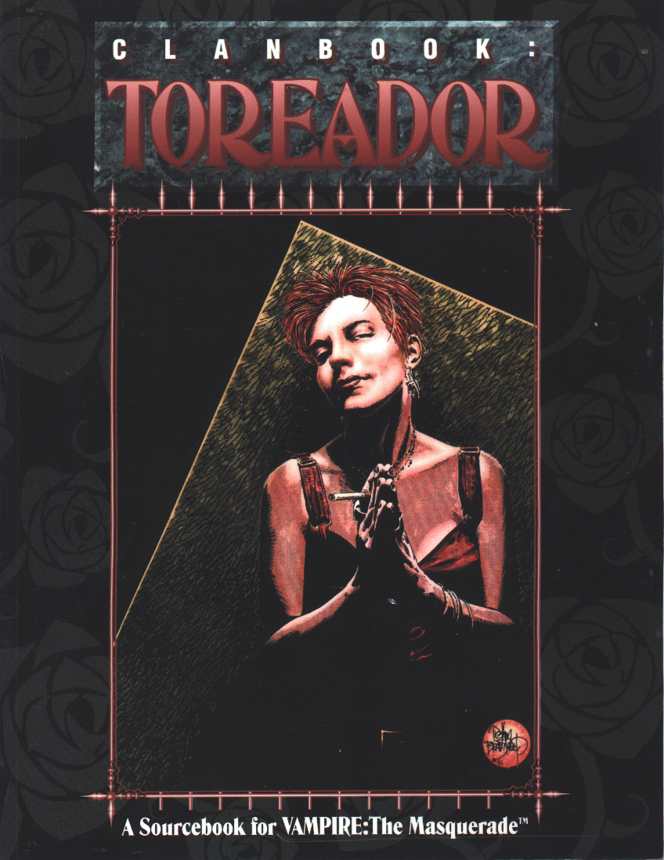

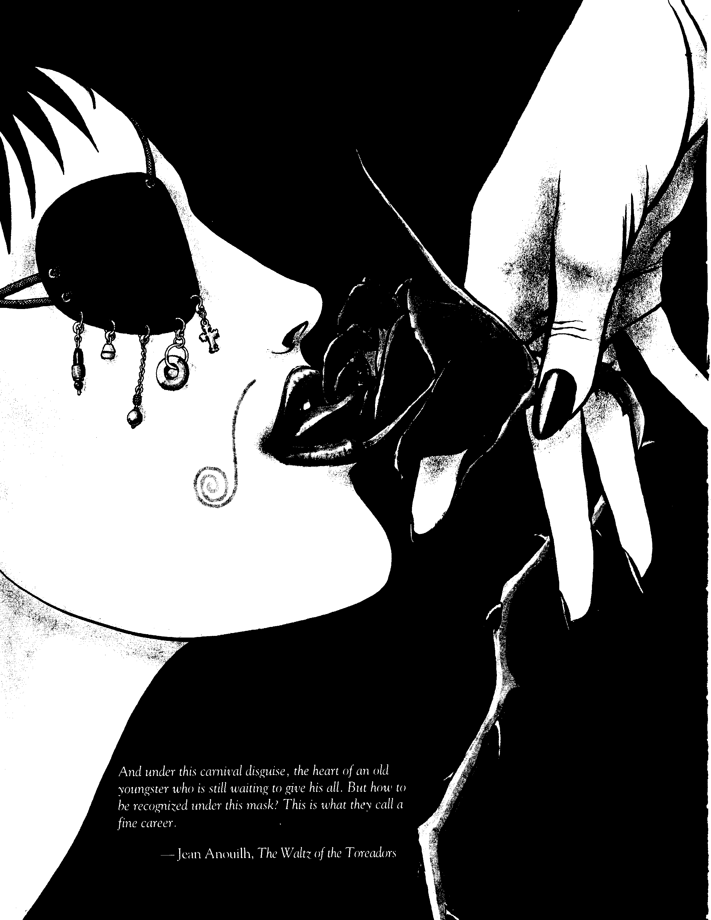

Music, lights, beauty and blood! Plunge into it. Grasp it with those clutching, cloying hands. Hold it against your dead bosom. Raise it to lifeless lips and kiss it with a mouth that knows nothing but obscene lies. This is the vibrancy you cannot feel. This is the raging excitement yliu have forgotten.
This is the seductive siren's call you lack. This is

inspiration. This is life.

Credits: Special Thanks To:

Written By: Steven C. Brown Developed By: Andrew Greenberg Edited By: Brian Campbell
Art Director: Richard Thomas
Layout and Typesetting: Aileen E. Miles
Art: Joshua Gabriel Timbrook, Doug Alexander Gregory
Front Cover: Timothy Bradstreet, Grant Goleash
Back Cover: Michelle E. Prahler



Word from the White Wolf Game Studio

We havf two new pigeons... er... persons... er ... people here at White Wolf. Ian Lemke and Mike Tinney of Night Owl Productions have decided to nest in our library, cranking out releases for Mind's Eye Theatre and running live-action games at conventions and anywhere hunters won't find them. When we got them to write bios for us, Mike said he enjoys long, quiet walks in a DMZ and Ian likes badger wrestling. Right.
4598-B STONEGATEIND. BLVD. STONEMTN., GA 30083 U.S.A.
WHITE WOLf GAME STUDIO
Josh "Aaaaaaahhhhh!!!!" Timbrook, for experi­ encing a cracked water krawler (I mean water heater).
Sam "I'm Broke!" Chupp, for barking up the wrong Prahler.
Chris "Summer Vacation" McDonough, for sharing his photos (and tattoo) with the world. Richard "To the Sun" Thomas, for his exquisite sense of timing. Push the Button!
Michelle "Happy Hat" Prahler, for throwing such a topical party.
Ben "Gym? What Gym?" Monk, for the better things he could have done with those bucks.
Steve "M. Bison" Wieck, for living the honorable code of the Streetfighter.
Jim "Key Chain" Townsend, for getting one that reveals such a truth - NOT!
Aileen "Nightmare Before Toreador" Miles, for listening to the soundtrack non-stop while laying out this book

© 1994 by White Wolf, Inc. All contents herein are copy­ righted by White Wolf, Inc. Vampire The Masquerade (TM) is a trademark of White Wolf, Inc. All rights reserved. Reproduc­ tion without written permission of the publisher is expressly denied, except for the purpose of reviews.
Disclaimer: The characters and events described in this book are fictional, any resemblance between the characters and any person; living or dead, is purely coincidental.
The mention of or reference to any companies or products in these pages is not a challenge to the trademarks or copyrights concerned.
Due to the mature themes presented within, reader discre­ tion is advised.



Table or Contents:

Chapter Two: Onlire Amon
1&,
,.

;:/ ' ',

' ·,, ,,,"'• ,'\ :_-, /v",

Chapter Three:

Chapter F iToreodor Templates

:.i 42

Appendix'!T<>repelor or Note
64

Contents> 5

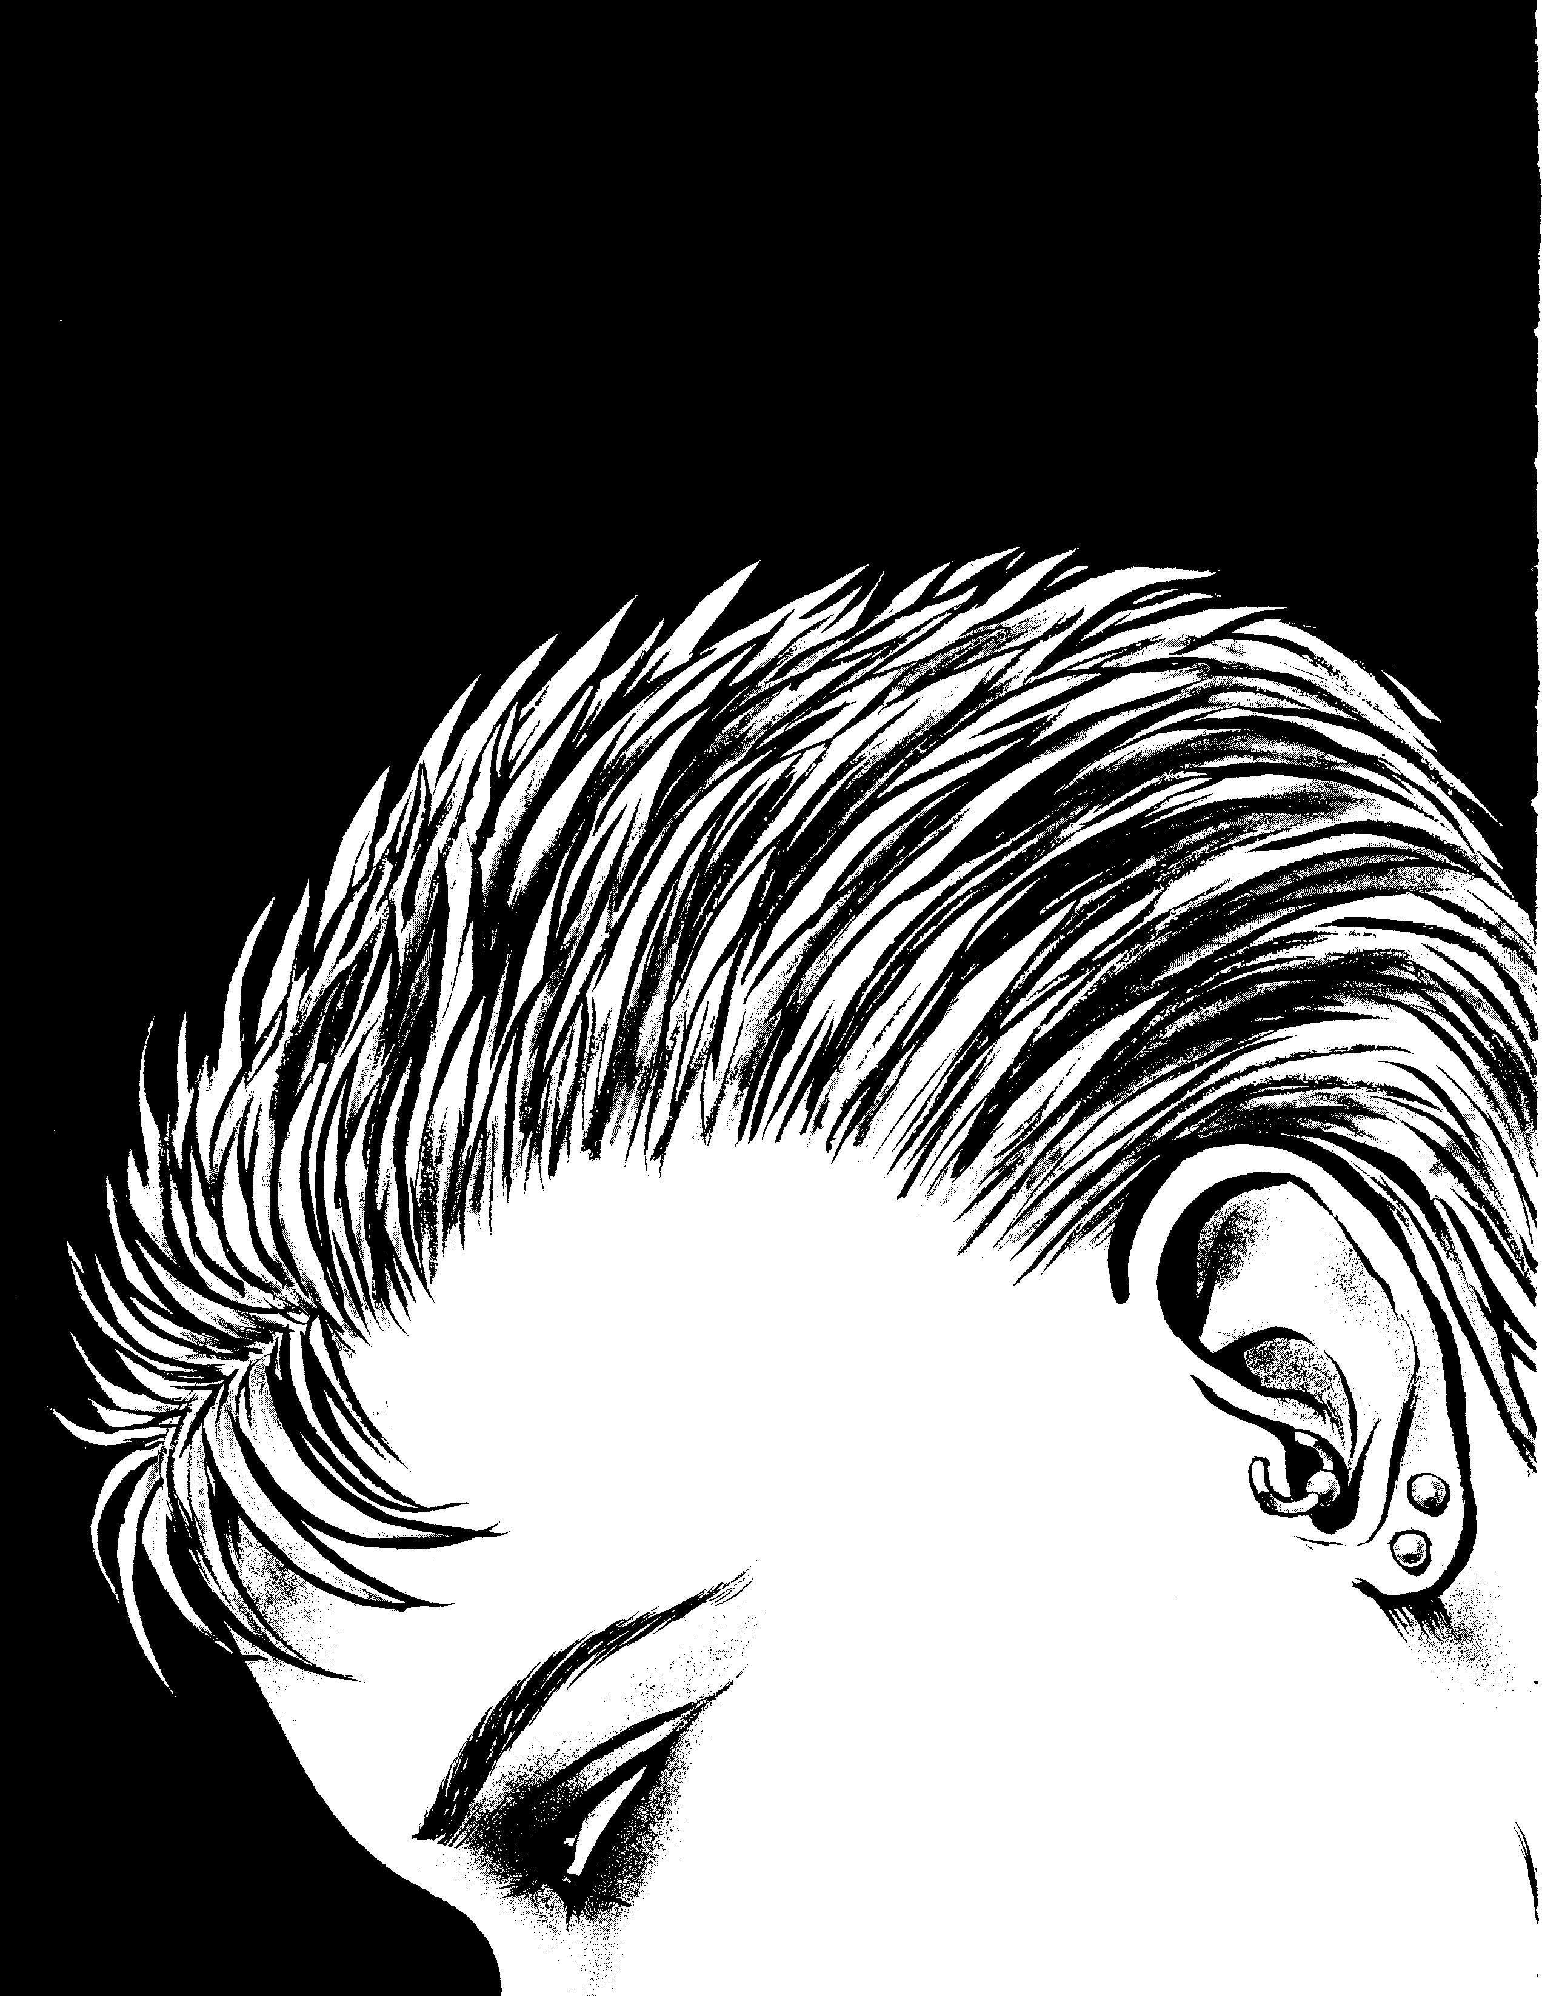


Clarissa was not happy. She had no choice but to leave. There just wasn't time tu see her stepdaughter's performance as one of Santa's reindeer. Her husband would understand as much as any human could. Explaining it to Mandy, her stepdaughter, would prove to be a little more difficult, how­ ever. Clarissa walked out of the auditorium to her convertible BMW.
She was already running late, and Annabelle would not be pleased. It was expected that undead guests would be fashion­ ably late, but Clarissa was still a neonate, and the deadline for fashionably late ended over an hour ago.
Clanssa put the pedal to the floor and ignored all the red lights she could. Her straight, black hair whipped behind her in the cold Chicago air, but she did not notice. While she had dressed more for the school play than for a Guild party, her white bluuse and gray skirt hugged her sharely body which, coupled with her gorgeous dark blue eyes and perfect smile, would make up for the outfit's lack of flair.
The party was being held at one of Annabelle's many extravagant mansions. Clarissa knew the location of three of them, but there were certainly more. Each home had a huge hall that served as her gallery for displaying the works of her favmed artists: Max Ernst,Juan Miro, Salvador Dali, Alexander Rodchenko, Francis Picabia, (3ianlorenzo Bernini, Caravaggio, Rubens and others. The ghoul servants who cared for the mansions were all attractive, and none of them appeared to be over 25.
As many as 40 Kindred would show up at the more promi­ nent sllcials, all dressed in the finest of fashiuns and accomranied hy their ghoul consorts. The refined Damned who gathered for

them always provided witty and provocative conversation. If only the mortals in the nearby houses could have known what savagery was seething beneath the coats and evening gowns of these honored and mannerly guests.
Clarissa handed the keys to one of Annabelle's valets and entered the mans1un. One of Darian's ghouls immediately greeted her and took her coat. Clarissa studied his features as he hung her coat on the huge mahogany hat stand in the front sitting roum, hut she could not place where she had seen him before. Darian inevitahly made ghouls of artists with limited talent, and Clarissa took pride in the fact that she never knew them.
Clarissa quickly made her way through the front parlor. The room was filled with important Cainites in antique Queen Anne chairs discussing current Kindred events. Clarissa hur­ ried to the next room, only taking time to note that Annabelle had the good grace not to place couches in the room. These noted undead would not have the displeasure of sitting beside one another.
She spotted Annabelle talking with the beautiful raven­ haired neonate, Portia, and her handsome and narcissistic lover, Bret Stryker. Bret unce belonged to Annabelle, and Clarissa was struck by how flagrantly he and Portia flaunted their relationship hefore Annabelle.
Annabelle turned as Clarissa approached. "Darling! It is so good to see you," Annabelle said with feigned delight. "I'm glad you made it, even though we've already toasted Darian's success in New York. I'm sure you'll love his work. It's quite unusual for him ... a radical departure from his last showing."
Introduction> 7


Clarissa said little to Annabelle. Annabelle had a way of twisting what Clarissa said, making her feel ignorant and rude. Annabelle knew about Clarissa's former rivalry with Darian, and Clarissa did not want Annabelle to remind her of it in a room filled with her peers.
The pair entered a long hallway filled with various sculp­ tures. Despite Clarissa's dislike for Darian, his works were incredible. She had long considered him a poseur, no matter what the other Toreador claimed, but this challenged even her conviction. As she moved around the works, she joined in a number of discussions concerning various pieces.
"The texture in this is just amazing. It conveys to me that Darian had a real vision when he created this. I can see the energy of his libido springing forth form all angles," one critic proclaimed.
"The juxtaposition of those figures is outstanding. The interval and rhythm are such that he evades direct symbolism," another announced.
Such lofty praise usually meant nothing, but in these works, she could see the critics were right. She examined one of the larger bronze works, Acclamation of the Pariah, which showed a pitiful figure tormented by something looming outside the work. She could feel the force's presence as much as the character in the work could. And then it hit her.
Her mind shut down all outside functions. She let herself be drawn into the work. She followed every line, every contour and each pattern that emerged. The work took on new mean­ ings, deeper meanings. Her subconscious was being altered by it, scarred by it. The work was powerful because the emotions it conveyed were real.
Clarissa saw what lay outside the work itself, what fright­ ened the figure in it so much. It was fear of the self, fear of utter failure, hopelessness, meaninglessness- it was the Truth. The work had not let her senses go so easily. The revelations were not over, and the mechanisms in her mind refused to shut down. Then she saw what was never meant to be seen, and she knew the most horrible secret buried within the work- Darian had nothing to do with its creation. It could only be the work of her missing sire, Emily.
Clarissa left the party early. She knew she had to reveal Darian as a fraud. She had long sought to do so, and now she would destroy him. Her three ghouls, Peter, Jacob and Bill, would aid her by spying on Darian. Her Jacob was once a police detective. Besides, Darian's flamboyance would make it an easy task.
The next night, as her ghouls scoured the city for clues, Clarissa sat in her big lazy recliner, gazing at Emily's ring. It seemed as though she found it an eternity ago. She had picked it up from the dewy grass of the cemetery, where Michael Paine accidentally dropped it as he ran away. Another Kindred was running from the site after his clandestine meeting with Michael- the Sheriff, Balthazar.

The only reason Clarissa withdrew from her performance work was to hone her vampiric powers until she could use them against Michael and the Sheriff. She had hopes of capturing Michael Paine and torturing him for information about Emily. Now he was gone, destroyed by Lupines in their attempt to take the city. Ewell, as Sheriff referred to himself after Lodin's demise, was still too dangerous. He had gained the primogen's support after helping to restore order to the city.
As her thoughts drifted, her gaze was locked on the intricate detail of the ring. Before she could react, she found herself fixated upon its design. She fell into the fascination, taking pleasure in what other vampires considered her clan's weak­ ness.
Suddenly, a shock ran down her spine as a new image took form- an image of the ghoul who accompanied Paine and Ewell in the graveyard. "My God," she screamed aloud. He had taken her coat at the party. He was Darian's ghoul- she had overheard Darian tell him to return to his haven to check his phone messages.
Questions boiled in her brain. What was the connection between Darian and Ewell? Could they be connected to the Sabbat? Darian was going to New York, and the Sabbat still controlled that area. The ring's spell over her finally faded, and she awoke from the nightmare to find herself srill in her easy chair, crying bloody tears.
By the next night, her ghoul Peter had discovered Darian's huge phone bill. Most of the calls went to two Manhattan numbers. One number checked out as the gallery, but the other was untraceable. Clarissa's only choice was to follow Darian to New York. Bill and Peter could go on ahead, while Jacob would travel with her. Then, imagining that she could hear her dead heart beating, Clarissa called Annabelle and arranged a meet­ ing near the Fine Arts Theatre early the next night.
Upon awakening the following sundown, Clarissa adorned herself with a beautiful black silk dress, clipped her hair to about half its normal length and put on a perfume her sire had used to drive Annabelle mad with passion. Then she did something she had never done before. She put on Emily's ruby ring.
The coffeehouse where they were to meet emptied shortly after Clarissa arrived. The mortals had merely been there biding their time before a play. Clarissa waited for Annabelle until 9:30. She was about to leave when she saw the Toreador leader come through the door.
Annabelle had tied her hair back in a ponytail. She wore jeans and a flannel shirt. Her look did not fit her image, but she still stood out as the most beautiful being in the room. Clarissa lost herself in Annabelle and remained quietly entranced as the angel walked over and sat down across from her.
"I love you, Clarissa," Annabelle said. The words struck her like a blow, and they returned Clarissa to her senses with an explosion.

8 4,_ Clonbook: Toreador


'II�
J

"What?" Clarissa exclaimed.
"I said, 'What can I do for you, Clarissa?"' Annabelle said, smiling.
Disconcerted, Clarissa wondered what Annabelle had re­ ally said, and then shook her head. "I need a favor."
"Really." Annabelle shifted moods, suddenly becoming very serious.
"I need permission to go to New York City for an indefinite time. I need you to make a call to your friends there," Clarissa declared.
Annabelle looked into Clarissa's eyes. She seemed about to refuse, but then her eyes glanced down to Clarissa's hand, and she caught herself. "Do you know what you're asking of me?"
Clarissa found her throat too dry to answer, and nodded instead.
"And what do )IOU offer in return?" Annabelle asked "Another drinkisalU have to give," Clarissa whispered.
"This would be your second. You would only need one more," Annabelle said w1tl:iout emotion.
"I know."
Annabelle's only response was a smile. She ordered the waiter to bring her an e ty cup. Once the mortal left, Annabelle drew her wrist. quickly across her mouth, and Clarissa caught only the bartisthint of a fang before Anna belie allowed her vitee to spill inWthe cup. Then Annabelle licked her own wrist until the da f ted line across it was gone.
Without speaking a word, she: ed the cup across the table, and Clarissa drank. • ••• •••••
likely Kindred, although Clarissa could not tell. If the stranger was Kindred, he was most likely Sabbat. She had to follow, reminding herself to thank her mad friend Ian for teaching her how to fade into the night.
When the pair walked under a streetlight, Clarissa got her first good look at the stranger. He seemed to be a man in his 50s, with short gray-black hair and a well-trimmed moustache and beard. He wore an expensive black suit, carried a tan trench coat under one arm, and held a walking cane in the other hand. His aura was a pale light blue and was filled with the black tendrils of a Diabolist.
When the two sat on a bench on the outskirt"S of Central Park, Clarissa drew as close to them as she possibly could. She focused her thoughts and remained very still, tuning into their conversation from a distance where most humans would have been unable to tell that a conversation was taking place.
"... as I promised. I haven't betrayed you. Besides, I want it even more than youdo.Justdoas I say and everything will work out fine," the stranger said in a deep, gravelly voice.
"I will do as I have promised. But I need the rest of Emily's work now," Darian said.
"You will have it when I say so. Not before. You still have work to do," the stranger replied harshly.
Clarissa heard Darian stand and rub his hands together - an action he usually took when he was exceptionally nervous. "My Blood Cult is growing stronger night after night," he explained. "Everything is going according to plan. You have no right to say I have not proven myself. I will destroy them."

"I will make the call as soon: to New York, you will be member known as Shaw........
her or her underlingst: :: ta e
ave here. When you get otection of a Sabbat
"You will wait until I give you the go ahead. I want to see
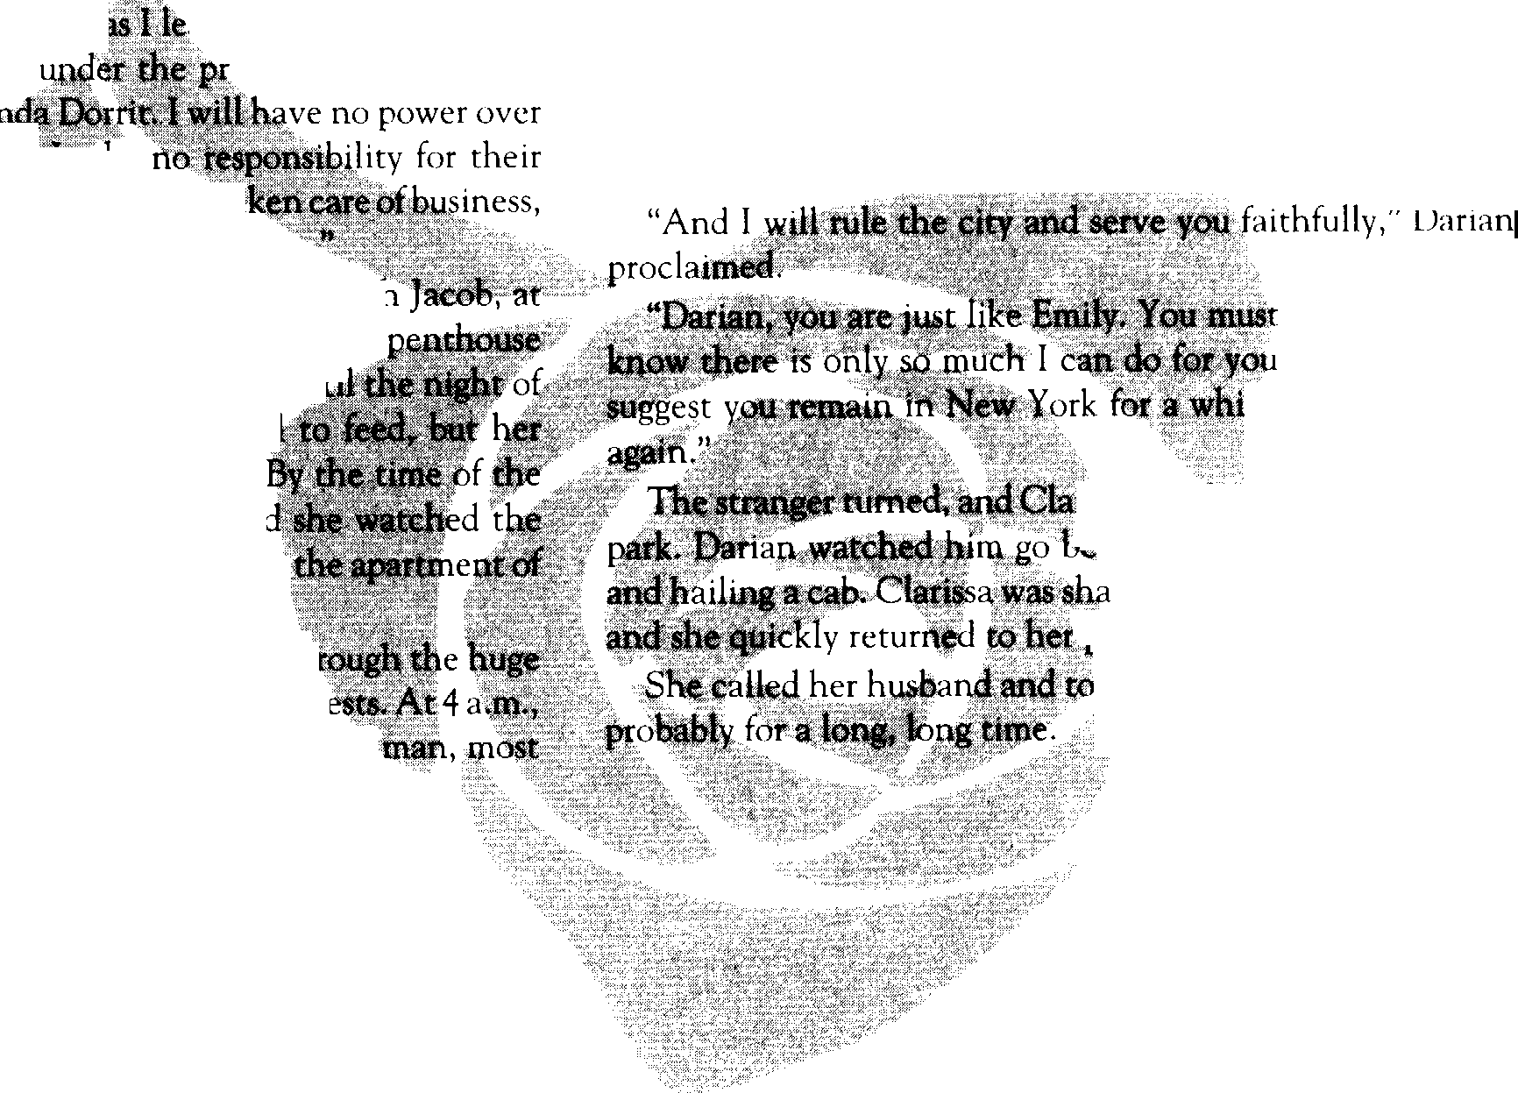
what happens with Balthazar first. lfwe are lucky, the primogen will make him prince. Then we can remove anyone who poses a threat to us. Within a year, Chicago will fall," rhe stranger
said.

actions "Annabelle tfl'."Now, having t
tell me 'what you thi } of Son's new friend ...
The next night, P f pickei;her up, along wit LaGuardia Airport. He tJ61ttn two of them to the he had rented for them near Central Park. Un• Darian's show, Clarissa only left the hot . ghouls managed to check out the gallery. opening, Clarissa had made her plans, an
gallery party from across the street, hiding in a young man she effortlessly seduced.
For hours she sat there, watching Darian th windows of the gallery as he mingled with his gu when the gallery closed, Darian left with another

be careful. You
. I have to go. I ( . We must meet

- sasaw hitn walk off into the ' .• re t ning to the streets
.. ken f,f at she had heard,
·,,:.: thou : •
id hiitt ould be away-

Introduction> 9

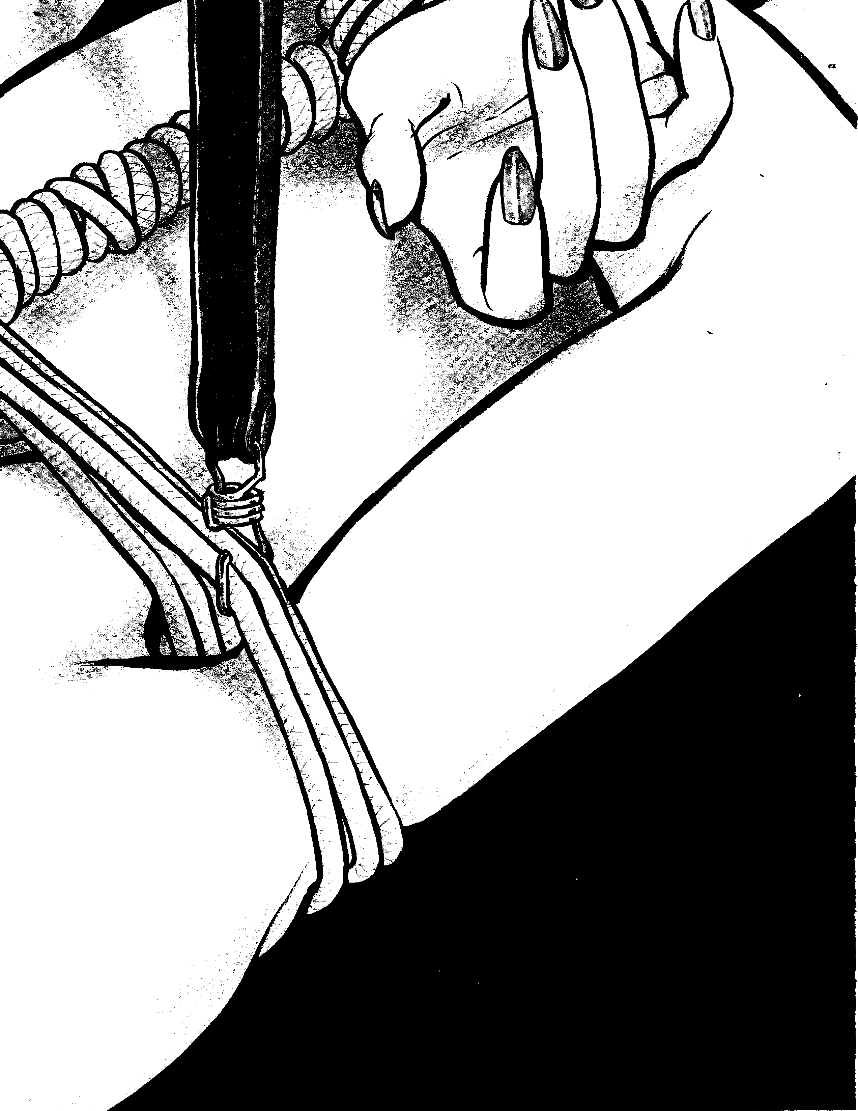

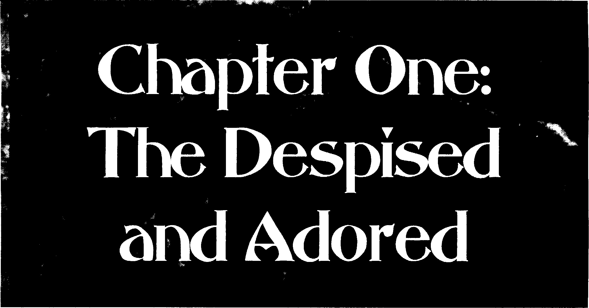

What happens when the intoxication of success has evaporated?
- Bauhaus, "Silent Hedges"

Effete poseurs, naive dreamers, hedonists, lovers, creators of bemty, sardonic critics, murderous seducers and devout vi, sionaries- the Toreador are all these things and more. The Toreador, despite their vampiric nature, are more like us than
:my other Kindred, for they still possess the energy and vision they had in life.
Though they intermix with the kine more than other Kindred, they hide behind the Masquerade they have created, keeping their secrets safe. As we get a glimpse of them, do not fix your gaze for too long. They are masters at perfecting appearances. We can only see a brief vision of what they truly are.
A Brief t1istory of the Toreador
Don't mock the faith ... to hell with the truth! A.1 the history of the world proves, the truth has no bearinp; U/)()n anything. It's irrelemnt and immaterial ... The lie of a pipe dream is what gives life to the whole misbegotten mad lot of us, drunk or sober.
- Eugene O'Neill, The Iceman Cometh

The Hellenistic Period
Toreador spread across the ancient world, playing promi­ nent mies in Crete, Mesopotamia and other lands, but Ancient Greece hosted the first concentration of the clan. Here they brought ahout the establishment of civilization as they per­ ceived it should be.
The Kindred were as gods to the kine, and some Toreador claim they inspired Homer and others in creating the tales that became Creek mythology. Even after the age of heroes, vam­ pires continued to play an important role in Greece, and the Toreador were a major factor in Athens. Even faeries and mages joined the Kindred there. For a while, it appeared as if Arikel was trying to establish a third city, one far greater than the first two.
The Lasombra and Ventrue who controlled Sparta had no desire to see Athens overtake their city in political influence. Thus, the Peloponnesian Wars were fought. The war left the Toreador in power, but any chance of turning Athens into a great city had passed. Within a few generations, the Ventrue and Brujah of Macedonia invaded Greece. They cast the Toreador from power, Arikel's messengers disappeared, and the clan was no longer united.
The Punic Wars
After the decline of Greece, Toreador spread out across the Mediterranean and into Persia. A number ofT oreador went to the city of Carthage, joining the Brujah to continue their pursuit of the arts. Over time, Carthage drew not just Brujah and Toreador, but Kindred of all bloodlines. Together, they began a united quest for Golconda.
At the same time, Rome, controlled by the Ventrue and Malkavians, was becoming a major power. The Ventrue wanted control over Carthage, and this led to the Punic Wars. At first it appeared as though Carthage would triumph, hut the wars were long and bloody. Eventually, most Kindred realized both sides were near equals. Rumor has it that a Toreador traitor provided the Ventrue with the information they needed to
Chopfer One ,..J, 11



A Frightening Legacy
My dearest Geneveve: I have come across the most darling little story, and thought you would appreciate it. All my love, Rafe C. One nisht, shortly after Caine became ruler of the first City, he sat alone in his palace. While the people of the city worshipped the first lmmortal, crafted sculptures and sans sonss in his honor, loneliness set in, for even
with their love, Caine was the only one of his kind. He left thecity for the desert, where he encountered a tribe
of nomads.
Amons the nomads was a youth of such sreat beauty that Caine was struck dumb. Caine took the youth back to enoch, watched the child srow and, when the child became an adult, made his beloved the first,,_E>orn. Later, two others were also embraced, but they arc not important to our story.
'Che first 6orn, who remains nameless (thoush not forsotten), became the prince of the first City. 'Che new prince served Caine z:calously, brinsins him sifts of incense and sold, thoush such thinss did not hold value for He Who Was Cursed. Caine sousht only forsiveness, but he knew now that the city he had created for sood had become decadent under the rule of his first 6orn.
lt came to pass that Caine's two other childer made childer of their own. Caine was furious, For he knew their misplaced love of him would be blasphemous to the father of his Father. After the Oeluse came and the first City was destroyed, Caine wandered the deserts once more. Misery tore at his heart, for he knew what he had created should never have been.
'Che first 6orn, who had not created proscny, came before his father and bessed for his return. His pleas fell on deaf ears. and Caine slipped into the nisht. 'Che first 6orn returned and joined his brother and sister, and their own proscny, in crcatins the Second City.
'Che loss of the father and the destruction of the first City hardened the first 6orn. 'Che survivors worked to build the Second City, but the first 6orn sat at the center. alone in a sea oF servants, worshippers, soldiers and merchants. lt was not Lons before the first 6orn Felt as the father had felt and finally made his own proscny to case the loneliness. 'Chese twins. a brother and a sister, were named Malkav and Arikel.
Arikcl was a sculptor- an odd profession for a woman in those times, yet her work silenced those who would have spoken asainst her. She was embraced because her wondrous creations spoke to the heart of the first 6orn, the one who had sired both her and her brother. 'Che first 6orn was kind to her, providins her with evcrythins she would ever need to continue her work throushout eternity However, the first 6orn demanded she not produce any proscny of her own.
'Che youns immortal pursued her art for decades, but eventually she srew weary. While she loved the company of mortals, and immersed herself in it, she Found it somehow lackins. eventually, the urse overtook her and she embraced one she did not wish to sec srow old. Her passion had overwhelmed her, and she knew she would be punished.
Seekins any way to avoid this Fate. she convinced 6rujah, another of the 'Chird Generation, to slay his sire, whom he hated very much. 'Che war between the ascs erupted. She sathcrcd those of her seneration, and tosethcr they banded toscther to destroy their parents.
Lescnd hos it. however. that the first 6orn, sire of the sire of the 'Corcodor, survived. escapins into the desert, the first 6orn followed the settins sun as his father had done and was never heard from osain. Some susscst that Arikel could not brins herself to slay her sire, while others say she merely did not set the chance.
'Chus. for those who would believe old lesends like this one. it misht be said the 'Corcador is the eldest of clans, for its line is unbroken. Caine still exists. 'Che first 6orn still exists. Arikel still exists. And her praseny have continued to multiply.

12 Clonbook: Toreador



defeat the Carthaginians, though the Toreador say this is typical Brujah whining.
Whatever the case, the Ventrue and their mortal legion­ naires protected the Toreador who came to Rome after the sack of Carthage. Toreador like to brag that it was the Toreador art, architecture, theater and love of beauty that made Roman civilization great.
By the time the Roman Empire fell, many of its Toreador had moved to Byzantium, where they believed they were safe. Some claim that if the Toreador had never left, the Westem half of the Empire would never have fallen. Others say a traitorous Toreador provided the Brujah, T zimisce, Giovanni, Lasombra and Gangrel with the information and aid they needed to destroy Rome. Many elder Ventrue believe this, and they secretly harbor a grudge against the Toreador they will, one night, repay.
Byzantium
The Toreador benefited greatly from the decline of the Ventrue in Rome. They established themselves in Byzantium, secretly controlling much of what happened there. Whtie
there were grave conflicts with various groups of mages, as seen through the Iconoclast Controversy, the Toreador claimed a great deal of power.
Haughty and proud, the Toreador of Byzantium managed to offend almost all the other groups of Kindred, but no one co ild equal their incredible talents at intrigue and subterfuge. In­ deed, some Cainite scholars say this period shaped the Jyhad into what it is today, and "Byzantine" became a lasting word for intrigue and complexity. Under Toreador direction, Byzantium had its Golden Age.
Between the 10th and 12th centuries, however, the Bruiah became more powerful in the city and, under the direction of many ancient Kindred, became the Toreador's equals. T orea­ dor claim, with some justification, that this p riod led to Byzantium's eventual collapse, for Brujah-controlled noble families battled the families controlled by the Toreador, and outside enemies began to cast covetous glances at the empire. Other Toreador, unwilling to share their city, banded to­
gether to cast out the Brujah, but their battles greatly weakened the empire. Other clans and enemies of Byzantium took advantage of their weakness, and attackers from east and west

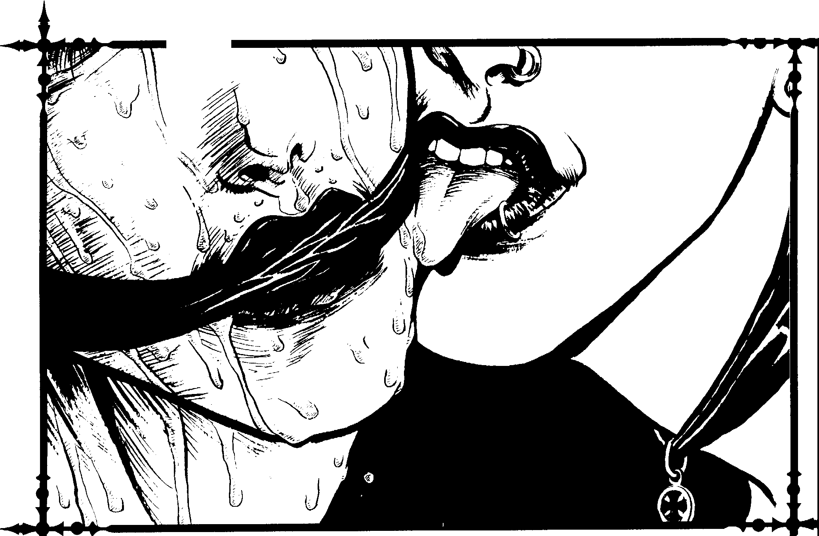
{)t,>;,,,,:
\.

Chapter One > 13


'
&.-
'
.;'.

>1)
····,'
I
_,..

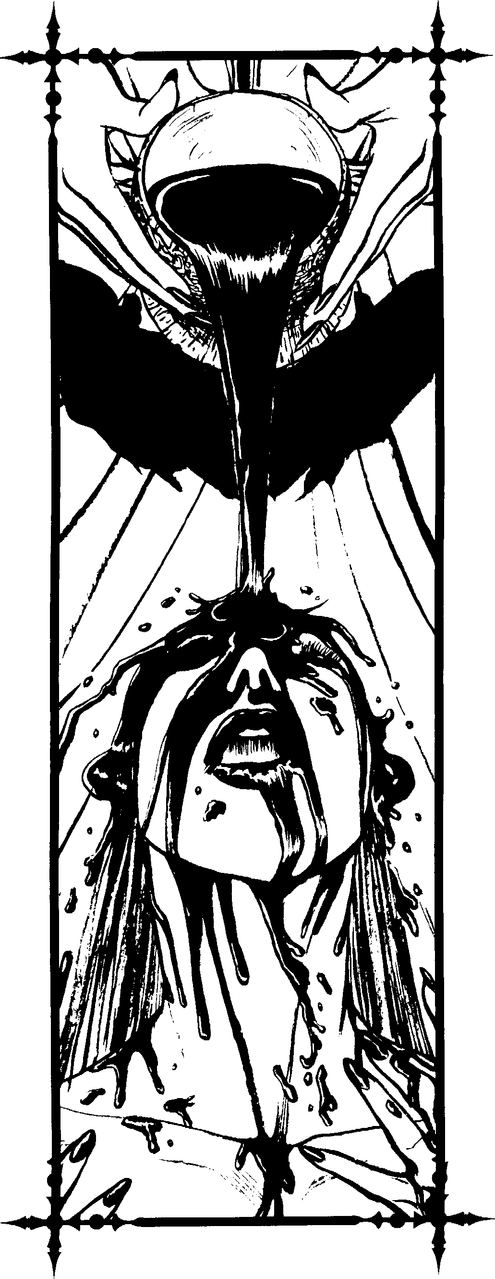

14 Clanbook: Toreador

ts•
beset the empire, Though they succeeded in reducing Brujah influence in Byzantium, by the 15th century, other forces combined to destroy what the Toreador had created, Thus, the Byzantine Toreador were chased hack to Italy, where they helped start the Renaissance, '
The Middle A es
While some believe the time between the foll of Rome and the beginnings of the Italian Renaissance was a "Dark Age", it was not so. When Rome fell, many Toreador headed south and east to more civilized cultures, leaving Europe to their less sophisticated kin. African civilizations flourished during this time, and Islamic culture reached its peak d•uring the 9th century.Toreador influenced many Islamic writers, musicians and architects.
During the ninth century, Europe also become more appeal­ ing. With the rise of the Carulingian Dynasty, the arts began to grow there once again. A few Toreador, such ,ls Callisti y Castillo, actually returned to Europe during this period ,md established political footholds. Unfortunately, the Ciiovanni and Ventrue had great control over the Church, and the Brujah and Lasomhra wielded much of the secular power. Despite this, the Toreador became entrenched in Europe.
During the Late Middle Ages, the Toreador set to work on the creation of new art. Looking hack to the work they produced with their sires in Greece and Rome, and remember­ ing their own efforts in Byzantium, they began laying the groundwork for the Italian Renaissance. New interests in Humanism, literacy and education spread across the continent and eventually led to the Renaissance,
The R.enaisSance
A general Renaissance swept Western Europe at the end of the Middle Ages, but nothing could compare with what took place in Italy. In a bold attempt to claim power, the Tore;idor took advantage of the growing curiosity and eagerness of the kine, and, through their efforts, both the clan ;ind the Renais­ sance thrived.
Those living during the time clearly recognized it as a new and better age. Through their unique methods and allegiances, the Toreador assumed control over much of Italy. However, the process was not a simple one.Just as the Toreador intrigued against the other clans, their own interpersonal rivalries com­ plicated their efforts.
The Ren,iissance involved far more than art, education and literature; it was a new age for both Kindred and kine. Though there had been a gradual rebuilding of civilization after the fall of Rome, the Toreador were hack in full force, Through its efforts, humanity changed forever to suit the vision of the Toreador,
Some would claim the Toreador's efforts were not without cost, for they were the catalyst for the greatest changes am, mg the European Kindred, leading to the Reformation, the Roman Inquisition, the Age of Reason and more.


)-
'II'

The Napoleonic Era
Though the kine were actually responsible for the French Revolution, rhe Brujah, Sabbat and Seti res milked it for what it was worth. They chased many Toreador from France, though rumor has it that anarch Toreador greatly contributed to this. The Toreador who had not fled with the nobility managed to use their influence among the squabbling Brujah. The release of Napoleon Bonaparte from prison was one result. After Napoleon emerged victorious over the masses and saved the Directory government, the Brujah and Toreador worked to­ gether to affect his appointment as a general.
The Brujah had hesitantly agreed to this collaboration. It proved to be their undoing. Napoleon was a strongly indepen­ dent kine who crushed the plans of the Brujah, though he unknowingly aided the French Toreador by acquiring and bringing to Paris many of the greatest works of art in European history.
The Modern Age
Other clans complain chat since the onset of the Indu,trial Age, the Toreador have become a stagnant clan. They hold a
,great deal of power, but they seldom use it. Its members have once again turned to their pursuits of pleasure and the arts. Some say the Gothic-Punk world is entering a new Dark Age. Only rime will tell whether or not the Toreador will be able to lead rhe world into a new Renaissance.
Around the World
While this clanbook looks at the Toreador in general, it is worth noting some important interests of the Toreador in various parts of the world.
North America
The Toreador of North America are second only to the Ventrue in power within the Camarilla, and they have achieved this success without suffering the distrust the Ventrue have. The Tremere are not too happy with the situation, and they have turned many Toreador into enemies by quietly and gradually siphoning away power and authority for themselves. Perhaps this quiet aggression will force the Toreador to take some united action. Despite the Tremere's magical potency and solidarity, a united effort from the Toreador would be a terrible threat ro the Warlocks.
Despite the fact that the Toreador and Nosferatu seem like natural opponents, the Toreador manage to keep their troubles with them to a minimum. Some Brujah and Ventrue claim there is something sinister going on between the two clans, possibly an alliance, a secret network or something even more dangerous.Toreador who hear this rumor smile smugly, though if someone were to repeat it to a Nosferatu, the Sewer Rat would probably look at her as if she were mad.

Beauty and the Beast
There is a myth most fitting for the most beautiful and the most hideous of the Kindred. While wandering through the gardens of the city, Arikel the beautiful met Nosferatu, another Kindred a little older than herself. As Nosferatu was the most beautiful being Arikel had ever seen, the two fell hopelessly in love. They began resting in crypts together, feeding from one another from sunset to sunrise. Within a short time, each was Blood Bound to the other.
Their affair went on for decades, but Arikel noticed that Nosferatu's renowned vanity was more than a keen interest. It was an obsession- an obsession to hide his greatest flaw. Nosferatu's face bore a blemish, a small mark placed upon him by Caine himself. Even blood could not heal the scar. Arikel began to worry for her lover and decided that if she could not help him rid himself of the mark, she would help him accept it.
One night, shortly after they had risen from their tomb, Arikel mentioned to Nosferatu that he should not let such a little scratch bother him. She told him that she could accept his beauty, even though it was flawed. Nosferatu fell into a rage unquenched by the blood of a dozen young mortals. Arikel tried to stop his frenzy, but could not. Nosferatu skulked out of the city, ashamed of his actions, and fell into a deep depression- not because of the crimes he had committed, but because he was not the most beautiful crea­ ture in the world anymore. His secret was out.
Nosferatu mutilated his own face. If he could not be the most beautiful, he would be the most horrific. Because of his Blood Bond with Arikel, Nosferatu could not bring himself to slay her, for he loved her so. Still, he tormented her and her progeny for a long time. Arikel took no action against him, and her pity only drove Nosferatu to further extremes in his insecurity, which he expressed through evil and mayhem.
Supposedly, Arikel met with Nosferatu one final time in Rome during the second century. They came toan agreement and broke their mutual regnant over one another in some mysterious and unknown way. They parted without good­ byes or forgiveness. Although they were no longer bound by the blood to one another, some claim that they still secretly harbored deep love for one another.
Perhaps this tale is a lie. Perhaps not.
In Mexico, the Toreador are the most powerful of the Camarilla Kindred, controlling Vera Cruz and other areas. A long time ago, the Camarilla of Texas used Vera Cruz as a gateway into Mexico in their fight against the Sabbat. How­ ever, in the last hundred years, the Camarilla Kindred ofT exas have become involved in problems of their own, and the Kindred of Vera Cruz are sitting ducks. Despite this, the Sabbat seems to be Iieve the facade of strength shown by the Camarilla in Vera Cruz.
Chapter One> 15

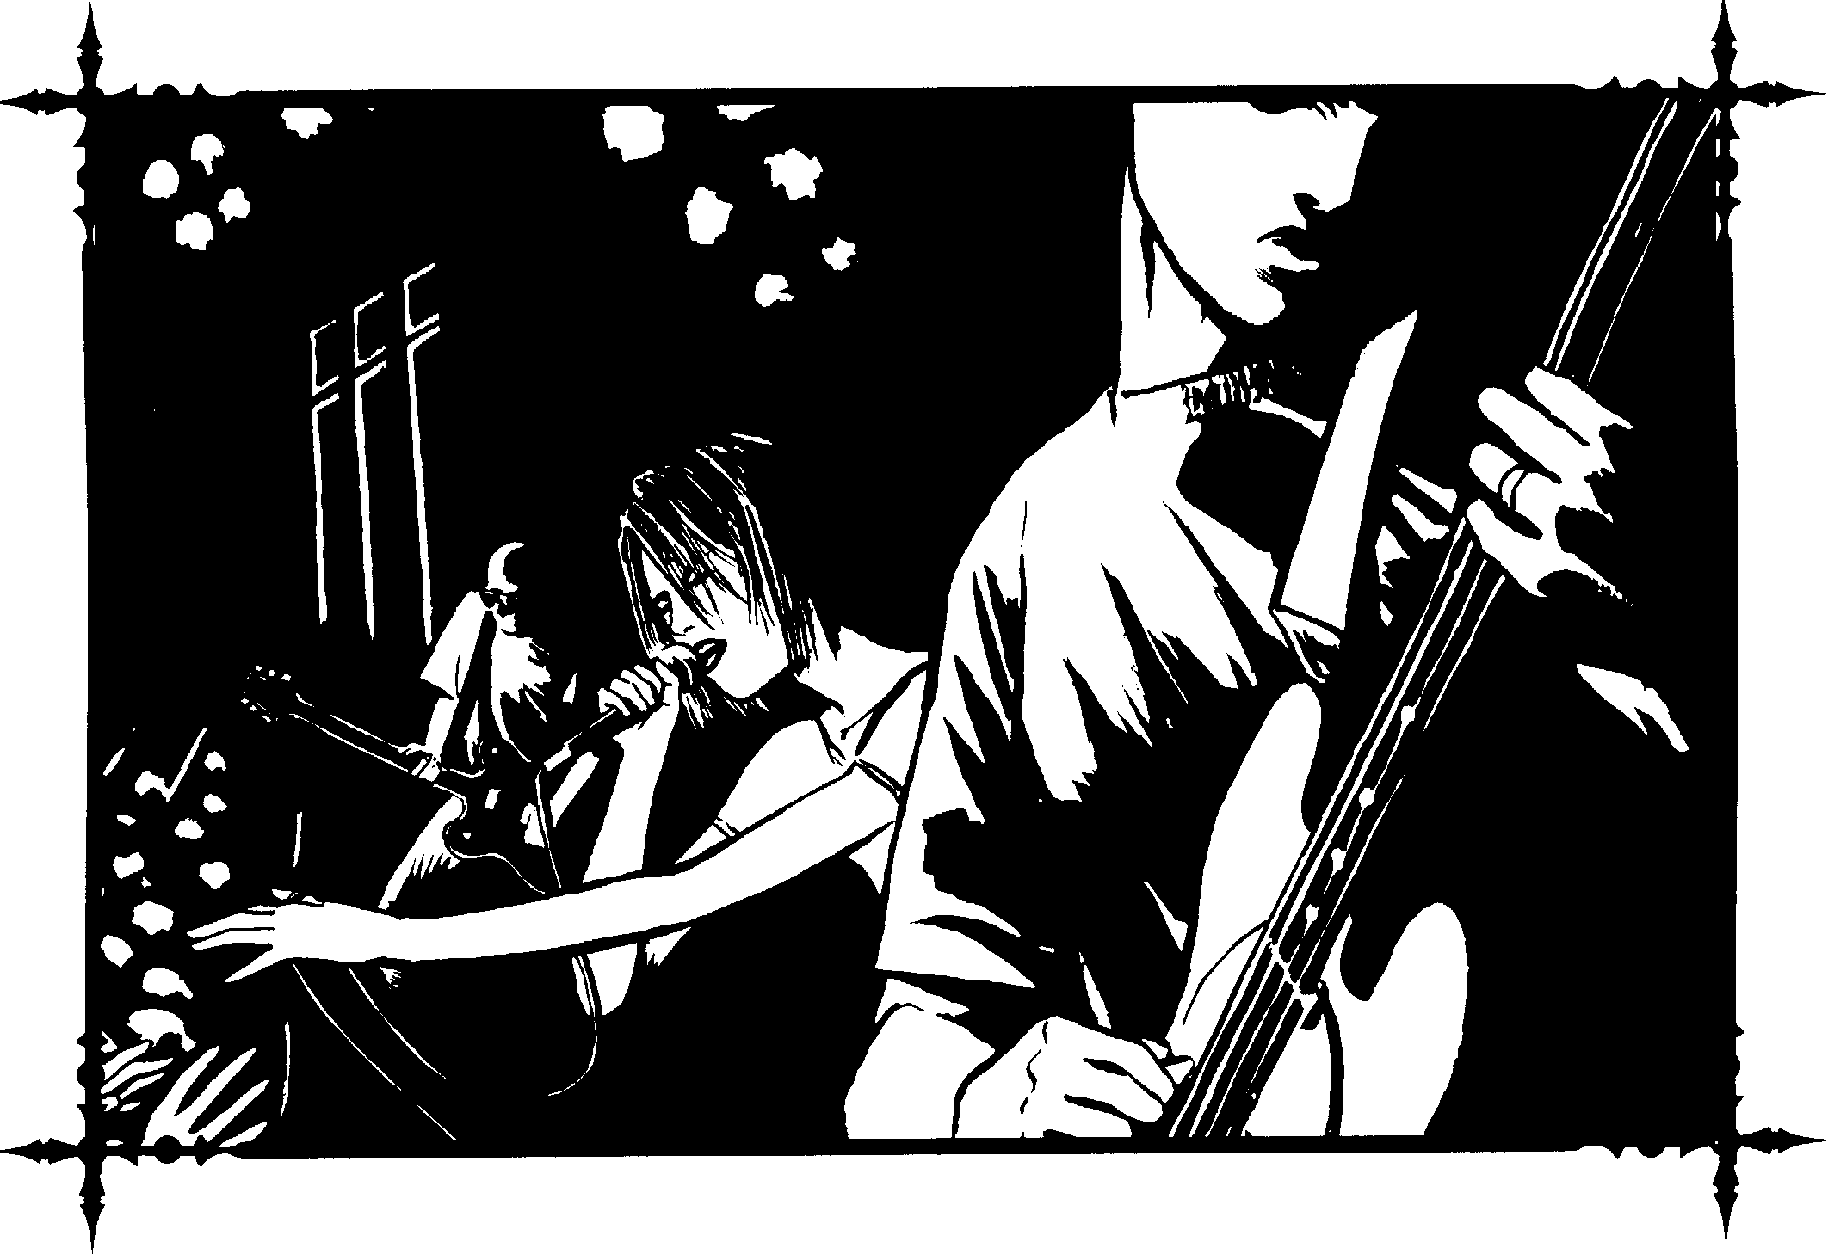
Central and South America
The Toreador have the most influential clan in South America. They make up the greatest percentage of Kindred and boast a number of the continent's princes. However, there are almost no Toreador in Central America, as the conflicts there are not to their liking. Most Toreador of South America are filthy rich, possessing huge estates and enormous herds composed of locals of great beauty.
Europe
The Toreador of Great Britain play almost no role in the current turmoil besieging the Camarilla. While the Tremere and Ventrue struggle to destroy one another and claim the mantle of leadership, it appears that the Toreador are true neutrals, interested only in survival. However, this may not be the case. Some claim the Toreador are in league with certain powerful and ancient Gangrel, though this is merely a rumor.
For the Toreador, France is the center of their world, and Paris lies at the very heart of it. In France, the Toreador outnumber and overpower any other clan by at least three to

one. The country is the sole bastion of their continued solidar­ ity. In Paris, Toreador elders may be found sharing the night with one another, free to roam the halls of the greatest Elysium in the world.
There are few Toreador in Germany. While many of the country's Ventrue leaders welcome them, others make them distinctly unwelcome. Even in Berlin, the height of German culture, Toreador often find themselves to be the target of violent opposition.
Toreador are numerous in Barcelona, Spain. They take no side in the war between the Tremere and the mages, but they make every effort to use the situation to their own personal advantage. Toreador still visit Spain regularly despite the dangerous situation there.
In Italy, several cities belong to the Toreador, including Naples, Milan, Genoa, Pisa, Verona and, most importantly, Florence. Milan also has a sizeable number of Lasombra, who protect the city. Despite the fact that other clans go to extremes to protect their own areas, the Toreador travel freely throughout all of Italy. Italy is often the first place Toreador visit when they begin their world travels.


16 Clonbook: Toreador


Eastern Europe
V
There are very few Toreador in any part of Eastern Europe. The Oradea League of the "Old Clan" Tzimisce, the lnconnu and the Russian threat tend to make this region of the world off-limits to Toreador travellers. Things are really bad in Russia, one of the few places Toreador used to risk visiting.Not even the most powerful clan members are willing to risk a conflict with whatever is controlling the country.
Arrica
Many Toreador have become enraptured by the natural beauty found throughout many parts of the continent, and the clan used to play a prominent role in the northern part of the continent. However, few make their permanent havens here any more. Those who do are among the most adventurous of the clan. Some clan members in the southern part of the continent are said to possess strange powers and are allegedly in league with Lupines who protect the nature preserves.
Middle East and Near East
Many Toreador are attracted to the art, architecture, history and culture of these regions. Despite warnings by the Assamites, Followers of Set and others, they continue to travel these lands seeking out some of the greatest and most exotic pleasures in the world. A few Toreador Ancients maintain permanent havens in Yemen, Iraq, Jordan, Syria, Egypt and Turkey. Many of these Toreador maintain personal cults to deal with any threats to their security.

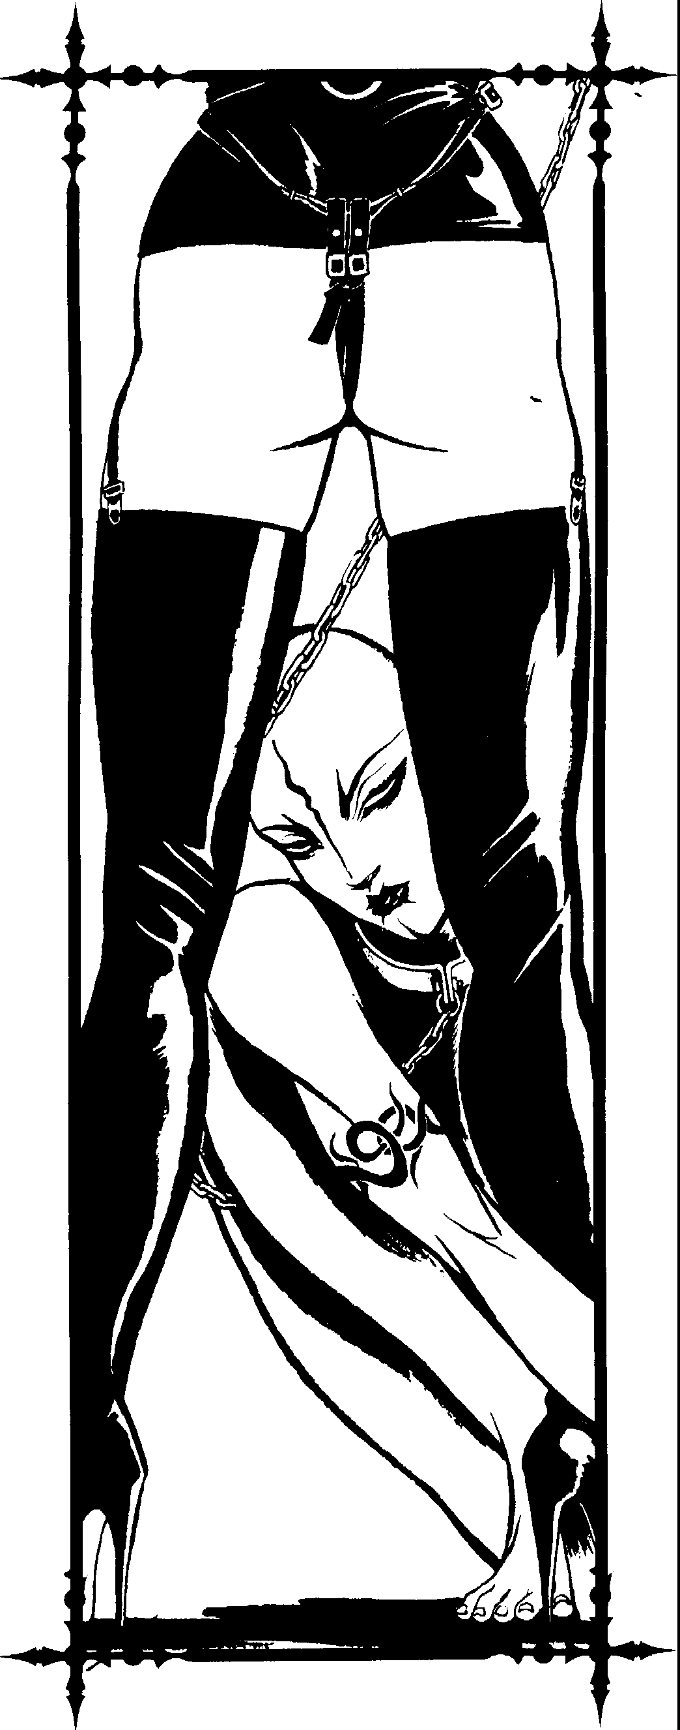

Chapter One> 17

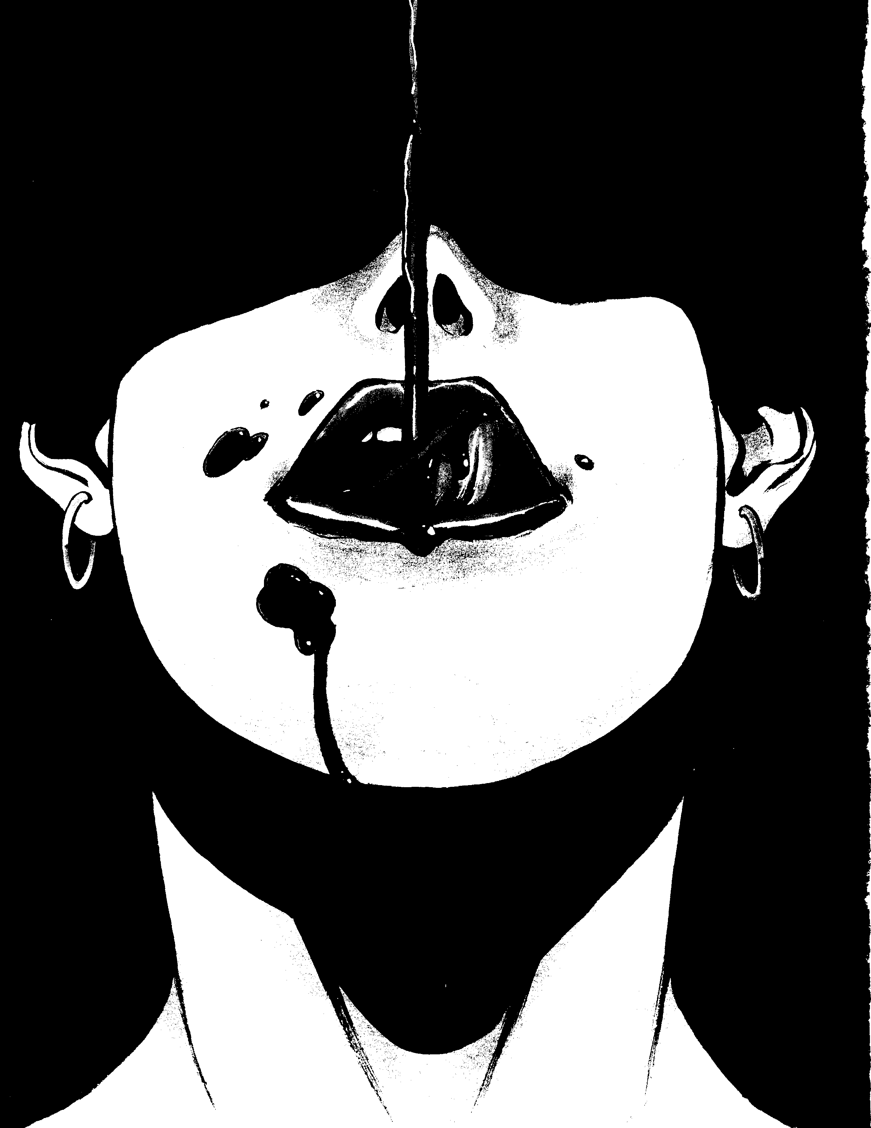



"Living" ror Your Work
The Det'il whispered behind the leaves, "It's pretty, but is it Art1"
- Rudyard Kipling, The Conundrum of the Workshops The Toreador exist in a world of darkness, a world where exploitation and unpredictable violence reign supreme. Turn­ ing their hearts and minds away from the ugliness they must endure, they give themselves entirely to their vision of perfec, tion. The pursuit of beauty is their noble vocation. As they follow this pursuit, the Masquerade requires them to draw upon what is held deep within their hearts. They must imitare humans to survive. However, although they love humans and
live like humans, they will never be human again.
Nonetheless, their unlifestyle is dear to them, and to keep it, they would give up everything other Kindred hold dear, in­ cluding political strength, ungodly wealth and personal power. Toreador see such things as mere trappings of the mortal world. Many Kindred pursued these things when they were alive, and many pursue them even more fervently now. The Toreador, however, look directly to the source of these trappings by examining the mortal world. They quest for something mor, tals hope these trappings provide- the "Good Life". By pursuing this quest, they have found a way to cope with the Beast that not many have found.
Playing the Mortal
Her heart is racing ... you can't keep up The night is bleeding like a cut
Between the horses of love and lust
We are trampled underjiJot
- U2, "So Cruel"
The Toreador love of humanity is a tainted affair. Mortals act as family members, wards and lovers, yet they are also prey.
Most Toreador consider a comfortable place in the world of mortals as important as any other part of their unlives. Indeed, they consider mortals far more trustworthy, beautiful, unpre­ dictable, vibrant, sane and energetic than other Kindred. Because of this, the Toreador have become the most adept of the clans at interacting with humans, moving freely in their world as no other Kindred can.
It is not uncommon for Toreador to go to great lengths to set up mortal identities, complete with friends, lovers, pets, a nice home and a "day job" that prevents them from seeing anyone until dark. Some Toreador spend an entire lifetime with a particular group of people entirely devoted to them. Others discard their chosen mortal cohorts as soon as they grow tiresome.
Seldom do they Embrace these mortals, though many make them into ghoul lovers. These immortal lovers rarely serve as bodyguards. Toreador rely on expendable servants for such tasks- animal or human ghouls for whom they have no real attachment.
The bonds some Toreador share with their mortals are so strong that they might actually make them their spouses. A Toreador might simply live with a mortal spouse forever, making him into a ghoul, or until the spouse grows old and dies. A few actually Embrace their spouses so they can share in the same pleasures (and curses) for the rest of their unlives.
Toreador rarely, if ever, feed from their mortal friends. Many believe doing so devalues the victims, so they avoid it except when ,1hsnlurely necessary. In addition, Toreador usually will nor feed in the sight of their mortal friends, even those who know they are vampires. They fear the impressions it might leave on them.
Younger Kindred find themselve., existing for the nightlife, sharing whatever new experiences they can find with their mortal friends. Many Toreador have attachments to the rap­ idly growing Blood Doll subculture, hut few actually 11se them
Chapter Two> 19


i-
)
_> !t
>N
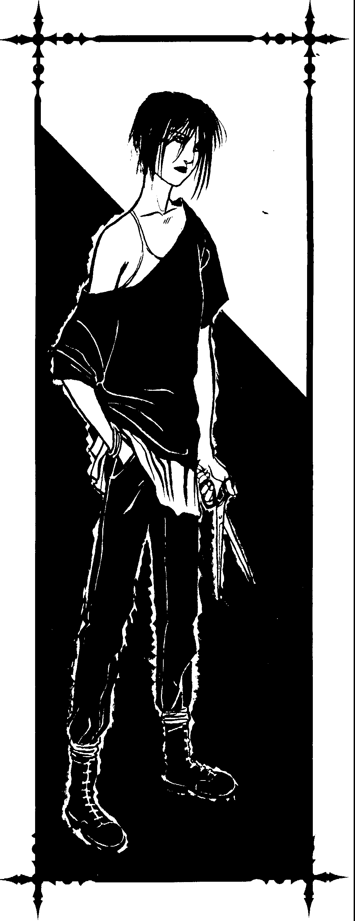
as a herd, fearing they might carry diseases or endanger the Masquerade.
Toreador love humans so much that they spend many years perfecting the art of "living", allowing them to interact with mortals on almost every level. Eating and drinking is a major problem, but most Toreador develop skill at Carousing and Masquerade (see The Vampire Players Guide), allowing them to get by. Some Toreador have even learned how to become flush and warm through the expenditure of blood points (using a secondary Talent called Body Control).
The Artiste
There are no teachers, saints, prophets, good people, hut the artists.
- Virginia Woolf
What does it mean to be an Artiste? The word is a double­ edged sword. Invented by the Poseurs in retaliation to their own name, Artiste is ,1 ,lerogatory term. Ir implies that the Toreador is nai\'e, otherworldly, effete, egotistical, obsessive, fickle, weak and quite possibly insane. Conversely, it also means the Toreador posses,es dedicatil m, unnatural talent and an eye for heauty.
While Toreadm Arttstes speak of themselves as artists, the derogatory term issued hy the Poseurs has clung to them. Now, all Toreador with unique and onginal vision, and the talent to express it, are constdereLl Artistes. Some Artistes have mag­ nanimously accepted the name as a sign of distinction and Poseur jealousy, while most others still see it as a stigma.
Each Artiste has a own unique vision; th,it is the key. Toreador Poseurs are some of the most skillful in their chosen areas of artistic expression, hut they are merely clones of the real artists. They hnng nothing original, nothing new to their work. It is the Artiste who can lnok upon the world and see something new even after centuries of existence.
Many Artistes pursue perfection- not necessarily in form, hut rather in the feelings their works convey. Their vision allows them to quest for the truths of existence, and their insight guides them in appreciating the beauty in all things. This internal process is reflected externally in their art. Infact, many Artistes pour so much of their Slluls into their work that a work of art can take on supernatural qualities. A masterpiece can actually contain a part of the Artiste.
A Toreador writer can spark ideas never before realized; a Toreador musician might play a tune which overwhelms the listener with emotion; a Toreador sculptor may instill in his work a semblance of life. From this vision, and the dedication to that vision, mc1gtc flows.
Toreador Artistes can ,1chieve prestige hy throwmg parties and gaining patrnnage, but the edge they have over the Poseurs is the prestige gained from their uwn work. Their clan is not one with a stable hierarchy. Greatness achieved today may be gone tomorrow. No Artiste can rest on the laurels of past accomplishments. Because of this, the efforts of the Toreador

20 Clanbook: Toreador


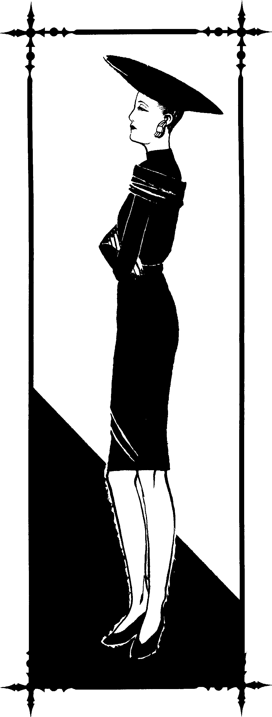
Artistes never end. As is necessary in real art, there arc new ideas, new modes of expression and opportunities for radical breakthroughs.
Toreador "Art"
I don't want life to imitate art. I want life to he art.
- Carrie Fisher
While most Toreador are interested in traditional forms of art, many have much broader definitions. There are Toreador Artistes involved in most fields of human endeavor rc4uiring creativity and talent. While this includes theater, ballet, classical music, opera, sculpting and painting, it is not limited to these areas. Photography, architecture, mo';:lern dance, modern music, performance art, martial arts, body building, philosophy, film, television, illustration, poetry and writing have all attracted Artistes.
In almost every area, two or three Toreador stand out, hut many who are e4ually skilled remain hehind the scenes, train­ ing mortals and their own progeny. These Toreador arc considered the "te,ichers", and their students form their "schools." However, there arc no actual schools. In most cases, the teacher simply acts ,is mentor and patron to those with the proper talent and vision. Only the most paranoid Toreador teachers Blood Bond their students, fearing it might stifle their creativity.
Students of a school commonly share a hond with one another through a particular style or area of focus. In fact, rivalries often develop among pupils seeking to be the hest. Once a student has learned all she can, the teacher turns her loose to pursue her craft in her own way.
Toreador also try to develop mortal artists. While most Artistes let talented mortals work without their influence, all clan members seek out new talent. Some of the must talented musicians, singers, movie stars, directors, comedians, modern artists, novelists and dancers were Toreador pets. Their abili­ ties to shape the mortal world make the entire clan more influential.
While the use of mortals is common, a few rare Toreador Artistes never let mortals view their work and never use mortals as pawns. These elitists are considered Artistes e4ual in every other respect, and their desire to reach only an extremely limited audience is often considered nohle. How­ ever, they seldom achieve the popularity or greatness of their influential colleagues.
The Poseur
Oh we're so pretty, we're so firetty vacant.
- Sex Pistols, "Pretty Vacant"
It is remarkable how many "beautiful pe()ple" arc in a cLm which prides itself on its artistic nature. According to older Artistes, too many mortals were chosen fur the Embr,ice based solely on their looks. Some Toreador have not huried their old sex drives, and perhaps some were Embraced as acts of rebel-
Chapter Two> 21


lion. Whatever the case, the Poseurs are now great in number and power.
Poseurs set the standards of social grace in Camarilla society. They hold parties, often inviting prominent mortals, espe­ cially those who serve as pets. They also serve as patrons ro all surts of artists am\ performers. Poseurs gain prestige through these methods, and set trends in both the mortal and immortal communities. While Artistes also influence society through their work, the real impact is never felt until many years or decades (or possibly even centuries) have passed.
Poseurs are not necessarily arrogant buffoons. They serve a vital rnle to the clan in providing cohesiveness and serving as links to the highly independent Artistes. They also serve as critics, ensuring that masterful Artistes are rewarded. The madequate artists are properly chastised and sent back to their havens to try again.
While must Pllseurs accept their roles with good humor, manv wish to be Artistes themselves. Indeed, even those who do a cept their roles as Poseurs cannot stand the word itself. It is a derogatory term invented by the Artistes to offend those whnm thev deem unworthy of consideration as real Toreador. Despite rh.e fact that rmmy Poseurs are experts at their craft, they lack the vision required for greatness. Because of this, they will ne\·er become true masters.
Some younger Poseurs become very embittered with the wav things are within their cIan and instead turn to the anarchs fur acceptance. Once these Toreador abandon their clan's cast system, they stand very little chance of ever being accepted back into the fold. When a Toreador chooses to become a social outcast, he must accept that fate for the rest of his unlife.
Degeneracy at its Finest
It's all riiht letting yourself go, as long as you can iet yourself hack.
- Mick Jagger
Aside from the typical Artistes and Poseurs, there are the burnuuts. These Toreador once had vision, and may still have It, though it is clouded by self-doubt, insanity, the Beast, depression or worse. To the burnouts, the world will never a,1.;ain hold the luster it unce held, the moon will never shine as bright as lung ago, and the smile on a beautiful face will never again hide the realities of pain and death.
Most burnouts are older Kindred. Many horrid events have tarnished their shield of idealism. These Toreador tend to he c1mong the wealthiest members of the clan, and they usually run: some of the most beautiful ghouls. They no longer pn:tencl to he human and instead concentrate their rime on the undead world, allowing them to increase their power and influence.
They dabble in vampire politics as a diversion from other interests, and unfortunately, they tend to lead most Guilds. Because of this, they provoke younger Kindred to great feats of treachery for the sake of art ( in addition to the near-mandatory

treachery for personal gain and glorification). If the young did not do so, true Toreador art would vanish.

Toreador Guilds
Death and sorrow will be the companions of our journey; hardship our iarment; constancy and valor our only shield. We must be united, we must be undaunted, we must be inf1exible.
- Winston Churchill, Report to House of Commons With rare exceptions, all Toreador belong to ,i political and
professional body known as the Guild. The Guild serves as the primary political tool for the clan. It also provides a hazy picture of hierarchy among the Toreador with.in the city.
The Guilds seldom meet, but when they do, all Toreador put aside their differences between one another to serve the good of the clan. Disrupting such solemn occasions with personal arguments assures that no one invites the offender to clan socials, and continued disturbances can lead to expulsion from the c;uild.
Most Ch1ilds are moderate to conservative in their political positions, despite their members' liberal unlifestyles. Toreador enjoy their protected status within the Camarilla and do not wish to jeopardize it. However, they must weigh this comfort against the growing influence of the Ven true and T remere. To main tam the balance of power, Toreador Guilds will take drastic action.
Despite all this talk about the solidarity of the Toreador through their Guilds, it should be noted that Guilds seldom meet. As a matter of fact, there are many Guilds which have never even met. Others only meet to deal with questions of art and expression, and never deal with politics.
The Guilds hold meetings in secret, well-guarded locations, and only Guild members may attend. The Toreador settle most questions in one night of polite discussion. However, in par­ ticularly divisive issues, meetings lasting a week or more are not uncommon.
It's a Dead Man's Party
Won't you come and dance with the beautiful dead?
- Killing Joke, "The Beautiful Dead"
For the Toreador, there is a killing field where battles are won or lost. Some think of it as a court of honor where the highest praise is given and the greatest condemnation is meted. Some see it as a symposium where brilliant ideas are expounded by the keenest of intellects. Others use it as a sanctuary where one can act freely. Regardless of personal interpretations, it is, for everyone involved, a laboratory where one is poked, prod­ ded and tested.To most Kindred, it is simply referred to as the Toreador social.
In fact, if you ask any vampire what is most characteristic about the Toreador, they will tell you about their marvelous parties. Invitation to a party hosted by a Toreador elder is indeed a great honor for someone outside the clan.

22 Clonbook: T oreodor



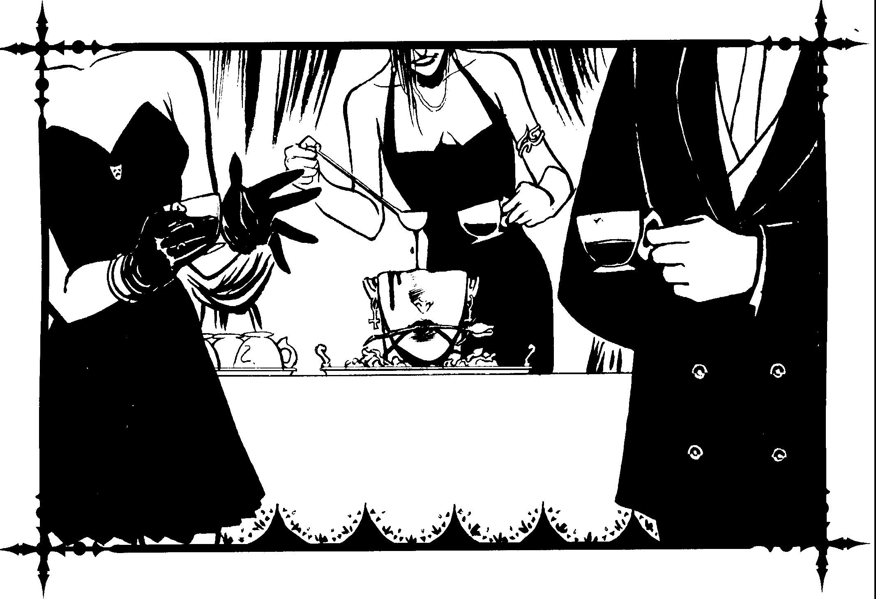

The art of invitation is one of the clearest ways of viewing clan hierarchy. Those with the highest prestige receive their invitations first, while those with little or no prestige are seldom, if ever, considered as guests. Hosts rarely gain prestige by selecting the appropriate guests, but they do lose it through inappropriate selections. Those who invite bitter enemies to the same function also risk losing prestige.
Crashing a Toreador party is the height of gaudiness, and party crashers dig their own social graves. Not only do the Toreador blacklist them from future events, but anyone else who wants Toreador support must do the same. Any Toreador who crashes an event will lose prestige based on how they crash the party, their behavior, their company, the type of party and who held it.
In many ways, Toreador socials are works of art unto them­ selves. The more outlandish and stylish the social, as expressed in location, theme, attire, servants and ambiance, the more prestige the host receives. However, good tastes must be balanced into the equation to get the most out of the experience.
Only Kindred attend most of these parties. On rare occa­ sions, well-chosen kine, usually pets or the untalented nouveau
riche, may attend. The latter serve as an inside joke among the Kindred, while the former provide new and interesting conver­ sation, helping to offset the carefully spoken "conversations" of the Damned.
Few socials are purely social affairs. Most hosts have an ulterior motive. The reason may or may not be obvious, and could be something as benign as an opportunity to introduce a new ghoul lover, or a motive as devious as the chance use innuendo to rip apart the prince's latest schemes. Whatever the case, a social event, on the surface, can gain a Toreador prestige, but it is the party's underlying purpose and its success which often garners the greatest reward for the host.
Many Kindred use Toreador gatherings to form alliances, check on the recipients ofhoono, and stay up to dare on events in the mortal world. In addition, parties are generally consid­ ered "safe" events in that violence rarely, if ever, occurs. Too many Kindred attend for a troublemaker to start a fight and survive. Also, parties open solely to Kindred allow for open blood drinking without fear of breaching the Masquerade.
Chapter Two> 23


4----,
- '
.( --

-/ '

'f'l.

Narm without Violence (or "The Tongue is Sharper than the Stake and Twice as Deadly")
Satire should, like a t)()lished razor keen,
Wound with a touch that's scarcely felt or seen,
- Lady Mary Wortley Montagu
Every Toreador would be well-advised to master wit, in­ trigue and language, These are the greatest weapons a Toreador possesses, and they are especially important to the Poseur who has no special talent to fall hack upon, With these weapons, a Toreador can (figuratively) stake an adversary to the ground or shield herself through hiting sarcasm and sly insinuation,
Toreador incapahle of witty repartee seldom go far, simply hecause the clan will not accept those who are not socially aggressive, Getting one's point across without being hlunt is the- key rosuccess. The more subtle one is, the more respect one gains. Such is the language of refined bullying.
In fact, many Toreador gain and lose respect simply through conversation. Those who sense weakness move in on it and dig at it with sharp tongues, Those defending themselves learn to turn a poorly chosen phrase upon its wie Ider. The ohjective is to make an opponent lash out, Among the Toreador, this is a powerful game, It allows those with good Self-Control, Ma­ nipulation, Wits and daring to advance more rapidly.
Because of this "game", many social g,1therings become very tense occasions. Everyone present harburs some secret scheme and searches uut weaknesses in nvals while staying on the defense against all others, As with any other sort of warfare, the key to success is knowing when to attack and when to retreat. Artistes must endure some of the greatest hardships at parries, since their work is usually the topic of conversation. If
an Artiste is unprepared for terrible criticism, her self-confi­ dence and determination may be shattered. The key is knowing how to play the critics. Even when they shower an Artiste with glowing praise, the best thing the Artiste can do is give little or no credit to the critics, This will make responses to later criticisms much more credible, Many Artistes arc not brave enough to he critics themselves, since doing so would open up their work for attack by those who have been criticized.
Puseurs are often suhject to the tastes of their fellow clan memhers as well. However, the critics seldom take the efforts of Poseurs as senously :is those of the Artistes. Usually, a Poseur's efforts as a host and a p,1tron are opened for criticism, although It is consiclered p,)or taste to criticize c1 party while in attendance, Subtle Toreador can cast their opinions around the room without speaking a word.
Aside from criticism, most Toreador consider rumnr-mon­ genng of utmost importance. Every Toreador social features the gossiping and the tradrng oflirtle lies for valuable informa-
it
'ti

Art's Defilers
The Toreador have never understood the attacks on the arts which have occurred throughout history. Even in more enlightened times, groups of mortals gather together to stop those with artistic vision ,ind talent. These attacks rarely involve physical conflict and often concentrate on the artists' credibility and fundmg.
Artistes have long sought to uncover the root of this problem, and most have blamed it on Poseurs hoping to destroy the Artistes' base of support. A name has recently emerged in connection with this threat - ,_the Seventh Generation, Nohody knows whether this is a group of powerful Poseur Ancillae or something worse, though rumors have begun to stress the latter possibility.
tion. Gossip has ruined many Kindred, especially when the Toreador spreading the rumors is not a known enemy. Torea­ dor who practice this art make it appear that such rumors originate from some source other than themselves. While a vampire can fight enemic., with claw and fang, rumors are for more 111sid1ous and impossible to combat effectively.
On the other hand, Kindred cajoled or taunted into a violent outburst provide a source of amusement to other vampires. No one will let a vampire get out of control, hut even so, most will use the loss of temper as an opportunity to emharrass the Kindred. Should it really hecome necessary, other guests will subdue their rowdy fellow in an unkind manner, usually with a stake through the heart (adding injury to insult). Because of this, most Toreador do not take sarcasm and hurtful remarks too seriously.
Impressing Others
Give me a minute to talk away my face, and I can seduce the Queen of France.
- Voltaire
Toreador have a certain protocol which any vampire who hopes for at least a modicum of acceptance must follow. This section merely derails some of the best ways to gain and lose prestige.To a lesser degree, this :ilso applie toStatus, since the Toreador set the social standards for the C:amarilla. Toreador protocol sometimes clashes with Status, however, so these are not hard-and-fast rules.
Behavior ;it social functions 1s extremely important. Mak, ing the simplest wrong move could set a character back years in prestige. Because of this, those who attend Toreador parties know how to swim with the sharks without being eaten. Of course, this means they have to 10111 the rest of the pack in eating the scared and wounded,
Cienerally, the most emharrassing and stupid thing one could do at a Toreador social is physically assault someone. This is very tacky, and the attacker will he escorted out, never

24 Clonbook: T oreodor


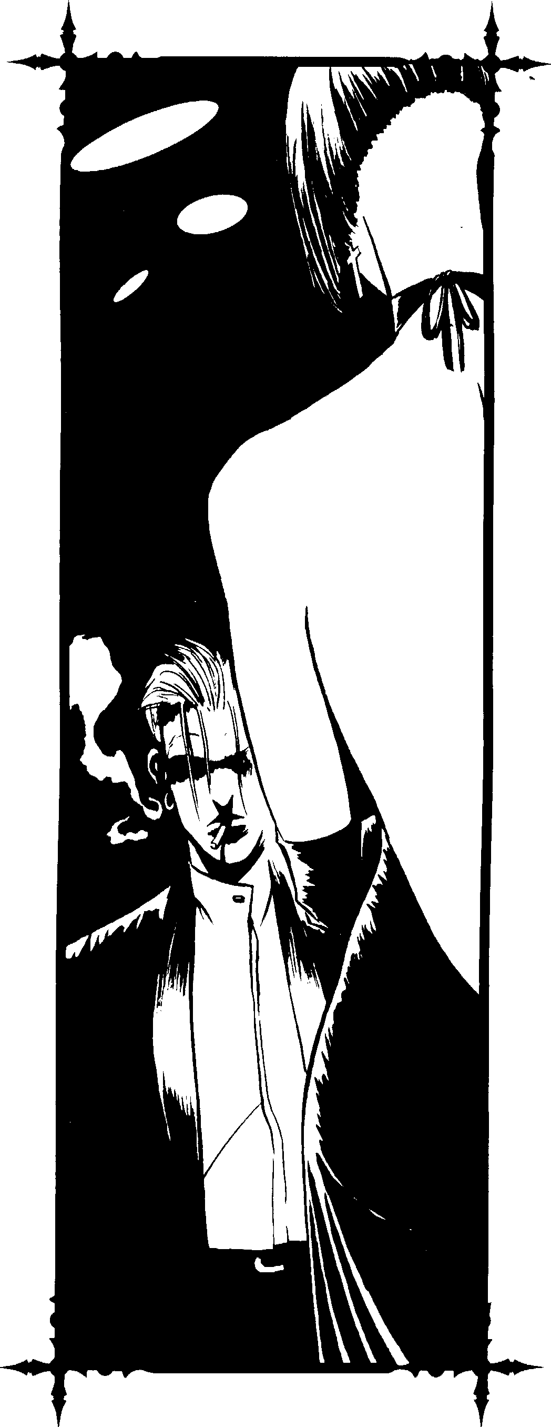
to he invited to anuther social agam. Even those who are eventually invited hack must suffer heing the hutt of jokes for years to come.
The next worst thing a KmclreJ can Ju 1s hring someone who was not 11w1ted. This is rude to the host ,md especially insulting if the uninvited guest is disliked hy the hnst or is not Kindred. The ch:uacter will likely get plenty of st.ires and some rude cumrnents. The host's serv,mts may escurt the vampire and his guest out into the street where they can have their own little party.
It is considered had manners to act rudely to the host, and to a lesser degree, to the guests. However, all Toreador (except the one on the receivmg end) appreciate quick wit and sarcasm. Guests should never excessively drink alcohol-tainted or drug-tainted hlood either hefore or during the party, since such vita: reduces mhih1tions and makes the wit dull and vulgar.
Characters can also !'lit on parties of their ,1wn - if they have the ,l.(uts. Rememher, nothing 1s as simple as it seems in the world of the Tmeador. A p.trty is more that a simple gathering of vampires for a guud time. It 1s a demonstration hy the host of her understanding of everything it means to he part of a community of vampires.
It requires good taste, knowledge of the hitest trends, sizable sums of cash, a suirahle location, good organi:ation ability, incredible social graces ,md ,1cknowledgment hy all other Toreadm within the l uild. If a young Torca,lor sends out invitations unly to find most of them politely declined, or ( worse yet) ignorccl, it is a sign she is not cunsidered a respected memher of the clan.
Of course, Toreador may gain admiration rhrough orher merhods. Art is cerr,1inly the gre,1test means pllssible. Art, by definition, includes all areas of human interesr relying on vision, originality, ralenr and dedicarion. Ry presenting a work, whether it 1s a performance of some sort or an art showing, a Toreador who is good at her craft gains respect. The hest work is original, regardless of its medium, design, effect or intent. For Poseurs, knowledge uf rhe arts and rhe ability to critique with an eloquent hut caustic style is helpful.
Also, patronage uf mortals is a goo,! source of prestige, especially if the Toreador cm claim the mortal as a pet, or has her own school. Because Kindred patrons have limited control over these humans, they may gain from the mort,1l's successes without taking full resronsihility for the mortals' blunders.
In dealing with mortals, Toreador consider the regular use of varnpiric powers on friends and students a mistake. The hest control is enforced through manipulatiun, thus avoiding the loss of creativity often found in mortals suhjecr ro Dominate and Presence. Those who du subjugate rheir m,1rtals through Disciplines find it harder to g,1in respect.
Finally, boons may pmve a valuable sllurce for increasing one's social stand mg. Toreadllr h,l\'e an advantage in this area because of their mllrtal tics. Since rhey often have Influence, EHne, Contacts, Resources ,md other h1ckgrnunds, they cm
Chapter Two> 25


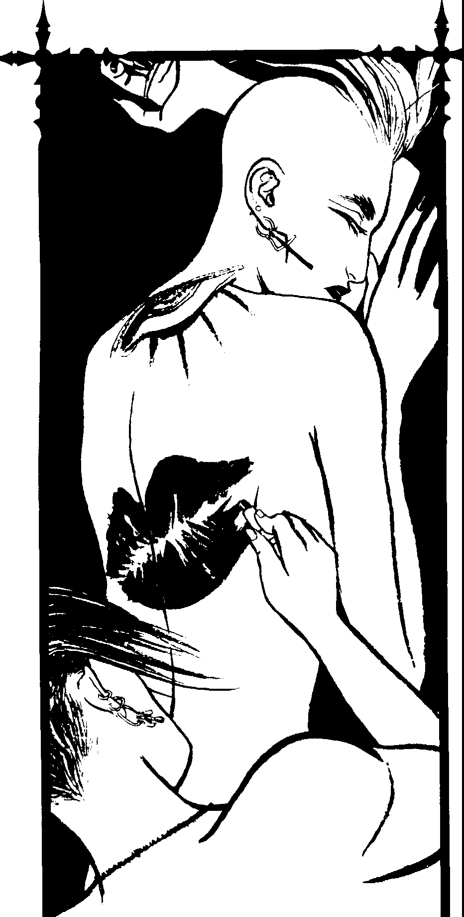


26 Clonbook: T oreodor

get things Jone other vampires can't. Additionally, srncc events of great importance to the undead often occur at Toreador socials, these invitations can be very valuable.
The Importance of Art
It is the glory and good of Art,
That Art remains the une way J>ossihlc
Of speaking truth, to mouths like mine, at least.
- Robert Browning, The Ring and the Book
Since the importance uf image and the snare of the critics have been discussed, it is time to look at the importance of art. Most Toreador were selected for one of three reasons: because they were beautiful, because they had a talcnNo create things of beauty, or because they could appreciate beauty more than the average person. Because of this, there arc very fcw Toreador who did not appreciate art as mortals, or learned to appreciate it after the Embrace. While art is not necessarily beautiful, the fact that it conveys emotion is.
Most Toreador own works of ,lft or personal art galleries. The size, quality and choices making up unc's collection reflects wealth, prestige and personality. Even Poseurs or those who engage in some artistic pursuit other than classical forms of art still own galleries, because it hclps define one's self and present that image (even though it may he a false one) to those who visit.
Toreador often share their private galleries with one an­ other, since they are rarely located near their havens. Toreador often use these galleries for very private parties, and usually keep their private galleries in locations as secure as their havens. Still, most Toreador keep one or two of their favorite pieces in their haven.
Buying and selling art is a major Toreador concern. Owning works by the masters only heightens one's reputation. Many Toreador pay exorbitant amounts or valuable boons for harJ­ to-find works. It is rumored that only ahout one-third of the greatest works of the masters arc in museums or known galler­ ies. The vast majority are in the possession of Toreador. For instance, the Toreador Prince of Santiago, Chile has in his collection a forty-foot statue by Michclangclo<lepicting Ulysses (despite the fact that the artist preferred sculpting Christian figures).
While it is important to own arr, it is equally important to note that stealing from Elysium marks a Toreador, or any other Kindred, for destruction. All Toreador seek the death of those who steal from these sacred places. Despite this terrihle warn­ ing, it is done. It is said that one of the greatest art thieves is a Toreador elder who paints undetectabk forgeries of the great works and steals the originals.
For an Artiste, and for some Poseurs, creating art is very important. Through their work, many Kindred learn to under­ stand their inner fcclings and visualize their constant internal struggle between Man and Beast. In some cases, creating art can actually restore Humanity to a Toreador. It is as if by



creating works of art, the Beast is somehow whipped back down for a time, allowing the Man to rise to the surface again.
The Importance or Travel
If you want to know a man, travel with him.
- English proverb
Most Kindred prefer establishing themselves in a set loca­ tion and working towards increasing their respect, security and influence. While these are important goals for Toreador, few stay put in one city year in and year out. Unlike other vampires, most Toreador travel abroad.
Toreador know they can see only so much of the word from the windows of their havens. To get the most out of undeath, they must visit all the beautiful and exotic places in the world. Doing so teaches them about their world, humanity and themselves. By travelling the world, they better appreciate and utilize their own power and place in Kindred and mortal society. The Toreador love of art is another big reason for their constant travels. By visiting Elysiums of all major cities, they enjoy the art, architecture and other works of civilization.
Some claim that by travelling, they are able to stay "alive" in some respects. It prevents them from growing stagnant and falling into boring routines for eternity, unlike many other Kindred. Through travel, Toreador form greater connections and relationships to vampires outside the microcosm of their home city, giving the clan an edge. It also allows them to stay in constant communication with one another.
Because most of their time in other cities is spent in the Elysium, they are generally safe from harm. A traveller will seldom take a large entourage, and usually leaves his progeny or a number of trusted ghouls in charge of his property while away.
Because New York and other important cities are controlled by non-Camarilla sects or clans, or even by Lupines and other beings, elder Toreador have made solemn pacts with these enemies to assure the safety of clan members visiting cultural centers. Some pacts are tenuous at best, and in some instances, there are no deals at all. Through this method, however, Camarilla Toreador travel freely where others of the Camarilla may never go. Clan members have travelled safely through New York City, Toronto, Montreal, Detroit, Philadelphia, parts ofJapan, Mexico, Asia, Africa and the Middle East. Many other Kindred of the Camarilla point to these pacts as another sign of Toreador treachery.
The Source or Power
It is of great consequence to disguise your inclination, and to JJlay the hypocrite well.
- Niccolo Machiavelli, The Prince
Let it not be said that all Toreador are complete hedonists. Most know what it takes to survive. Beauty, wits, talent and
mortal friends alone do not make a Toreador, and even the greatest of Poseurs knows it takes more than clever repartee and stunning good looks to get by in the world. In fact, many
develop keen interests in temporal power. Ancillae and elders alike increase their influence through their understanding'rif and relations with mortals. While Toreador dislike flexing their muscles, most can. When the need arises, they can surprise both the Ventrue and the anarchs.
Unlike the Ventrue, who latch onto whatever mortal is in power, the Toreador groom their own and assist in their climb to power. Because of this, Toreador rely almost completely on elected officials, while the Ventrue control appointees. This gives the Ventrue more staying power and the opportunity to create a more stable power base, though Toreado? often con­ trol the bureaucracies of local and national arts councils.
Few Ventrue attempt to override the influence of the Toreador, who are among their primary supporters. Rather than challenge them, Ventrue attempt to work against more immediate threats to their position. In addition to political officials, Toreador control many community interest groups, especially those with an interest in the arts.
Generally, Toreador lack control over mass media, which is primarily in the hands of the Ven true, magcs and other forces. However, the clan would love to gain a hold over television so that they could revolutionize it and put it to artistic and cerebral uses.
Some Toreador own their own businesses, giving them financial security and supporting their outrageous unlifestyles. Most possess chic and trendy retail stores, the majority of which sell clothing or jewelry. One of the more popular ways to support one's self is by owning ,1 nightclub. In addition to providing an income, it also provides access to mortals and a good location for parties.
Many Toreador keep a sizable number of attractive ghouls to serve and protect them. Few clan members enjoy engaging in fisticuffs, preferring their ghouls do their dirty work for them. However, valued ghoul friends and lovers are almost never used as bodyguards.
Toreador are skilled at intrigue and gathering information. Most elders know this and consider the Toreador to he a clan of traitors. Why else would they hold all those parties and invite Kindred they do not like unless they were up to some­ thing? While not on par with the Nosferatu, they are the equals of the Tremere when it comes to information.
Toreador, unlike the Nosferatu, almost never let on that they arc fully aware of all that is going on and rarely trade valued information to those outside their clan. Also, Toreador seem less organized and threatening than the Tremere. What­ ever the case, the Toreador enjoy heing considered "degenerates." They prefer tu be underestimated, because it provides them with a valuable edge on their enemies.

Chapter Two> 27


The Source or Beauty
But if you could JUSt see the beauty These things I can never describe.
Joy Division, "Isolation"
Whc1t causes a Toreador to find rapture in the oddest things? What makes their entire minds and hodies lock up so they cannot see, feel or do anything but experience one thing? Not even a Toreador can answer these question, but there are legends.
Many Toreador believe the Embrnce brings out the Man in them rather than the Beast, allowing them to experience a far greater range of ;,ositive emotions. Others believe it is similar in effect to the altered percq1tions experienced by Malkavians. Whether this is true remains unanswered, and possibly unan­ swerable. Huwever, many Toreador claim their libidos are far stronger than they were when they were alive, and most attest that unlifc increases their creativity.
Whatever the cause, little details, minor nuances and in­ sight into mundane things often entrance Toreador, possibly proving them to be more closely related to the Malkavians than either group wishes to believe. When a Toreador takes notice of something that strikes him as amazing or heautiful, a process in his brain sets into motion.
It is as if an entire program has been built into their brains granting them a new sense of perception; one which recognizes and analyzes anything extraordinary. It focuses mostly on beautiful things. However, as a Toreador's Humanity de­ creases, the process slowly broadens in focus to include more negative things. Thus, the higher the Humanity, the less chance of suffering the weakness.
Th<: mental program is not under the Toreador's control. It may take only a few seconds of entrancement, or it can take hours. Legend has it that some Toreador have become en­ tranced for weeks at a time over particularly interesting sensations, and some joke that Arikel is not in rorpor, but has sat entranced in front of a mirror for 2,000 years. Most T orea­ dor do not see this fascination as a detriment, for they believe it provides them with the insight needed to create new art. Many even attempt to reach such states of fascination for sheer pleasur<:.
While the entrancement is in effect, it is as if the Toreador is in a daydream. They are often unable to snap out of it without a degree of outside effort. If the process is halt<:d midway, the Toreador often becomes irritable.
The fascination may be triggered by works of art, talented performances or heautiful music. It seems Toreador are as easily entranced with everyday things as they are with "artistic" things. Therefore, it is possible for a Toreador to walk through

an entire museum without triggering the process, only to walk out into the street and become fascinated by a cigarette butt lying by the curb.
Mortal Love
If I could stay ... then the night would give you up Stay, and the day would kee/J its trust
Stay, and the night would he enough.
- U2, "Stay"
Because most Toreador do not lose the inner light within themselves, they still see mortals as creatures of beauty. While dual lives among Kindred and kine are common among the Toreador, some go far beyond this - some fat! in love.
In most cases, intimate relationships with mortals are disas­ trous, but for a brief moment, the Toreador experiences love, something most Kindred have forgotten. Through love, Hu­ manity is restored, insanity cured and zest for unlife renewed. It is, perhaps, the possibility of love that makes the Toreador so special. Love is a powerful force, superior in many ways to all the dark powers of the Sabbat, the respect of the Ventrue, the intrigues of the T remere and the secrets of the Nosferatu. It is a force of good that nurtures and heals.
Despite all the wonderful things that can come out of such relationships, they are generally discouraged. Fortunately, few Kindred actually take action in such cases. Unfortunately, mortal mates are usually the first victims of attacks on Torea­ dor.
Love Among the Damned
Love is the distance between reality and pain.
- Robin Hitchcock, "One Long Pair of Eyes" (Spoken Word Version)
Sometimes the Toreador obsession with beauty leads to romance with another Kindred. Flings with other Toreador or even members of other clans (or even other supernatural creatures) are not uncommon. These romances usually last only a short time, but some l<:gendary ones have lasted for centuries.
It seems that Toreador love company far more than other Kindred do, and they arc among the few capable of developing real relationships with others of their own kind. Because of this, many Kindred see Toreador as either impressively brave or incredibly naive. It also makes more than a few jealous.
In the long run, there are only fleeting comforts gained through such relationships, but pain and problems resulting from breakups can haunt them for a long time. Still, many of these heartbroken Toreador do not give up. Instead of wallow­ ing in self-pity (like most Kindred), they seek out new lovers.

28 Clonbook: Toreador


'IIJ
J i

The Forever Tragic Tale
Loi•e will save you from the black night and the lightning and the ghost
And loi·e will save you from your misery, then tie you to the bloody post
And lot'e will save you from the hands that pull you down beneath the sea
Low may ,at'e all you people, but it will never save me.
- Swans, "Love Will Save You"
Loss uf Humanity is terrihle fur any vampire, but for T orea­ Jor it is particularly pitiable. Because the clan maintains such close relations with mortals, using humans solely for food is a terrible thought. However, in many cases, this will happen.
As centuries pass, many Toreador grow c,ild-hearted. They begin pursuing base pleasures. The first sign something is wrong is when a Toreador begins feeding off her mortal students, friends and lovers. Most Toreador are loathe to do this. At this point, most consider the Toreador in question to be a burnout.
After existing in this burned-out state for some time, most lose interest in maintaining any sort of connection with humans. Instead, they see mortals only as cattle. The beautiful cattle are transformed into ghouls or Blood Bond members of their herds. Finally, loss of beauty and loss of vision is inevi­ table. The Toreador weakness begins to function only on that which is evil and vile, which may explain why many Sabbat Toreador antitribu show a particularly strange bent in their art.
The Darker Side or the Clan
... when you ha1ve extinguished his soul in this world and placed him where the ray of hope is blown out as in the darkness of the damned, are you quite sure that the demon you have roused will not turn and rend you1
-Abraham Lincoln, speech at Edwardsville, Illinois While the Toreador have may wonderful aspects, the clan has a dark side as well. Even though one of its most prominent
aspects is a general love and respect for humanity, there is an
element within the clan which thrives on exploiting kine.
Made up mostly of burnouts, the exploiters are those who have learned to draw power, wealth and influence from the pleasures humans demand. Many of the Toreador involved in exploitation form gangs unto themselves, while others gather mortals around themselves and create ghoul servants.
These Toreador operate in child pornography, prostitution, slavery, gamhling, bL1ck marketeering and cultism. With their great experience in mortal dealings with humans, they have no problem establishing themselves in any of these fields.

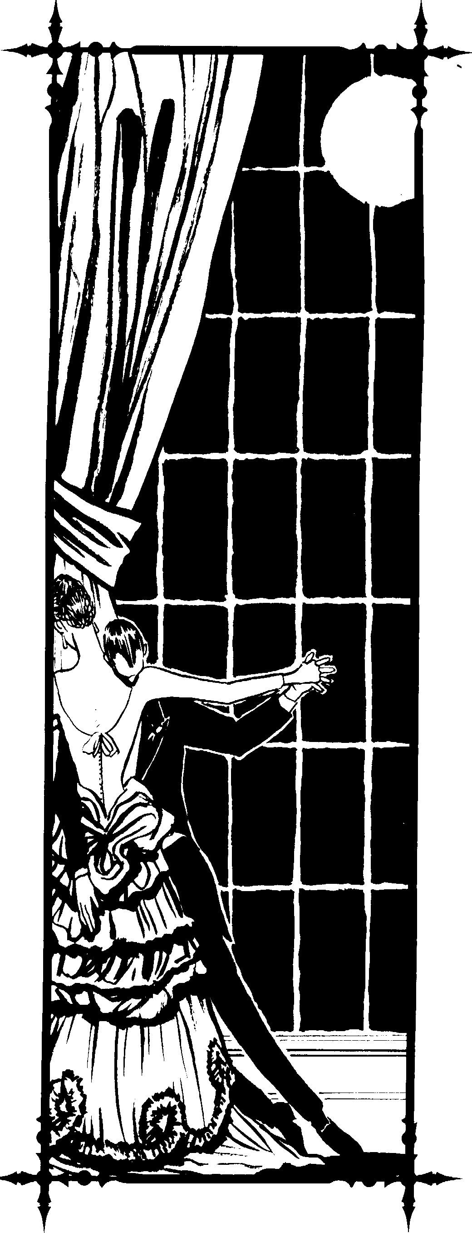

Chapter Two> 29

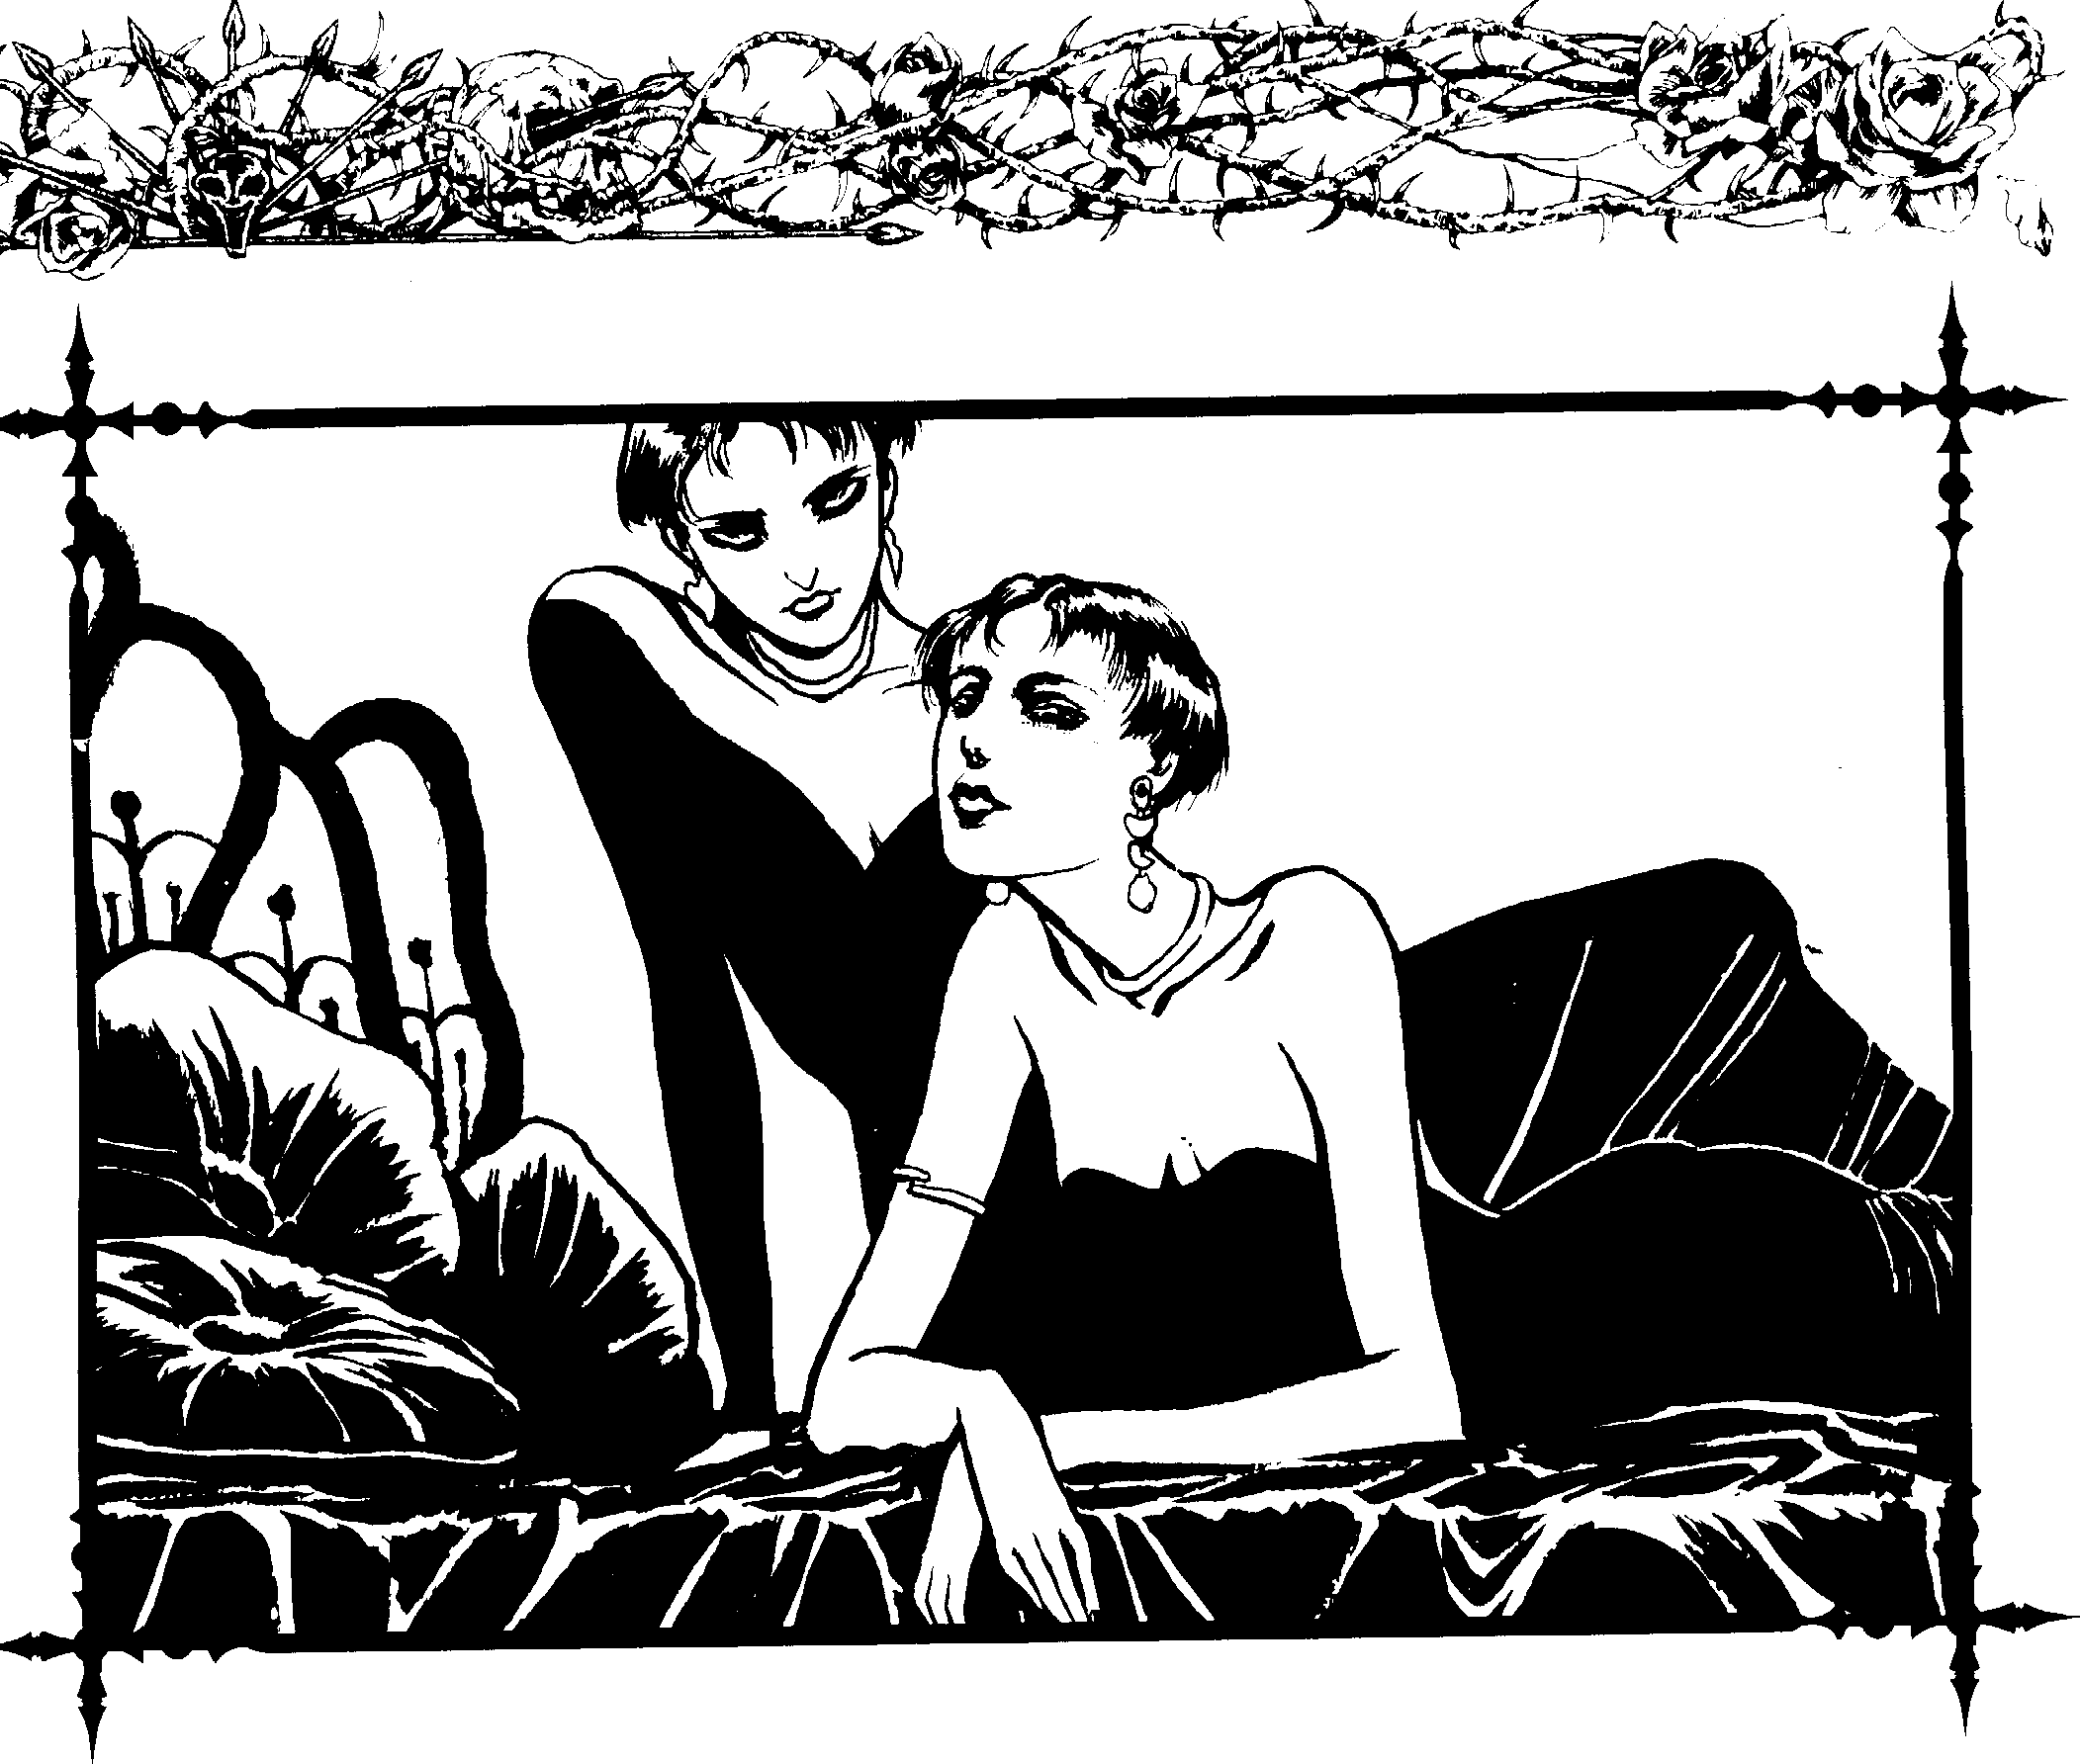
Within the pornography industry, there are many sleazy clan members who Blood Bond young innocents and can force them into doing anything, no matter how degrading or per­ verse. An interesting side note is that some Toreador who have perfected the art of Masquerade and who possess Thaumaturgical means of simulating human functions have been porn stars themselves. They love the notoriety and consider their work counterculture art, or anti-art.
Pimping is a common practice among Toreador. Some will readily put young men and women to work as prostitutes, providing themselves with a nice income. They usually Blood Bond their "employees" by giving them their blood in a cup. Most do not drink prostitute blood, however, for fear of diseases.
Though some Toreador sold African slaves centuries ago, other Toreador were in the slave business long before that, and some still practice it today. While there is a big market for white women and children among the rich in the Third World, business has opened up so much that persons of any race, color or background can be sold into slavery. Some believe the Toreador who control the slave markets arc in league with Assamites and Followers of Set.

(,ambling has been around almost as long as the human race. Life is a gamble, and gambling games arc just the conden­ sation of risk into a form of entertainment. While Las Vegas may seem the worst thing a Toreador could experience, others have said it represents the ultimate Poseur rejection of the Artistes. Controlling casinos all over the world, often vying with Ven true and Setites, the Toreador have found a way to get rich without any real effort.
There are many types of black markets, but the illegal trade of stolen artworks, ancient artifacts and other items of rare beauty are the most appealing. Often those involved in slavery also work in this line. Those who claim there is an art mafia formed of Toreador elders would link them to this group, but so far nothing has been proven. If such a secret organization does exist, T oreadur black marketeers most likely serve as pawns.
The most vicious and power-hungry Toreador are those who have their own cults. They are referred to as Blood Cults, because the cultists give their masters sustenance and power. Blood Cults can be very dangerous to even the most powerful of kindred. Cult masters establish hidden temples and gather followers ranging from homeless people, to mercenaries, to

30 Ckmbook: Toreador



politicians, to CEOs, to the family next door. Most Blood Cults are versatile and powerful, yet small enough to act with precision. While cults vary in purpose and practice, the sharing of blood, the creation of great numbers of ghouls and even progeny, blood orgies and occult rituals are commonplace.
Rivi'llries
Winning isn't everything, it's the only thing.
- Attributed to Vince Lombardi
Some Toreador develop rivalries with others of the clan. In most cases, some past conflict touched off the rivalry, and each Toreador tries to outdo the other. In some cases, the rivalry is a game which neither party takes too seriously, making it more for show and protecting themselves from loss of respect. In these cases, the rivalry often serves as a prod to make sure each always works to the best of her ability.
Serious rivalries often last for centuries. In fact, some have become so serious that one rival ends up destroying the other. In most cases, whenever one Toreador does something to gain positive attention, the rival will do something to gain ev<2n more. Occasionally, rivals do everything they can to draw negative attention to each other through the use of rumors, intrigue and setups.
Toreador who admit defeat and move on to other areas of interest usually lose some respect, but if they do so with incredibly good grace and make their retreat seem le% serious, they might get away almost unscathed. Utterly shaming a rival is generally frowned upon, since there is no need to do so, and doing it is seen as a sign of insecurity or megal mania. Of course, the victor still goes to great lepgths to subtly ensure that everyone hears about what happened.

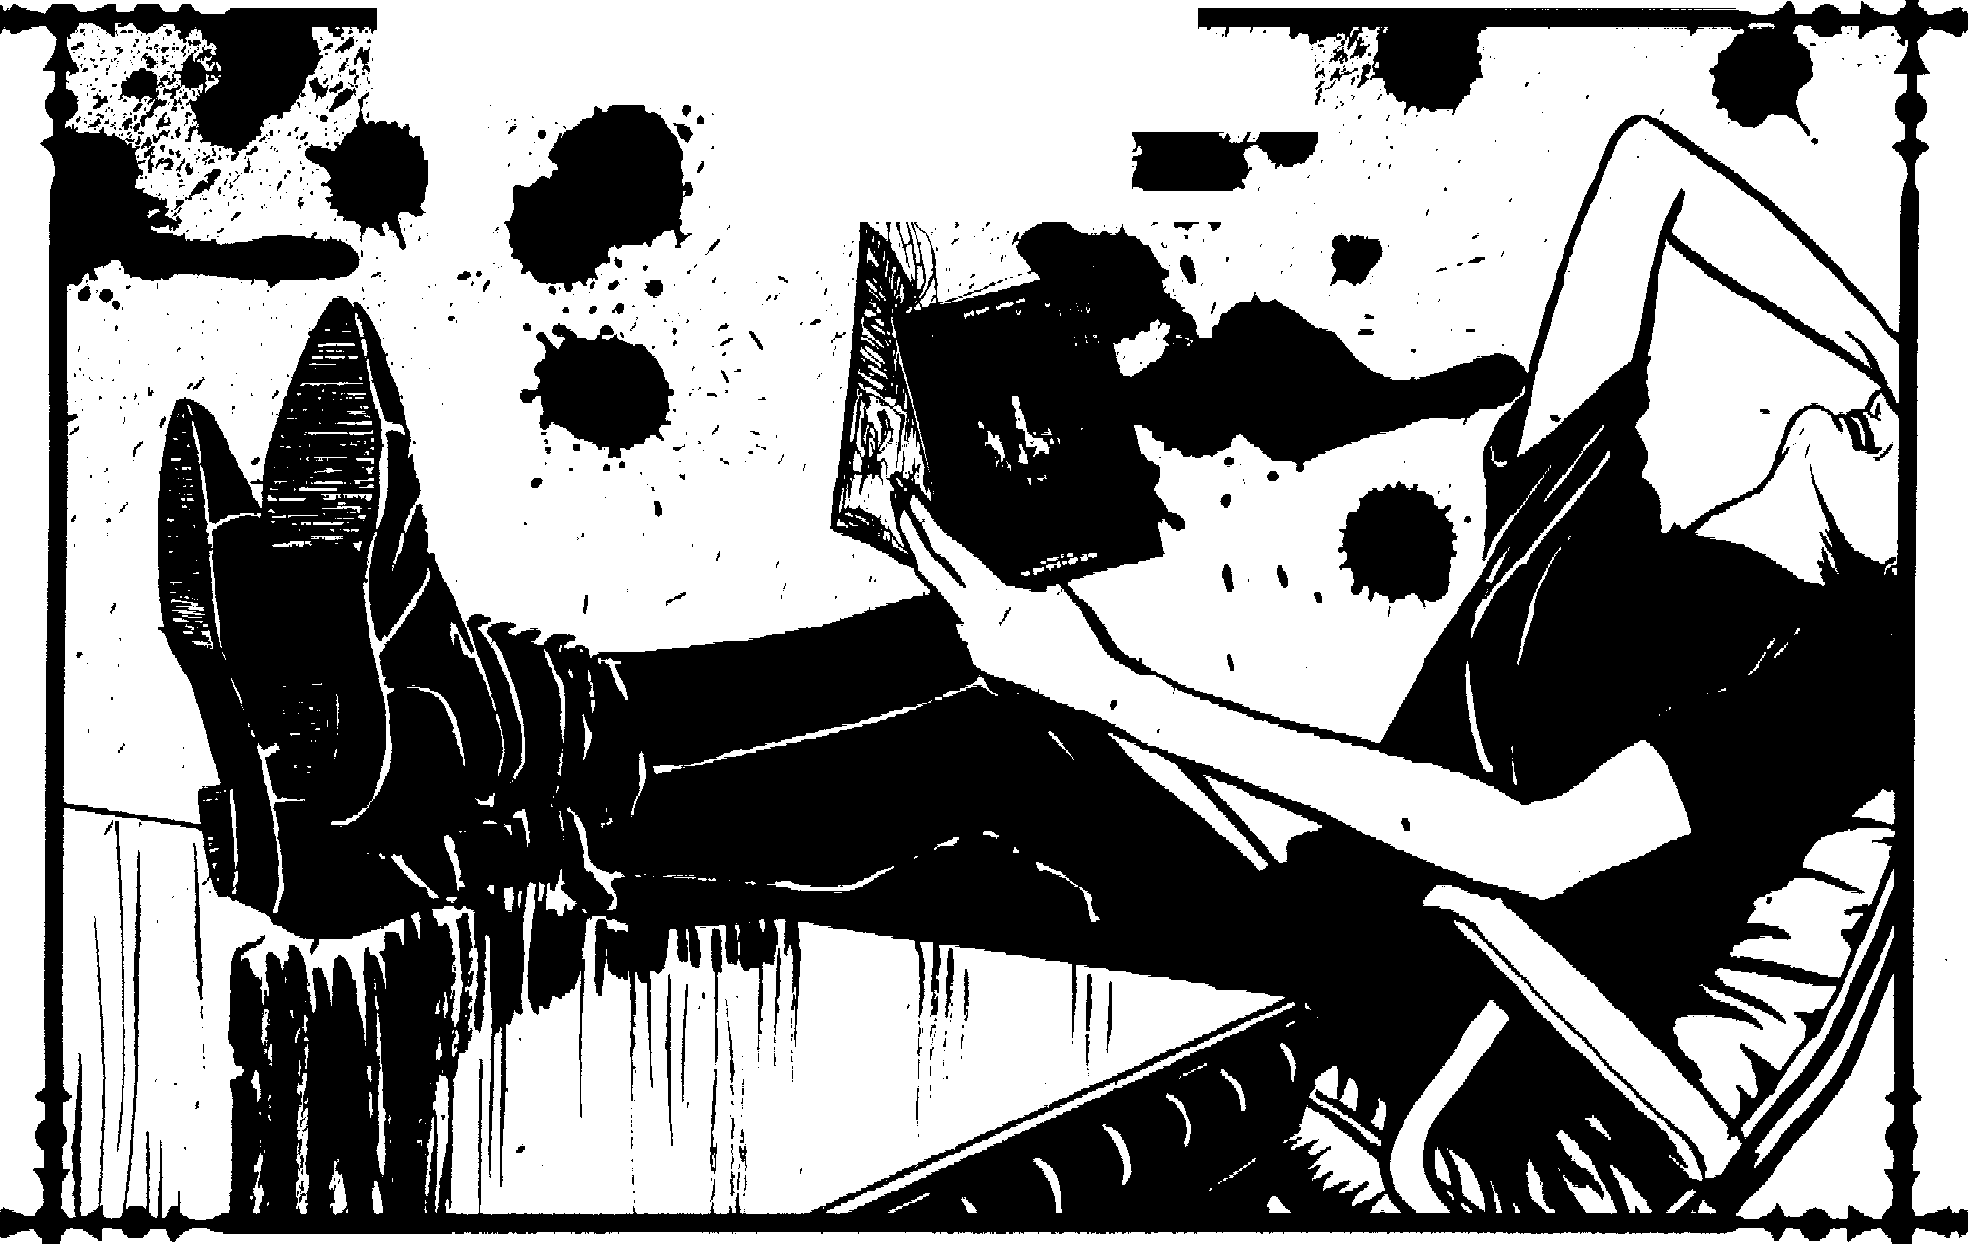
},,:- ,:·.
I·\; :'., :,
...
u • i-
. . ,; ,
'·,•. ..., ,, .;;:
. • .
. ,.
'.,•
-.
,
,>·_: --_::-; ;?·:.'• :,'. -.:, :·· ,.:,
. ,,.,,, .,
•
' .
, I , ,,,
; ('
.
, •I

Chapter Two> .31



...

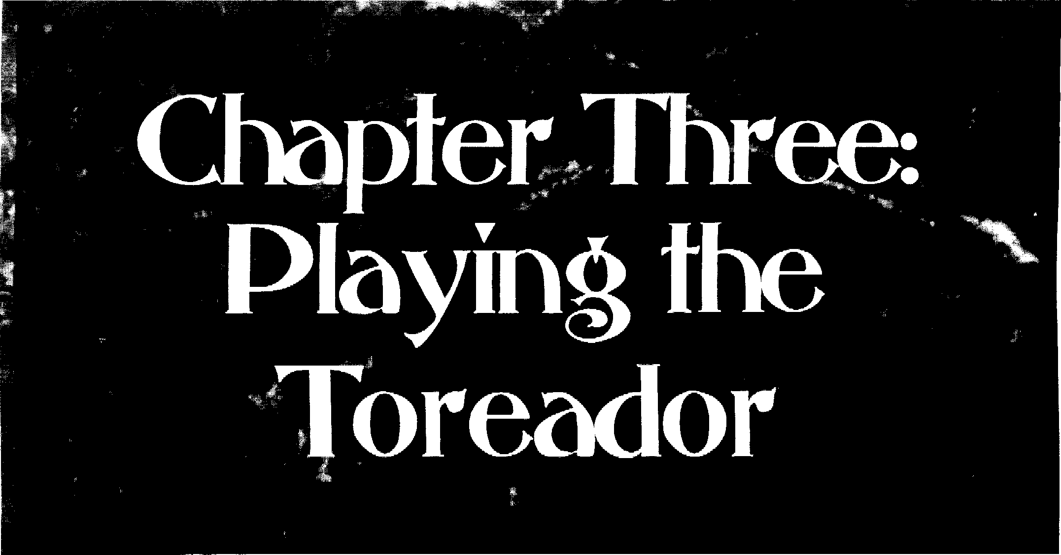

How dun it feel tr> he one of the hcautiful Jico/ilc1
Paul McCmLney, "Baby Yuu'rc a Rich Man"

Too many players view the Tore:1dor as effete artists, rock stars, moJels anJ hapless poets. Torcadur can be the most interesting or the most derivative characters in Vampire, depending upon how they arc played. If the distinctive strengths, we;iknesses and interests of the clan are played up, the game takes on another dimension by adding moral conflict. Torea­ dor attempt to deal with their human identities, conspire at Toreador socials, struggle for power, strive to create master­ pieces, protect their human loves from enemies and rival one another for critical acclaim and prestige.
Creating Art (c)nd
Less-than-Art)
This became a credo of mine: attempt the impossible in order to
imprni1c your work.
-- Bette Davis
Due to the limitatiom of game mechanics, it is hard to convey the subjectivity of art. In spite of this, the following system provides for I he creation of art. The system gives the Storyteller a fairly accurate interpretation of the quality of a work, which she can then relate through the criticism and praise of supporting characters. As with all systems, Lhis method is optional. Storytellers who do not like it should not feel obligated to use it.
First off, there is a new Twit which all Toreador, and only Toreador, should have-Creativity. TheStnrytellcrwill know the character's rating, but she does not have to tell the player.
This makes knowing if a character's mt is good enough to m:ike her an Artiste h:-mler. Creativity is used whenever a character is developing a concept for an art project, no matter what the art form.
A character's creativity is left to chance. To determine the Creativity score, roll one die and subtract three. If the score comes up zero or less, then the effective SCl>re is zero. Whenever a character wishes to create a work of art, be it a dance, a new martial arts move, a painting, a piece of prose or anything else, she must m:1kc ;m Intelligence+ Creativity roll to develop the concept.
The Storyrclkr has the option of keeping these die rolb secret. The pbyer descrihes wh:n his character 1s attempting to create, :md the difficulLy for each rnll is based on the complexity oft he work. Compare the number of successes to the following chart tu determine the originality of the work:
Botch The Cimcept is so simple you are amazed no one has thought of it before. You are truly brilliant. (Of course, everyone else will see you for the fool you are.)
0 successes Thmk again. The idea is stupid.
J.2 successes It's derivzitive, but a frw pcopk might not notice.
1-4 successes New concept, but nothing outstanding.
Maybe that's why nobody's used it yet.
S successes Really neat idea. People will notice.
(i successe, Everybody will wonder where you get your ide1s. Very interesting.
7+ successes If you pull this off, it will be a true master piece.
Chapter Three ,_11> 33

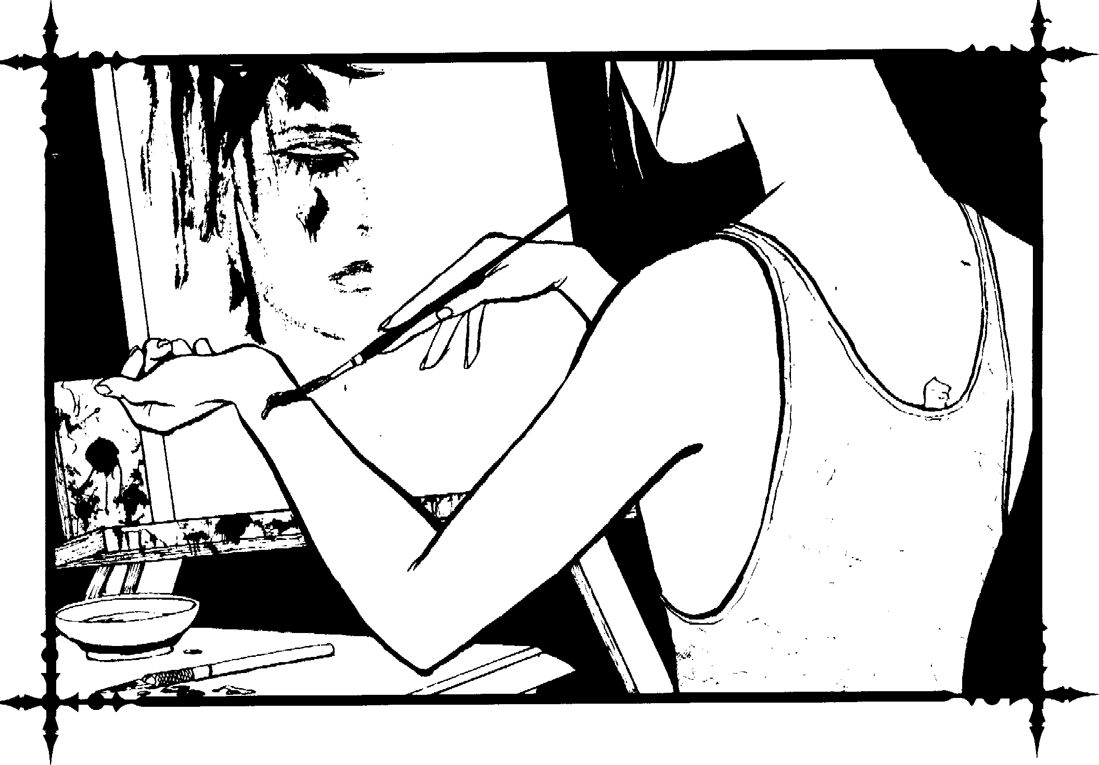
Once you know how good the idea is, move on to the production of the work itself. You do not have to tell the player how good the idea is, but you can throw out some hints, especially if the character (or the player) is experienced in her field. If the player wants to proceed, then move on to the production stage.
Producing art or staging a performance requires a Dexterity, Charisma, Manipulation, Intelligence or Wits (Storyteller's Choice) + Expression roll against a difficulty equal to the compkxity of the work. Complexity can be arbitrarily set by the Storyteller h:-ised on the description of the work or by some random method, such as adding three to half the result of a die mil. After rolling :1gainst the complexity of the project, the number of successes gained should be compared to the follow­ ing chart:

Botch While you think it is :-i masterpiece, every body else laughs at it- and you.
0 successes Better start over. This work sucks.
1-2 successes It's okay, but only a few people will really notice it and like it.
3-4 successes It's a quality work, but nothing extra- ordinary.
5 successes It's better than avernge.
6 successes It is an outstandin).! piece.
7+ successes If the work was based on a brilli:mt idea, it is a masterpiece.



34 4, Clonbook: Toreador


..

You will notice that Creativity and the actual creation of the work have little to do with one another. This is hecause there are many good ideas that are never carried out well, and there are many wonderfully-executed works hased on medio­ cre ideas. Coming to some halance near the upper end of the scale is the main objective.
Artiste or Poseur?
Let the world know you as you are, not as you think you
.,houlJ he, hecause sooner or later, if you are /)()sing, you wi,ll forget the pose, and then ivho are yuu?
- Fanny Brice
When players start the g:m1e with new Toreador char­ acters, they should he unsure whether the characters ;ire Artistes or Poseurs. Players with Toreador Poseurs cnuld find hidden talent in their characters, making them A.rt i,tes, while Artiste characters might suffer difficulty finding inspiration, lack training or be subjected to critics who rip their efforts to shreds. The line between Artistt: and Poseur, for neonates, 1s very thin.·
Eventually, characters (and players) learn which cat­ egory they fall into through the opinions ofother Toreador. A character who altains a number uf critical successes, or who is pursued hy clan memhcrs wishing to act as patrons, is assured a place among the Artistes. A character who 1s u m tant ly embarrassed, discredited or snuhbed might soun realize he has no chance of becoming a11 artist (or an Artiste).
After a work is completed, it must he critiqued. Most Toreador know how to critique at least one fmm of art. A character may critique the work of others, hut it is almost impossible to objectively appraisl' one's own. It is assumed the character has already gone through a process of revision and self-criticism while creating the work.
Critiquing requires a roll against Pc-rccption + Art Appre­ ciation (difficulty 7). The resulting number of successes can he referenced on the following chart:
Botch You utterly condemn a maslerpiece or praise a piece of crap.

0 successes
Y,H1 h;1ve no clue. You simply do nor understand the work.

1-2 successes You know within a range uf two successes (higher or lower) the originality of the work and quality of the work (as deter­ mined by the earlier charts).
3-4 successes You know within a range of one success (higher or lower) the originality and qual­ ity of the work.
- successes You know exactly the nriginality anJ quality of the work.
- successes Same as five, hut you cm add amazing insight into the work.
7+ successes Same as six, hut you can acid insight even the artist missed.
All the infonn,1tinn presented m this section is totally useless unless ,1 Stnryreller plays up the Ture;id,1r attrncrinn rn art. Storytellers shuuld nor limit themselves tu the mechanics explained here. Feel free to alter any of the rules tn make the game more realistic :md enjoyable.
A Toreador's Double Lire
It's a sobering thought that when Mozurt was my age, he had hecn dead jiff two years.
- Tom Lehrer, /968: That Was the Year thm Wa.,
Players should knuw Tnreadur have a fondness for mortal society, and Storytellers would do well tn encourage interest in the kine. When a player hen1mes interested in her charnctl·r's mort,1! relations, provide assistance. Plnycrs should rnlepL1y developing rel:iti,ms instead nf arbitrarily making up "friends" for the vampire to aut,1matically know and trust. Allow pL1yen, to decide the types of mortals their characters are interested in

befriending, including personality types, occupations, inter­ ests and luuks. While some mortab may be developed in the Prulugue, many should be added over the course of vampiric existence.
After discussing this with the player, occasionally drop a supporting character into the character's path. Meeting and developing relations with the mortal is then up to the player. This makes relationships a little more realistic and interesting.
Some very interesting stories come from relatiuns with mortals, especially if the mortals are involved rn dangerous activities - police work, smuggling, g,ing activities, serial k11lmg, rep, ining, rhrill-sceking, the occult, >r exp I, >r,1rion, just tu 11,1me a few.
An ,1dditilln:1I conflict mherent in tlu:se relationships is hnw to tell the trnth concerning undcad existence (and if you should tell them anything). How can a Toreador he sure she can trust her mortal friends when they find out she is a hi( lndsucker? These rebtionsh ips a Ilnw players to test out their character,' hurna111ty when they must come to the aid of their rn()rral friends, even when doing :,o risb the Mnsquerade.
In addition tot he duublc life Toreador lead, m:my spend a gre:11 :mwunr uf their t11nc Sl'l'kinia: out and patronizing mortal
:irtists. Toreador who reach mortals their own under,t anding of rheir arr le.id interesting double lives as well. This m;1y also he a source for excellent rolcplaying as the character Jets
:mrnnd the globe luuking fm talented kine while cumpeting
,1g,1111st Toreador ri v,1b.

Chapter Three> 35


-

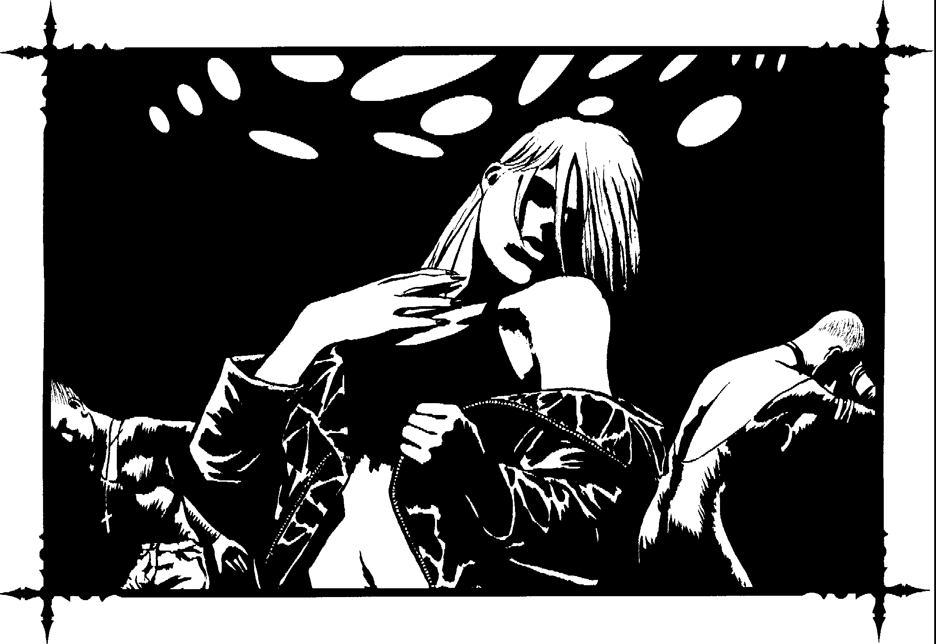

Toreador

Endowments
Toreador spend a great deal of time pursuing art. Because of this, many transcend mortal abilities and enhance their work through undead powers. The following Disciplines, Merits and Flaws are primarily for Toreador, though a few rare Kindred of other clans may possess them.

Disciplines
Both the Artiste and the Poseur seek to master their craft. Some Toreador learn to apply their disciplines to their chosen field of expertise through long and diff1C11lt effort. For the Artiste, this stands out in the y1mlity of the work. For the Poseur, it shmes forth in their mastery of social graces. The following collection of special powers will help Toreador stand out as the truly great artists ;md charmers they are. While it is possible for a character to have more th,m nne of these special Discipline powers, it is rare.
36 Clanbook: Toreador
Insight or the Talespinner:
Level 6 Auspex
lrnight ,11lnws a character to delve far into her own mind finding entire hooks and stories. The Toreador can summor; forth highly detailed characters and picture them in any situation to gain an innate feel for how each would react. In addition, the Discipline opens up the writer's vocabulary to its full expanse, allowing her to customize each character's vo­ cabulary to fit his personality and background.
A Toreador using this power finds it easier to write good stories. This does not help creativity, since the writer must come up with the s1ttrntion on her own. However, if the Toreador comes up with a good plot, the characters will practically tell the tale on their own. Often, the writer will not even know how the story will cnJ until she is finished.
In addition to its artistic uses, the power has another function. An entertainer can attempt to tell a story off the top
<:f her head. All those who ;.ire listening may try to resist. If they tail, they find themselves so caught up in the story they will he unable to doanything else. The character using this power may


....

determine the length of the t,de, hut it cannot last lunger than one scene.
System: If the Toreador uses this power to capture the full attention of the listeners, anyone within listening range must make a Wits + Empathy roll (difficulty 8) and gain three successes. Those who fail their roll must listen to the tale without interruption. In addition, all Artistic Expression (Writing) rolls are at -3 difficulty when using this power. This power costs a Blood Point to use.
Whot People Wont to Hear: Level 6 Auspex
A character with this p,1wer aut,1matically km1w:, the appn1- priate things tu say in a cunver:,atiun. The character dues nut have to s;1y anything ,md m,ty alter the words in any w,ty. The character may even take an opposing viewpoint on the suhiect, but she can relate her points in such a w;iy that the listeners will treat them with respect and admiration. This docs not neces­ sarily mean the listeners will change their uwn views, though it could happen.
System: Ry spend mg one Blood Point and concentrating for one turn, the character knows what to ,my to get a desired response. The Storyteller must decide exacrly how listeners react. If a character is using this power to advance an idea the listener finds fundamentally wrong, the listener is allowed a Willpower roll (difficulty 7). This power functions for up to one scene, but works only on the individual or group it was directed against.
Personality Metomorph: Level 7 Auspex
This power allows a Toreador actor to actu,dly reach within her own mind and draw forth original characters, complete with backgrounds and personalities. The Toreador then takes on another personality as if it were her own.
Basically, this power gives the character a controllable multiple personality disorder. The character could become a skilled assassin, an outstanding artist, a small mortal child or the spirit of a murder victim. The only limits are those imposed by the Storyteller and the player's imagination. However, alternate personalities should not be more powerful than the core personality.
System: By using two Blood Points, the character can create a new personality for one scene, though tme additional Rlood

The Toreador Weakness
Its horror and its beauty are divine.
Percy Bysshe Shelley, "The Medusa of Leonardo Da Vinci"
On the surface, there appears to be very little usefulness in the Toreador weakness, but it can serve as a useful Storytelling device with a little effort. Rather than simply telling ,1 player "four guys with Uzis hop out of a limousim· and start shooting, hut your character can't take any action this turn because he is fascinated by the bricks in the wall to his right," make the weakness part of the roleplaying experience. ...
Fur example, the Storyteller could say, "Oh, my. The wall two feet to your right seems to have heen laid hy the finest of masons. The technique is exquisite. The smooth­ ness of the concrete grooves augments the natural beauty of the color variations among the bricks. There is a pattern to It that 1s n:coi,:rnzahlc on some pnmordial level. It seems that the bricks are conveying tu yuu a feeling of pride while balancing this with stoicism ... "
Take the player aside and descrihe the scene to him. Do not descnhe what 1s going on around him. Instead of telling the player what is going on in the outside world, try to descrihe the beauty of the moment. Convey, with as much attention to detail and beauty as you can, the object or event that has captured the character's mind entirely.
The player might catch on and attempt a Willpower roll, but do not ask him if he wants one unless he is new to playing a Toreador. Even if he does make the roll, the Storyteller might attempt to talk him out of it. Also, you can occasionally throw in some special insight the charac­ ter m..iy glean from the rapture concerning problems he is currently facing. If the character resists the clan weakness too often, then the Toreador should become irritable and more likely to frenzy.

Point may he spent for every additional scene it is maintained. The new personality will have its own Social and Mental Attributes, Abilities and Virtues, along with its own Humanity and Willpower scores. In some cases, it might even have its own set of Disciplines. While the new personality is dominant, the character's actual Virtues, Abilities, Humanity, Willpower and Disciplines may not he used. Blood Poul is not affected,
,md Ht:alth ..ind Physical Arrrihures remain unchanged.

Chapter Three > 37


Aire or Elation: Level 6 Presence
Characters skilled in Presence and comedy can 11ctu:illy combine the two for new results. The effect is similar to Majesty, hut instead of making the Toreador feared and re­ spected, it makes her hilariously funny. At any time when the chanictu- is speaking, she can make the audience perceive what he says as an incredibly funny joke. Listeners can hurt themselves from laughing too much. This power is more effective than Majesty. It makes the character less threatening and more friendly and harmless.
System: This power can temporarily Incapacitate a target. Victims may make a Self-Control roll [difficulty of the character's Wits+ Artistic Expression (Comedy)] to act for a turn. Otherwise, the effects lasts up to one scene.
Capture R..eolity: Level 6
Presence
Some Toreador filmmakers ancl photographers pour an amazing amount of rc,1lity into their work. Ckver Toreador create films or photographs conveying variuus sorts of sulxon­ scious messages. This is easier to do in a film-the message will he clearer and more detailed than in a photograph. However, a series of photographs hearing the same message will convey the message just as clearly as a film.
System: The character must succeed in a Creativity + Artistic Expression (Photography or Film) roll (difficulty 8).

Intensification: Level 6
Presence
Certain Toreador, includmg artists, sculptors, filmmakers, photographers, writers and composer., ( i.e., Artistes who cre­ ate works instead of pnfi)rming them) can put a part uf their Presence in their work. The viewer of the work will feel p1rticularly intense emotion towards it. The ohject must carry at least some obvious symh()lism for the emotion conveyed in the work. With this power, a Toreador can pro(hi°n· a magical item of sorts, such as a phutograph which makes the viewers feel sad, a }_;()(ify-louking wooden figure which causes those viewing it to laugh, and so on.
System: Twenty Blood Points must he spent to make one of these ohjects, although no more than five may be spent in one night. Anyone who views the ohject can resist it by making a Self-Control roll (difficulty 7). Only ()flt:' emotional response m,1y he n mfrrred per ohject. The effect:; ()11 d1L· <>hjec.t are permanent.
Siren's Song: Level 6 Presence
This power allows a Toreador musician to reach a state of awareness using one particular type of musical instrument. She will feel as though it is an extension of her own body and soul. It also lets Toreador singers produce similar effects. In this way, the character can create some of the most heautiful music the world has ever heard. The character can influence the emo­

1 success

Z successes

3 successes
Viewers feel there is somerhing unusu,il ahout rhe photogrnph m film.
Viewers feel as if they know ex,1etly what the people in the photograph or film are fcclmg.
Viewer, feel as if they are in the photo graph or film, witnessing the events first, hand.
tions of all listeners. The effect is hased on the type of music
created. Additionally, the audience will he drnwn ro the music and unable to take any action to either harm the music-maker or nm away.
Emlltillns instilled by the music may vary, hut despite the emotion created, the Toreador will not have any direct control over the listeners' actions. While the music and lyrics can direct the audience to perform particular actions, the listeners will not all interpret the music m the same way.

4 successes Viewers believe they are smelling, hear­ ing and seeing things in the photograph or film. They might also form a strong symp:1thetic bond to ,1 particular charac­ ter in the work or to the work itself.
5+ successes Same as abuvc, hut the viewer will also have flashbacks from the photograph or film rhat gu beyond the scope of the work itself. If possihk, she will hegtn having reguLir dreams concern in}.; 1 he wurk 's
,etting or the ck1r:1cters in it.
System: The character automatically receives ,1 bonus of three dice to his Music or Singing Skill and can make music that has startling results. When this power is used, anyone within listening distance will he hit with effects similar to Awe unless a point of Willpower is spent. The effects of this power v,iry. In certain cases, such as trying to mduce bravery, the music might just add one or more dice to half the listeners'
Courai::e ratings wh1k making the other h;1lfFrenzy. The exact effects arc left up t<) the Sroryteller. Effects< ,f th is power last as long as the music is cuntmuously played, up to a nwxim11m of one scene.

38 Clonbook: Toreador


..

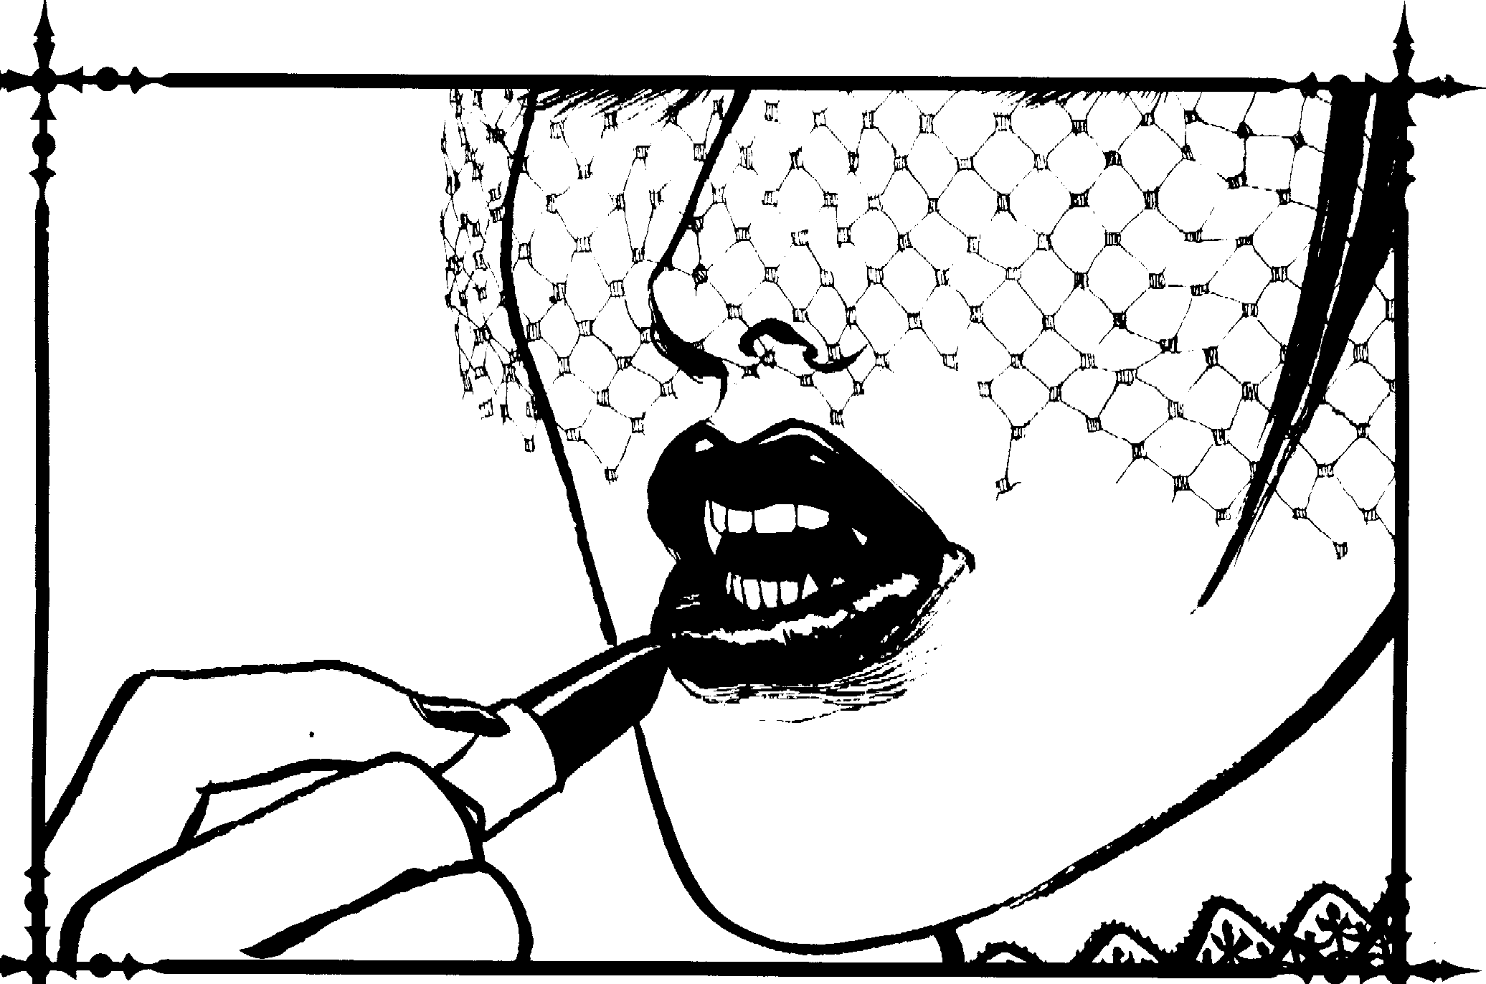

Sfilr Magnetism: Level 6 Presence
This power allows the character's Presence to carry over onto film, video tape, photographs or any other sort of visual recording. It even carries over to paintings if the portrait is an accurate representation. It may he consciously turned off, but it will otherwise snap into effect whenever a camera is turned towards the Kindred.
System: The representation resembles Awe, and the effects are permanent. Anyone who sees the image will be affected unless he spends a Willpower point every turn he sees it.
Two-Tiered Communication: Level 6 Presence
The Toreador can speak to someone in such a way that everything she says has a hidden meaning to it. The Toreador may talk about one thing and actually tell the listener some-
thing else, even if it is in radical opposition to the surface mes; ge. While the listener only hears the normal conversa, tion, he will subumsciously understand the underlying message.
A Toreador using this power might tell a person her art work is incredibly beautiful, while on the subconscious level be telling her that he would not even use it to start a fire. A Toreador might openly profess her love for someone while she's really telling him to jump off the nearest building. If the character spends more than one Blood Point per tum, this power may be used in conjunction with Domination.
System: This power lasts one turn per Willpower point spent. I low well the underlying message is conveyed requires a Manipulation+ Empathy roll (difficulty of 10, the listener\ Perception, with a minimum of J ). One success conveys a simple message, and elaborate messages may require as m:my as se·,en SIJCCCSSl'S.

Chapter Three> 39


Merits and Flaws
Controllable Thirst: (I pt Merit)
Because Toreador spend so much time around morrals, resisting Frenzy caused by the smell, sight or t:1stc of blood is easier for them. Whenever the Kindred makes a Frenzy roll over blood, reduce the difficulty by three.
Eye ror Beauty: (I pt Merit)
The Kindred is ,1 n;1rural critic. Reduce ,lifficulties fur Art Appreciation by four.
Mortal Double: (2 pt Merit)
You have the service., of some(ine alive who looks just like you. This person might be your actual twm. (Other cxpLma­ tions arc possible: a long-lost hrnther, a master of disguise, a Progenitor clone, a vict11n of Vicissitude, etc.) However, unless he is m:ide into a ghoul, he will cont1m1c to age normally. Eventually, he will no longer he your exact. double. The double may move about freely dming the d,1y, aiding you in hiding your varnpiric nature. The double must he fully aware of your personal life, including all your relationships and activities. He must also he a good actor.
Refined: (2 pt Merit)
You a member of the elite. You are at home in high society and you never feel out of place around the "heautiful people." The difficulty on all Etiquette rolls involving high society is reduced hy three. In addition, you are often invited to Tore,1, dor socials reserved for those of higher Tmeador Prestige ( m Camarilla Status) than yourself.
Blase: (3 pt Merit)
You are not easily impressed by others. You automatically resist all Presence powers. However, if the Kindred 11sing Presence is far more powerful than yourself, the Storyteller might require you to spend a point of Willpower to resist.
"Girted": (3 pt Merit)
The difficulty on all Creativity rolls and Art i,t ic Expression rolls are reduced by three.
Greater Colors: (3 pt Merit)
The vamplfc sees colors more distinctly and with greater definition. The world 1s far more colorful. Unfortunately, the

vampire is more likely to become enraptured hy colorful ohjects. Despite the drawback, when used in conj11nction with Aura Perception, the vampire will discover far more informa, tiun ahout her target. The difficulty for reading a target's aura is reduced to five. The player may ask the Storyteller' one question about the target for every success, and the Storyteller must provide accurate information. This may he used only once per story on a particular target. Finally, all Artistic Expression diffiuilties involving color arc red11cvd hy one.
Supernahiral SJX>use: (4 pt Merit)
You share a relatiunship cquiv:ilent to m:irrbge with a supern,itur,il cre;1f 11rc, ,rlwr than another Kindred. Both of yuu receive the hcndirs of the True Love Ment for one another. This creature may he :1 rnage, a werewolf, a clrnngcling, a wraith or something even more 11n11sual. Unfortunately, both of yoUI kind would consider you thre:Hs if they knew of your rehitiun­ ship. You m:iy decl:.1re your love fur u1w :m,lthcr openly,
:ilthough you ri:,k becoming :m outcast- or worse. You and your spouse would die or kill for one ,mother.
Powerrul Ghoul: (5 pt Merit)
You have a very powerful ghoul Blood Round tu you. The gho11l has six points to put into any Disciplines other than Thaumaturgy, although at least one point must be put into Potence. The ghoul is also very competent, possessing 15 points to distribute among Attributes, 27 points to distrihute among Abilities and 5 points to put into Backgrounds. The ghoul has reasonably good Virtues and Willpower ratings and will do anything you say, ,ince it loves you so much. However, the ghoul might also get jeak,us of any relationships you have with other,,
Vampire Spouse: (5 pt Merit)
You hold rcgnanr over another Kindred, though she holds regnanr over you as well. The two of you are in love, and you automatically have the benefit of the Merit: True Love. Your vampire spouse is your equal in terms of power and status. However, as a couple, you arc very formidable. You allow nothing to get in the way of your love. You and your spouse would die or kill for one another.
Poor Taste: (I pt Flaw)
You c:m never have the Art Appreciation skill. You arc forever a Posl'llf, and you have no ability to judge a masterpiece from trash. In fact, 1f you had the choice, you would choose the trash.

I'::

40 Clonbook: T oreodor


R.ival: (I pt Flaw)
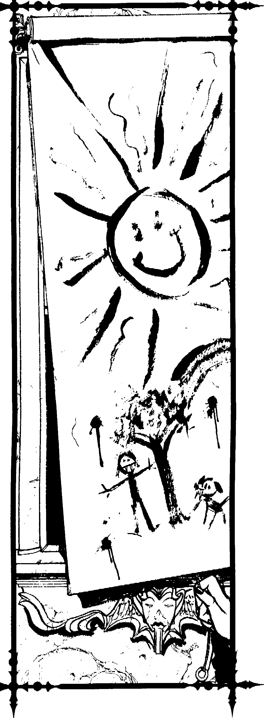
You have an intense rivalry with another Kindred. You are always competing with this individual, either for fun or out of spite. In besting this individual, you go to extremes, and he behaves similarly cowards you. Your rival occasionally gets the best of you, but you do the same to him.
Torfured Artist: (I pt Flaw)
You must suffer for your work. Your work is never good enough to suit you. You often suffer ennui for extended periods of time, preventing you from working steadily. In addition, you constantly find yourself in heartbreaking positions; perhaps you subconsciously lead yourself ir:i.to those situa ions to ac­ quire the experience you need for your work.
Vulgar: (I pt Flaw)
You will never fit into high society. You are crude, rude and socially unacceptable, forever a Philistine. You are treated as having one less level of Status when invitations to Toreador socials are prepared. You will never be fully accepted as a Toreador. Many will question your Sire and possibly ridicule him for choosing you.
Artistically Inept: (2 pt Flaw)
You must work harder than most artists to accomplish great work. You are still capable of creating a masterpiece, but it is tougher for you than for someone else of equal training. All difficulties on Creativity rolls and Artistic Expression rolls are increased by two to a maximum of nine.
Social Outeasf: (3 pt Flaw)
You have severed your ties to the Artistes and Poseurs. You no longer play their silly games. You will never rise in Clan Prestige, and you are the equivalent of an anarch. However, the anarchs will not accept you due to some past transgressions you have committed against them. You have no place in the world of the Damned.

Chapter Three> 41

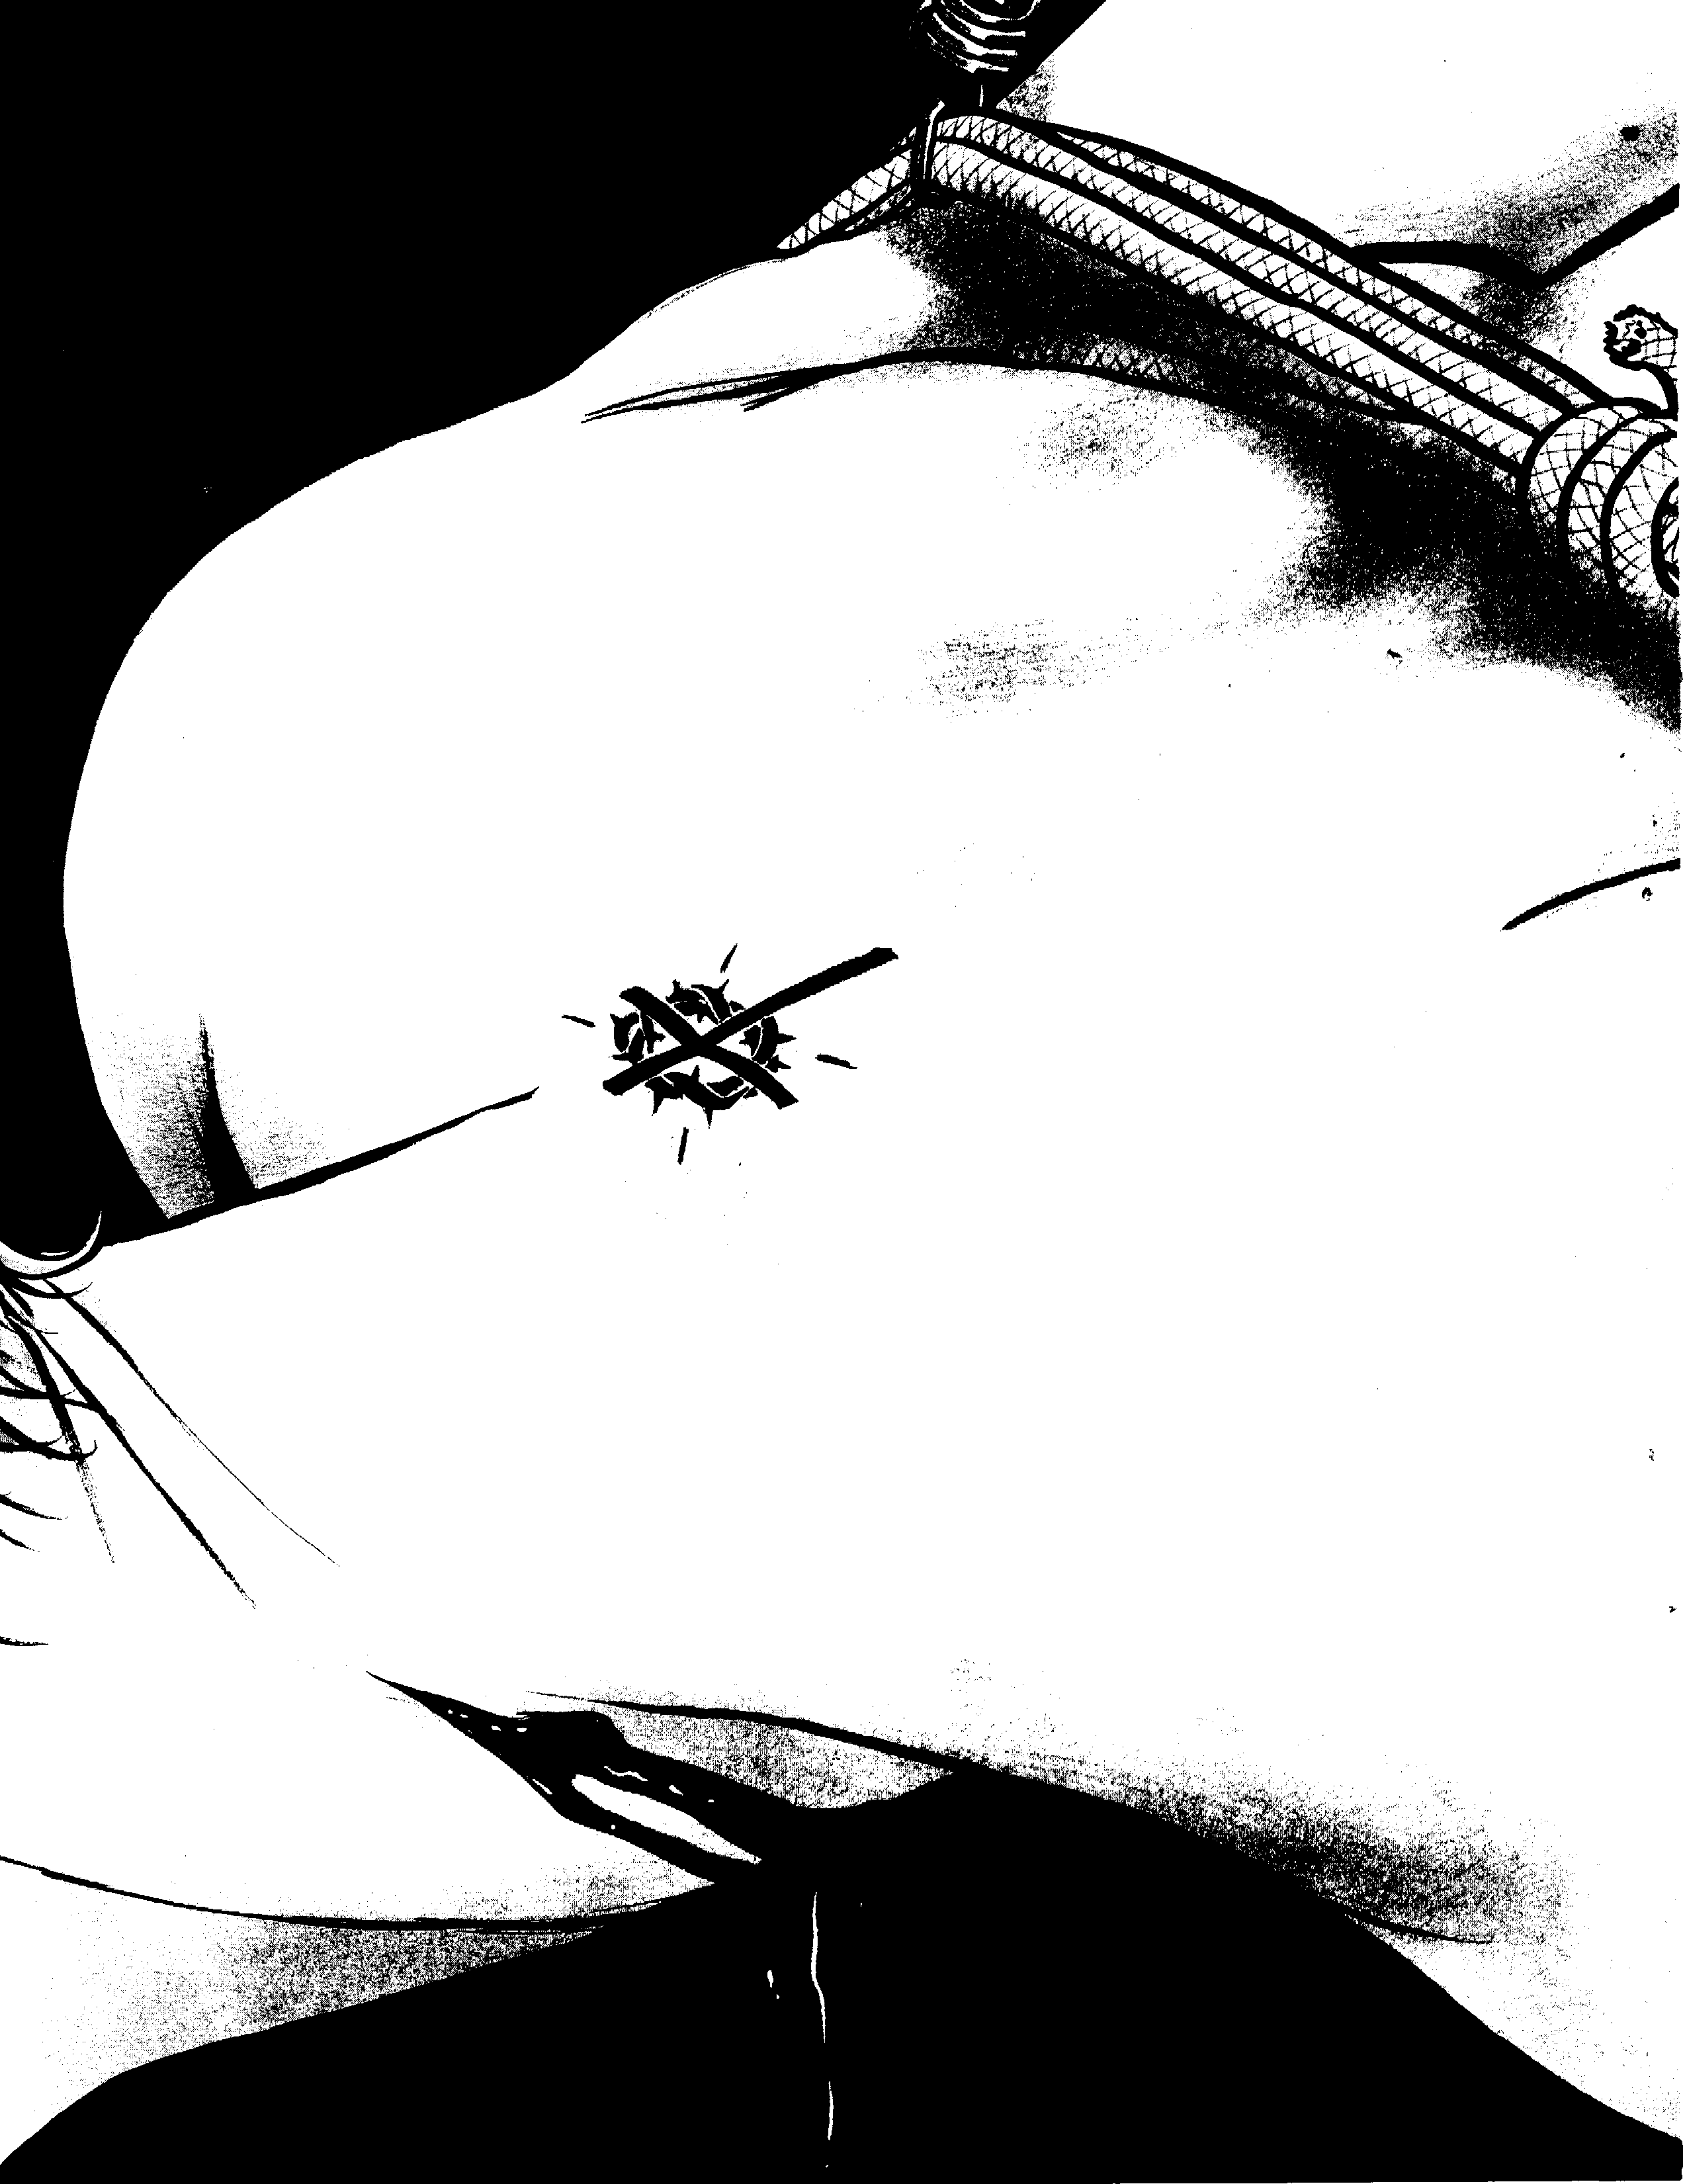



It is the addition of strangeness to beauty that constitutes the romantic character in art.
- Walter Pater, Appreciation


As mentioned earlier, the Toreador definition of art is anything involving creativity, talent and dedication. Because of this, the clan boasts an incredible diversity. Rather than present variations on the typical Toreador Artiste and Poseur, this collection of templates contains alternatives to the stan­ dard Toreador. Remember that concepts of "Artiste" and "Poseur" are simply stereotypes. Attaching one of these labels should not define the entire character or limit the character's personality and goals.
Feel free to tamper with the numbers, Nature, Demeanor or anything else in the description to make the character fit your needs. These templates serve as guides to creating your own characters. However, the best characters are the ones you design and develop on your own.
Also note that some of the Natures and Demeanors for these templates are from The Vampire Players Guide.

\_;
Coopter Four,.> 43

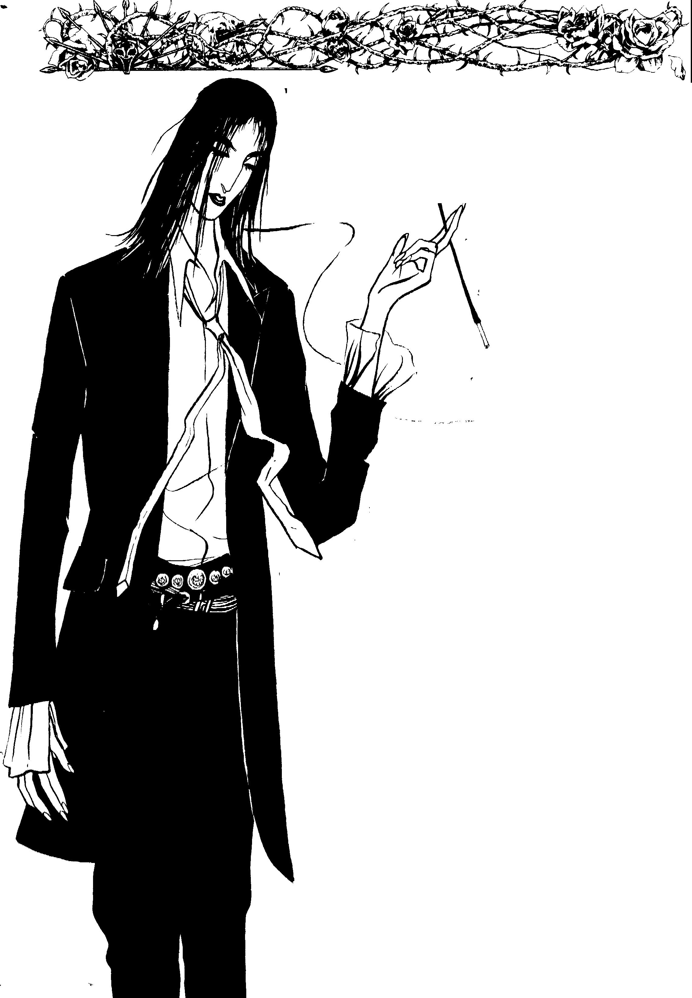
The Burnout
I have stood here before inside the pouring rain
With the world turning circles running 'round my brain l guess l'm always hoping that you'll end this reign
But it's my destiny to be the king of pain
- The Police, "King of Pain"
Quote: Yes, yes, l see what you are saying. The light textures do offset the blue tones in the way you describe. All I am saying is: so what?
I cannot understand how you can babble on for so long about such trivia. Ob dear, I seem to have finished this cocktail. Oh, waiter­ another please, a draught from one of the
healthy ones this time.
Prelude: You were the talk of the
- Guild for the first 10 years of your
----..._ unlife. A great artist in life, your paintings were unmatched even among the unJeaJ. Then your unlife suddenly changed fur the worse. You
found your mortal children dead and watched your husband die at the hands of ruthless Setites. You frenzied, destroying two of them before the others could stake you. They tortured you for nights, hut one of their servants made the mistake of removing the stake, and you repaid him in blood.
You killed anyone who came across your path. After escaping, you tried working again, but found you could not. You travelled the world partying, but after growing weary of it, you returned to your old
city, hoping for a new start. This time, you will acquire all the power you need to make sure no one degrades, hurts or controls you like the Setites did.
Concept: You no longer value mortals and drink far more vita! than you need. Art no longer concerns you. To you, it is a silly waste of time. Everyone knows power 1s the key to everything. You will use anyone and define any Kindred as either an enemy or a tool. You have many beautiful ghouls; your pet dogs receive better treatment than they do. Much of your time is spent engaging in politics, schemes and perversity.
Roleplaying Tips: You are ruthless, cruel and inhuman. Your vision is clouded with pain. The world is a far uglier place now that you have lost your family. It may be possible for you to love, work and laugh again, but finding a way will not be easy. Worse yet, you chose not to look. You prefer wallowing in your self-pity.
Equipment: Expensive, custom-fitted suit, small-caliber pistol and large amounts of cash.

j], r(J2,q @QJl ; ell
1
Name: Nature: Survivor Sire:
Player: Demeanor: Curmudgeon <ieneration: 11th
Chronicle: Concept: Burnout Ha,-en:
<e • Attributes=============== !"D•011==:::=::-..:.
Physical Social Mental

Strength eeoooooo Charisma, ••000000 Dexterity ••000000 Manipulation eeeeeooo
Stamina ••000000 Appearance eeeooooo
Pere tion eeoooooo Intelligence • • • 0 0 0 OO Wits eeeooooo

-<==e rt=M.....,.-., !::===============Abilities================= • •t=e =-
Talents Skills Knowledge ...

Acting..... eooooooo
Alertness, 00000000 Athletics, 00000000
Brawl eeoooooo
D •0000000
Empathy oooooooo Intimidation ••• oooOo Leadership oooooooo Stree e oooooooo
Subterfuge. •••00000
Animal Km 00000000
Drive eooooooo
Etiquette ••000000
Firearms ••000000 Melee •0000000 Music eooooooo
Repair 00000000
Security ••000000
Stealth 00000000
Survival •0000000
Bureaucraty oooooooo Computer oooooooo Finance oooooooo lnv ti tion ._00000000
w eooooooo
Linguistics •0000000
Medicine 00000000
Occult eooooooo Politics ••000000 Science 00000000

- == •• • o ================AdYantages============== -4, • • ==►►
Disciplines Backgrounds Virtues
'-- 00000000 Fame eooooooo Conscience. eeooo
Cderity eooooooo Generation ••000000
Presence. eeoooooo Resources •••00000

00000000 Retainers •0000000
00000000 Status •0000000
00000000 00000000
00000000 00000000
Seli-Control'---•••oo
---- •·-=·=·-

-Other Traits-
Artistic Expression ••••oooo Style ••000000 ArtHistory eooooooo
00000000
00000000
00000000
00000000
00000000
00000000
00000000
- Humanity ---­
• • • • • o o o o o
=-=• t!.!-- Willpower ---­
- e e e e e e O O 0
□□□□□□□□□□
- ..........Blood Pool--..,....
□□□□□□□□□□
--Health----
Bruised □
Hurt -1 □
Injured -1 □ Wounded ..z □ Mauled ..z □
Crippled ..5 □
lncapritated □
-... Weakness
EN RED
.tt."""
B\' BEAUIY.


00000000
□□□□□□□□□□
WILLPOWER ROLL REQUIRED TO BREAK FREE.

Comic Book
Celebrity
Bite Me, Fanboy!
-Lobo
Quote: Yeah. I'm one of the founders of Facade Com, ics, the hottest comic company around. We were tired of working for the other guy. Now we make the Big Bucks, and we can do things our way. No more modifying the art to fit the story. Nobody reads
comics anyway. They buy them for the art. We give them what they want.
Prelude: You got a lucky break from one of the big comic companies and worked
hard. You playeJ it straight and narrow until they realized
you were depenJ, able. Then you began develop­ ing your own style. You were hot. Then you joined up with some other big names and founded your own com­ pany. You were at the
top of the field- so what if some jeal­ ous people said you had no
talent? You knew you were great.
While on tour, you were abducted from your hotel room in the middle of the night and Em­
braced by a Toreador fanboy. Now you never meet your deadlines, hut you're a part-owner in the company. Besides, you're rich and im­ mortal. What does it matter, anyway?
Concept: All the fanboys idealize you. You are just plain awesome in their eyes- andin your eyes, too. You have an inflated ego, but your past success has given you reason to have one. You are still new to the Warid
of Darkness and have much to learn. Your creativity has improved since your Em­ brace, and all the new challenges you have had to face have given you new inspiration.
Roleplaying Tips: You are ncomfortablc in situations involving other Kindred. They frighten you. Many claim you are a Poseur, but you know they're just jealous. You refuse to listen to their criticisms, but you now
work less and less. Around comic collectors, your egomania shines
forth.
Equipment: Box of draw, ing utensils, bristol pad, roller ruler, new sports car, some unfinished comic pages and
a gold pen for autographing comics.

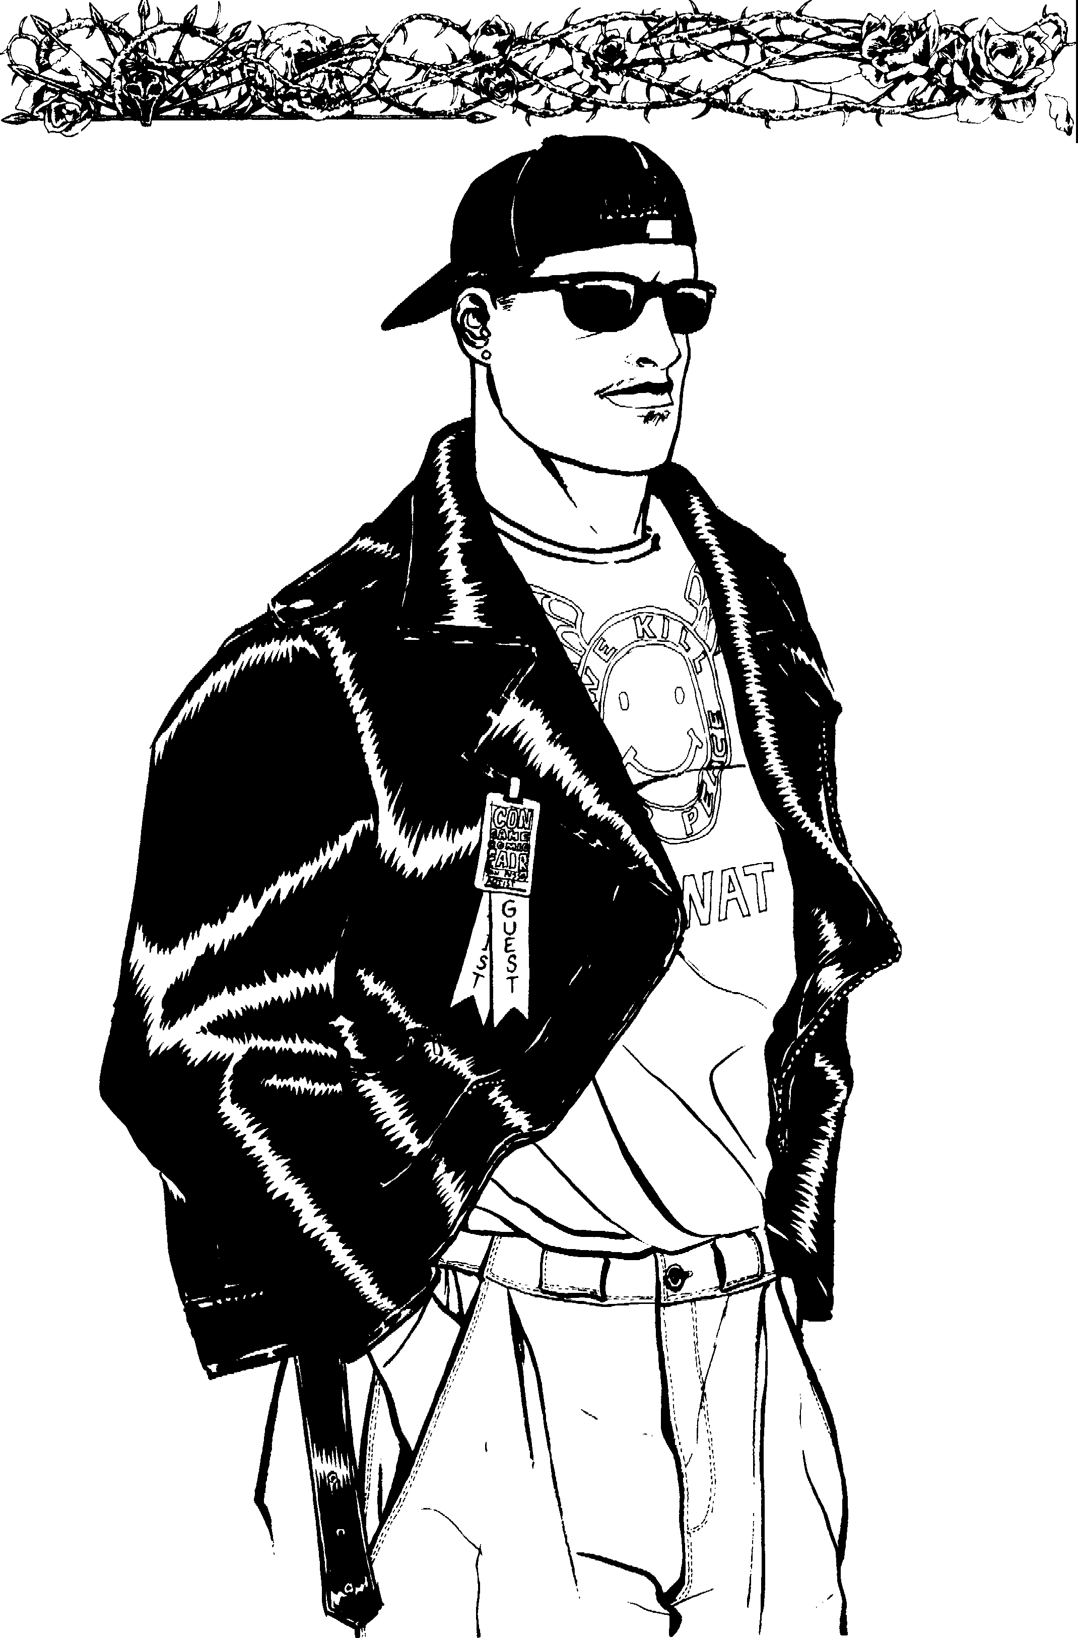
46

-ll
VAMPIRE: The MasqueradeM

Name: Nature: Autocrat Sire:
JO EADOll
Player: Demeanor: Architect <ieneration: 13th
Chronicle: Concept: Comic Book Celebrity Ha,-en:
<::=a ....r--v - c--: =============Attributes======== ==== V'-\,,-:-•to •-===>-►
Physical Social Mental

Strength. eooo0000 Charisma eeeeoooo Dexterity • • • 0 O O O O Manipulation ••• 0000 0 Stamina ••000000 Appearance eeeooooo
Perception eeeooooo
Intelligence • • 0 0 0 0 0 0
Wits eeeooooo

· Abilities J.!;.8CC►
Talents Skills Knowledge ...
Actin •0000000 Animal Ken 00000000 Bureaucracy oooooooo Alertness •0000000 Drive ••000000 Computer ••000000 Athletics 00000000 Etiquette •0000000 Finance ••••oooo Brawl 00000000 Firearms Investigation • eoO O O00 Dodge eooooooo Melee 0000000 Law 00000000 Empathy •0000000 Music 0000000 Linguistics 00000000
Intimidation-- ••000000 Repair 00000000 Medicine 00000000
Leadership •0000000 Security •0000000 Occult 00000000
Streetwise 00000000 Stealth •0000000 Politics •0000000
Subterfuge ••000000 Survival 00000000 Science •0000000
<e01=00 AdYantages •=
Disciplines Backgrounds Virtues
A 00000000 Allies ••000000 Conscience •••oo
Celerify ••000000 Contacts ••000000
Presence •0000000  00000000 | Fame  Herd | ••000000  ·••00000
00000000 | Resources | ••••oooo
00000000 |  | 00000000
00000000  » |  | 00000000

I':

Self.-Control •••••

••ooo
1. ►•-=
Other Traits===v" - Humanity Health
Artisti(:2 E r :zsiQtJ ••000000 e e e e e e e e O 0 Bruised □
M QU r d ••000000 Hurt -1 □
• 00000000 -_.........,. Willpower Injured -1 □

00000000 e e e e e e e O O 0 Wounded
-2 □

00000000
00000000
00000000
□□□□□□□□□□ Mauled -2 □
Crippled ..5 □

00000000 .- .,.. Blood Pool lncapacitated □
00000000

00000000 □□□□□□□□□□ s
Weakness




ENRAPTURED BY BEAUIY.
□□□□□□□□□□
00000000 WILLPOWER ROLL REQUIRED
TO BREAK FREE.
Attributes:7/5/3 Abilities:13/9/5 Disciplines:} Backgrounds:S Virtues:7 Freebie Points:1S ( 7/5/2/1)

The Cult
Leocler
It's nor enough merely to worshit> a god. You've got tu know which one's in charge. And Heaven help you if you mess around on the wrong turf.
- Harlan Ellison, Deathbird Stories
Quote: .Serve me, for I am the chosen one. I have seen the hollowness in your heart, and I will fill it. Come tome, my children. Let my love for you extinguish the flames of this Hell on Earth.
We shall live in peace away from the eyes of man. I will
fJrotect you and give you everythin[!. you need. The price you say? Nothing. Nothin1; but your faith and devo­ tion. We shall seek out the mysteries of the universe together. Companiomhit> is all I need.
Prelude: You dabbled in the occult as a teenager, though you never really took seriously. Your clean-cut good
looks and charm made all the adults thmk of you as a little angel, though you were far from it. After you went away
to college, you began delv­ ing deeper into the occult after taking a sociology course on the subject.
Your innate ability to
win people over to your way
of thinking was what at- trac ted your sire. You were at a fraternity party with two attractive young women, and you had con­ vinced them that you possessed psychic powers. You took the women back to your place only to find that one of them was not human. She Em­ braced you, and together you drank the other woman dry. Your sire taught you about the Kin­ dred, but she has shown you only the darker side of your existence. She left you a year ago, and you h,we since organized your own cult, feeling it would make your existence safer and more plea­ surable. Now you no longer have to hunt to feed. Ynm prey is ready and willing.
Concept: You cm convince people of just about anything, and you can bring them into your service with ease. You wish to become a powerful and respected member of your clan, hut you must hide your cult from the eyes ofother Kindred, or they will be used against you. You have begun training some of your cultists to become vampire hunters.
Roleplaying Tips: You act a little crazy some­ times. The power you wield over the lives of your followers has made you a bit giddy. You speak with passion about everything. You are slightly para­ noid, but you are also very excited and happy.
You can see the pain in others and bring it into the open to help them confront it. The only cost is that you usually convince them you are the answer to all their problems. •
Equipment: Custom-fitted black suit, straight razor, beeper, Glock 18 and a new black lim-

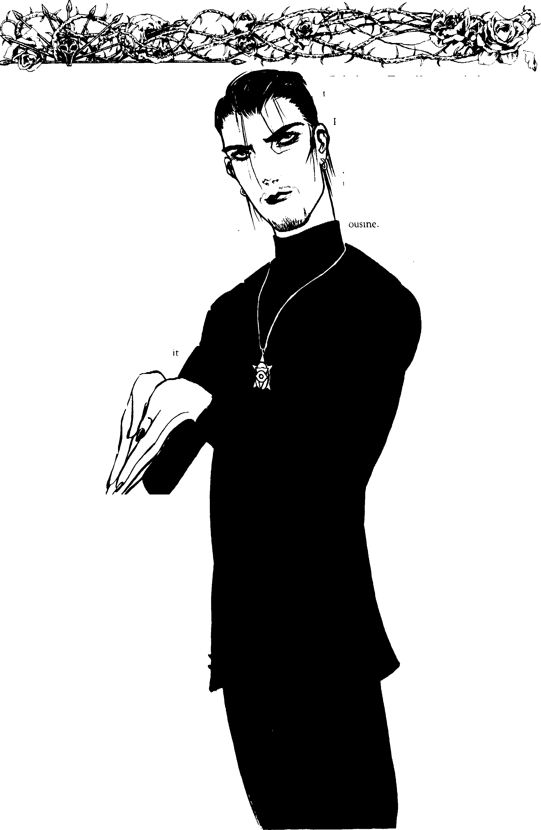
48 Clonbook: Toreador

- cl,....._,,,, VAMPIRE: The Masquerade™ F \..J II
M JOl{EADORJ t a -
Name: Nature: Director Sire:
Player: Demeanor: Visionary fieneration: 13th
Chronicle: Concept: Cult Leader Hal'en:
· :::41M l>'1 ►::!!!::::=============Attributes

Physical
Strength. ••000000 Dexterity • 0 0 0 0 0 0 0 Stamina •••00000
Social
Charisma •••••ooo
Manipulation ••• 0 0 0 0 0
Appearance ••o 00000
Mental
Perception. • • 0 0 0 0 0 0 Intelligence eeo<;>0000
Wits ••••oooo

=a::::::;:;0=411•..O..,....,vj oo.:: ===============Abilities================ 4.t4-=0 •D=---::::=>=

Actin Talen •••oooo
Anirrnl Ken
Skills00000000
Bureauct:w :00000

Alertness eooooooo Athletics 00000000
Brawl 00000000 Dodge eooooooo
Empathy ••••oooo
Intimidation •• 0 0 0 0 0 0 Leadership ••••oooo
Streetwise 00000000
Subterfuge 00000000
Drive ••000000
Etiquette ••000000
Firearms ••000000 Melee 0000000
Music 0000000
Repair 0000000
Security ••000000
Stealth •0000000 Survival 00000000
Computer oooooooo
Finance 00000000 lnvestigation 00000000 Law 00000000
Linguistics. .0000000
Medicine 0 0 0 0 0 0 0 0
Occult ••000000
fuli s eooooooo
Science eooooooo

< • 0 =============AdYantages==============:::!:: M • --- = ===-
Disciplines Backgrounds Virtues

00000000 He ••••oooo
Cderity oooooooo Mentor eooooooo
--•••00000 Resou es •••00000
00000000 Retainers ••000000
00000000 | 00000000
00000000 | 00000000
00000000 | 00000000

Conscience, _ • • ooo

Self--Control· ••••o Cournge ••••o

--Other Traits""""""'-- -=•=
- Humanity
- --Health -


00000000
00000000
00000000
00000000
00000000
- 00000000
- 00000000
00000000
00000000
- 00000000
- 00000000
e e e e e e e O O 0
-- Willpower
e e e e e e e O O 0
□□□□□□□□□□
----Blood Pool •=
□□□□□□□□□□
□□□□□□□□□□
Bruised □
Hurt ,1 □
Injured ,1 □
Wounded ..2 □
Mauled ..2 □
Crippled ..5 □
lncaincitated □
Weakness
ENRAPTURED BY BEAU1Y. WILLPOWER ROLL REQUIRED TO BREAK FREE.


The t1orror Writer
My business took over my life- by choice.
-Riva Yares
Quote: It's tough breaking into the field today, but somehow I made it. Now look at me. New home. New car. Wife and kids. I got it made. Well, almost. You see, I'm now one of the creatures I write about. Bad side is that I have to deal with a lot of powerful and evil beings. Good side is that they give me a lot to write about.
Prelude: You never really grew up. The monster under the bed, the werewolves who patrolled the woods behind your house- you carried them all with you into adulthood. You graduated college with a B.A. in English and tried to find work as a teacher, but had no luck. You ended up in a mill job, but spent your free time writing.
You had it tough at first. The rejections were hard to deal with, but you finally got a break. Within 10 years, you had sold seven best-sellers and a massive number of short stories. They even made a movie based on one of your
works. You attracted the attention of another writer, an undcad writer. Your work touched her like no other mortal's had, so she Embraced you.
Concept: You lead a double life and still live with your family. You told your wife the truth, and your kids are asking questions.
You are still writing, but your grim work has become even darker than it was be­
fore the Embrace. Perhaps the change has affected you on a deeper level than you realize.

Roleplaying Tips: You are very endearing and down-to-earth.
You have done well for yourself, but you have not let fame ruin your life. Making friends
;imong the Kindred has been easy, but many of them fear they will become characters for your sto­
ries. You are slightly paranoid, but you hide it well. Perhaps your fear is justified: there are rumors that some of the elders want you destroyed. After all, your writing might breach the Masquerade.
Equipment: Miniature tape recorder, note pad, pens, laptop computer, Rolex, Colt Anaconda, shoulder holster, extra ammunition, beeper and a couple of new novels by other writers.

50

cJ VAMPIRE: The MasqaeradeM
ii
JOR.EADO

Name: Nature: Architect
Player: Demeanor: Optimist
Chronicle: Concept: Horror Writer
Sire: Oeneration: 13th Ha,-en:

-- = • • b ==============Attributes================ • • <==--
Physical Social Mental

Strength eeeooooo Dexterity eeoooooo Stamina •••00000
Charisma eeeooooo
Manipulation •• 0 0 00 00
Appearance eooooooo
Perception •• 0 OO O oO Intelligence ••••oooo Wits ••••oooo

_{-==•} Abilities
Talents Skills
Actin 00000000 Animal Ken 00000000
Alertness eooooooo Drive ••000000 Athletics 00000000 Etiquette eooooooo Brawl •0000000 Firearms eooooooo
Dodge 00000000 Melee 0000000
Empathy ·••00000 Music 0000000
Intimidation-- eooooooo Repair eooooooo
Leadership 00000000 Security 0000000
Streetwise 00000000 Stealth 00000000
Subterfuge 00000000 Survival 00000000

owledge"'
Bureaucracy e0000000 Computer eeoooooo Finance eooooooo Investigation eeoooooo Law oooooooo Linguistics eeoooooo
Medicine 00000000
Occult ••••oooo
Politics 00000000
Science ••000000

< • o ►-= ================AdYantages============== v--v- •• •-==0>-=
Disciplines | Backgrounds | Virtues
Auspex;' •••00000 | Contacts ••000000 | Conscience. ••••o
Celerity oooooooo  00000000 | Fame ••••oooo
00000000 | ₀₀₀₀₀₀₀₀ Self..COntrol. |  | eeooo
00000000 | 00000000
00000000 | 00000000
00000000 | 00000000 ••••o

Resou es ••••oooo








=•,, Other Traits--­
Masa uerade eooooooo  Poetic.Expression •••00000  00000000 ._,, willpower  00000000 e e e e e e e O O 0  00000000 □□□□□□□□□□ | Bruised Hurt Injured Wounded  .Mauled | ..1  -1  ..2  -2
00000000 | Crippled | ..5

00000000

- 00000000
00000000
00000000
- 00000000
--- Humanity --· ,....-

=-.:aa ,,--Blood Pool
□□□□□□□□□□
□□□□□□□□□□
--'!191?•-- Health----
□
□
□
□
□
□
Incapritated □
...,,. Weakness
ENRAPTURED RV BEAUlY. WILLPOWER ROLL REQUIRED TO BREAK FREE.

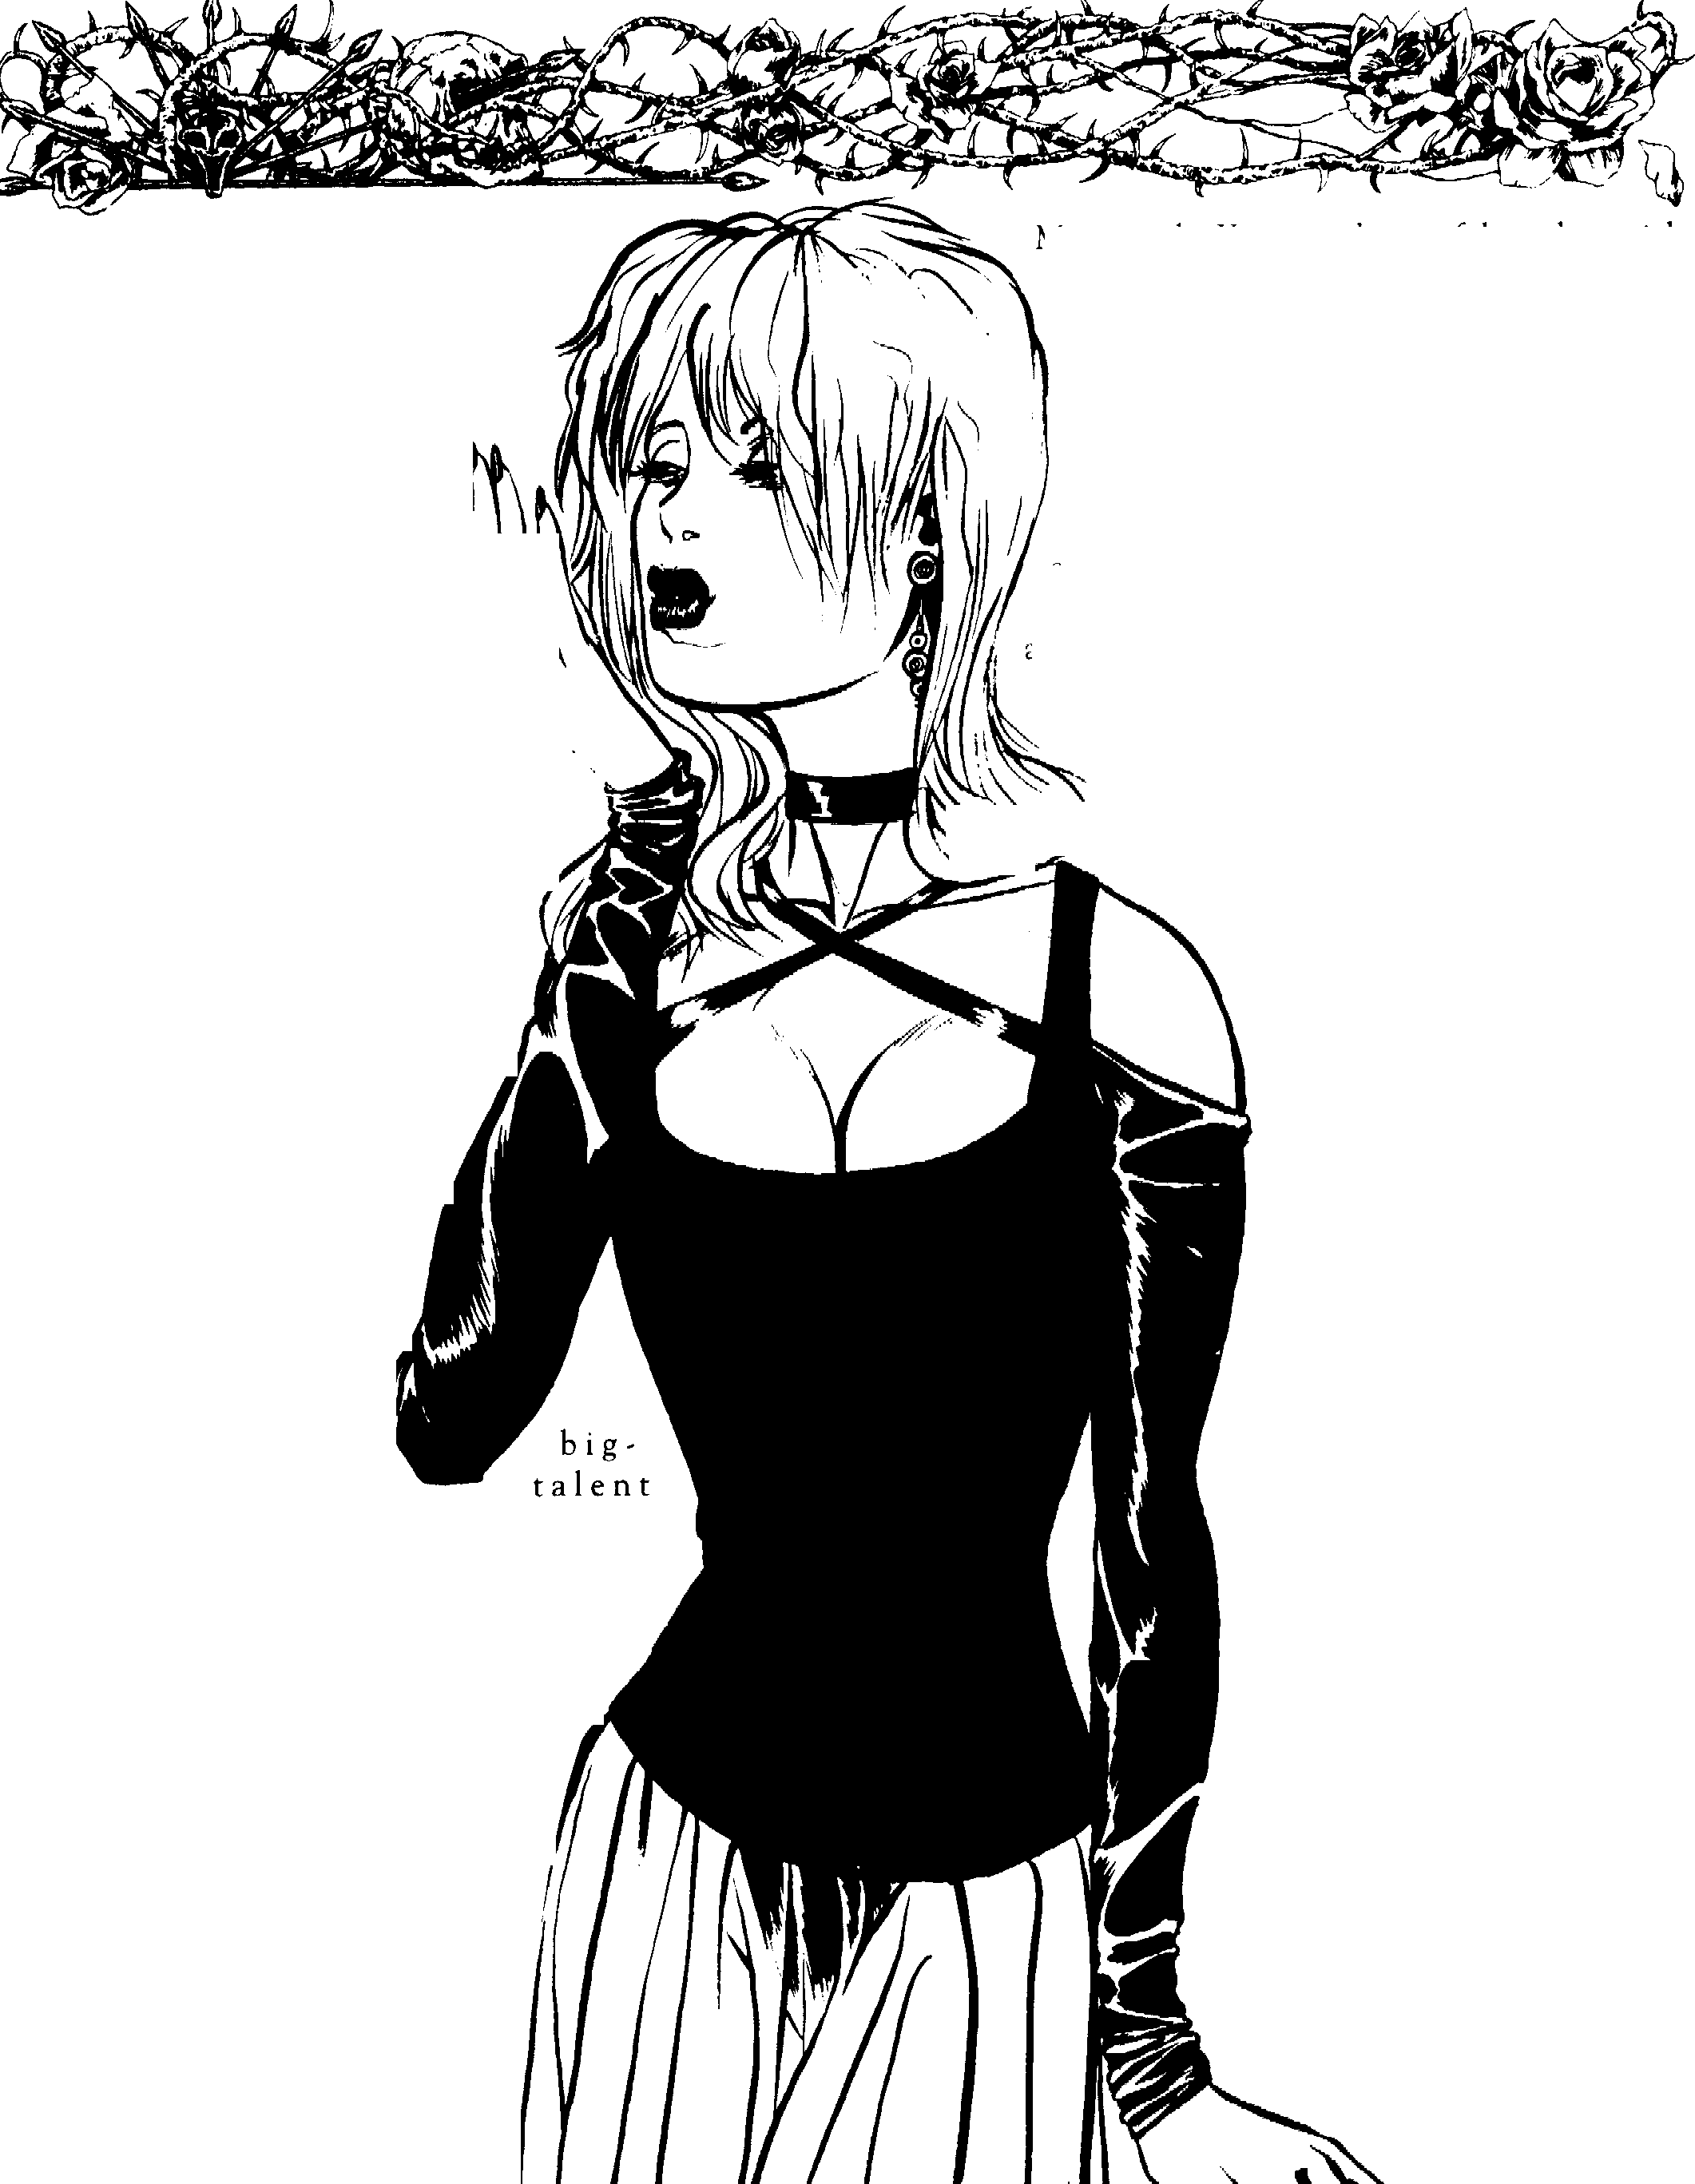
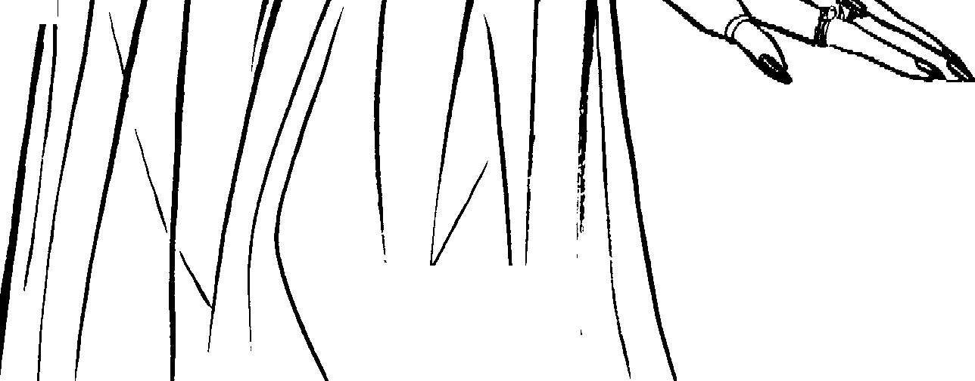
-

The Idol or

Millions
I have never quite understood this sex symbol business, but if I'm going i
to be a symbol of something, I'd rather
have it be sex than some of the other things they've got symbols for.
- Marilyn Monroe
Quote: Darling, how wonderful! You made it! It's so good to see you. You look fabulous. Have you seen my new movie? ... Why, thank you ... Oh, well, yes, it was tough, but the director was just a peach.
The schedule worked out perfectly. You know, it's grossed over 40 mil so far ... No, I'm not surprised. I'm glad people recognize talent when they see it.
Prelude: You grew up in De­ troit, one of seven children in a poor family. Well, atleast that's how you tell it. You worked your way through college, get­ ting a degree in drama. You went to Hollywood and ac­ tually managed to get a small
part in a low-budget film. A name director recognized your
and made you a success. By the time you were 23, you had starred in seven movies, and your name was almost always first in the credits. Your wild personal life was a hot subject for tabloids
and television shows.
One night, a Toreador production assis­ tant came into your dressing room and Embraced you. Since that time, you have managed to continue working some, though far less than if you were still mortal. You would not like being a vampire, except now you will never grow old. Still, you know you must retire from the movie business some
day before everyone begins to notice your ageless grace.
Concept: Most of the public adores you. You were once voted one of the sexiest people alive, and now you are certainly one of the sexiest people undead. The other Toreador grow weary of you be-
ca use you jeopardize the
52 Clanbook: \
I

•
Masquerade. You must be careful, or they might decide to destroy you.
RoleplayingTips: You ;,ire cold and haughty, except when interviewed by the mecl_ia, in which case you turn on the charm and humil­ ity. You see yourself as the star. Everyone else exists to serve you. You get tired of your fans
,1lw:1ys bothering you, but you secretly cannot st:1nd it when no one recognizes you. You con­ sider yourself the ultimate in toughness, beauty and charisma. Ynu cannot stand it when anyone bests you in anything.
Equipment: Trendy outfit, luby ring, shades and a .357 magnum revolver in a shoulder
==:: z:_. .- hobter
..... -_-

I

ii


'1AMPIRE: The Masquerade™ \J
J0 EAD0
D

Name: Nature: Competitor
Player: Demeanor: Praise-Seeker
Chronicle: Concept: Idol of Millions
Sire:
<ieneration: 13th
Ha,-en:

<==e - ►!=============Attributes== ==== ==== - = =
Physical Social Mental

Strength. eeoooo oo Dexterity •••00000 Stamina •••00000
Ck rna eeeooooo
Manipulation •• 0 0 0 0 0 0
¼ Man --•••••ooo
Perception •• 000000 Intelligence ee000000 Wits eeoooooo

-<::::=e.::::: 0:::!:::==============Abilities=-============== 4 • •G i=::e>>-
Talents Skills 14towledge ...

Actin eeoooooo
Alertness. 00000000 Athletics eeoooooo Brawl eooooooo
Dod ••000000
Ernpathy eooooooo Intirnidation oooooooo Leadership oooooo oo S ee e e0000000 Subterfuge. 00000000
Animal Ken •0000000
Drive eooooooo
Etiquette ·••00000
Firearms •0000000
Melee 00000000
Music ••000000
Repair 00000000
Security •0000000
Stealth 00000000
Survival 00000000
Bureaucracy 00000000 Cornputer oooooooo Financc eeoooooo Investigation oooooooo Law eooooooo Linguistics eooooooo Medicine eooooooo Occult oooooo oo
Politics oooooooo Science 00000000

<=== • o ===============AdYantages============== .-. • k =>
Disciplines Backgrounds Virtues
Al.lS(X!X;=--- 00000000 Contacts ••000000 Conscience. eeeoo

00000000 00000000
00000000 00000000
Self-Control. eeeoo

r'~-·A,.,,l,.'UJ. ---••••o
Celerity oooooooo | Fame | •••••ooo
--•••00000 | Resou es | ••••oooo
00000000 | Retainers | •0000000
00000000 | Status | eooooooo




-,.,-Other Traits--

cJ
Masauerade •••00000
Seduction •••00000
00000000
00000000
00000000
- 00000000
00000000
00000000
00000000
00000000
00000000
,_,.,._. Humanity _,
e e e e e e e O O 0
-.= Willpower- ,­
□• □• □• □• □• □• □o□o□o□o
--· Blood Pool
□□□□□□□□□□
□□□□□□□□□□
---Health----
Bruised □
Hurt -1 □
Injured -1 □
Wounded -2 □
Mauled -2 □
Crippled ,5 □
Incapacitated □
Weakness
ENRAPTURED B\' BEAUl\'. WILLPOWER ROLL REQUIRED TO BREAK FREE.



The Martial Artist
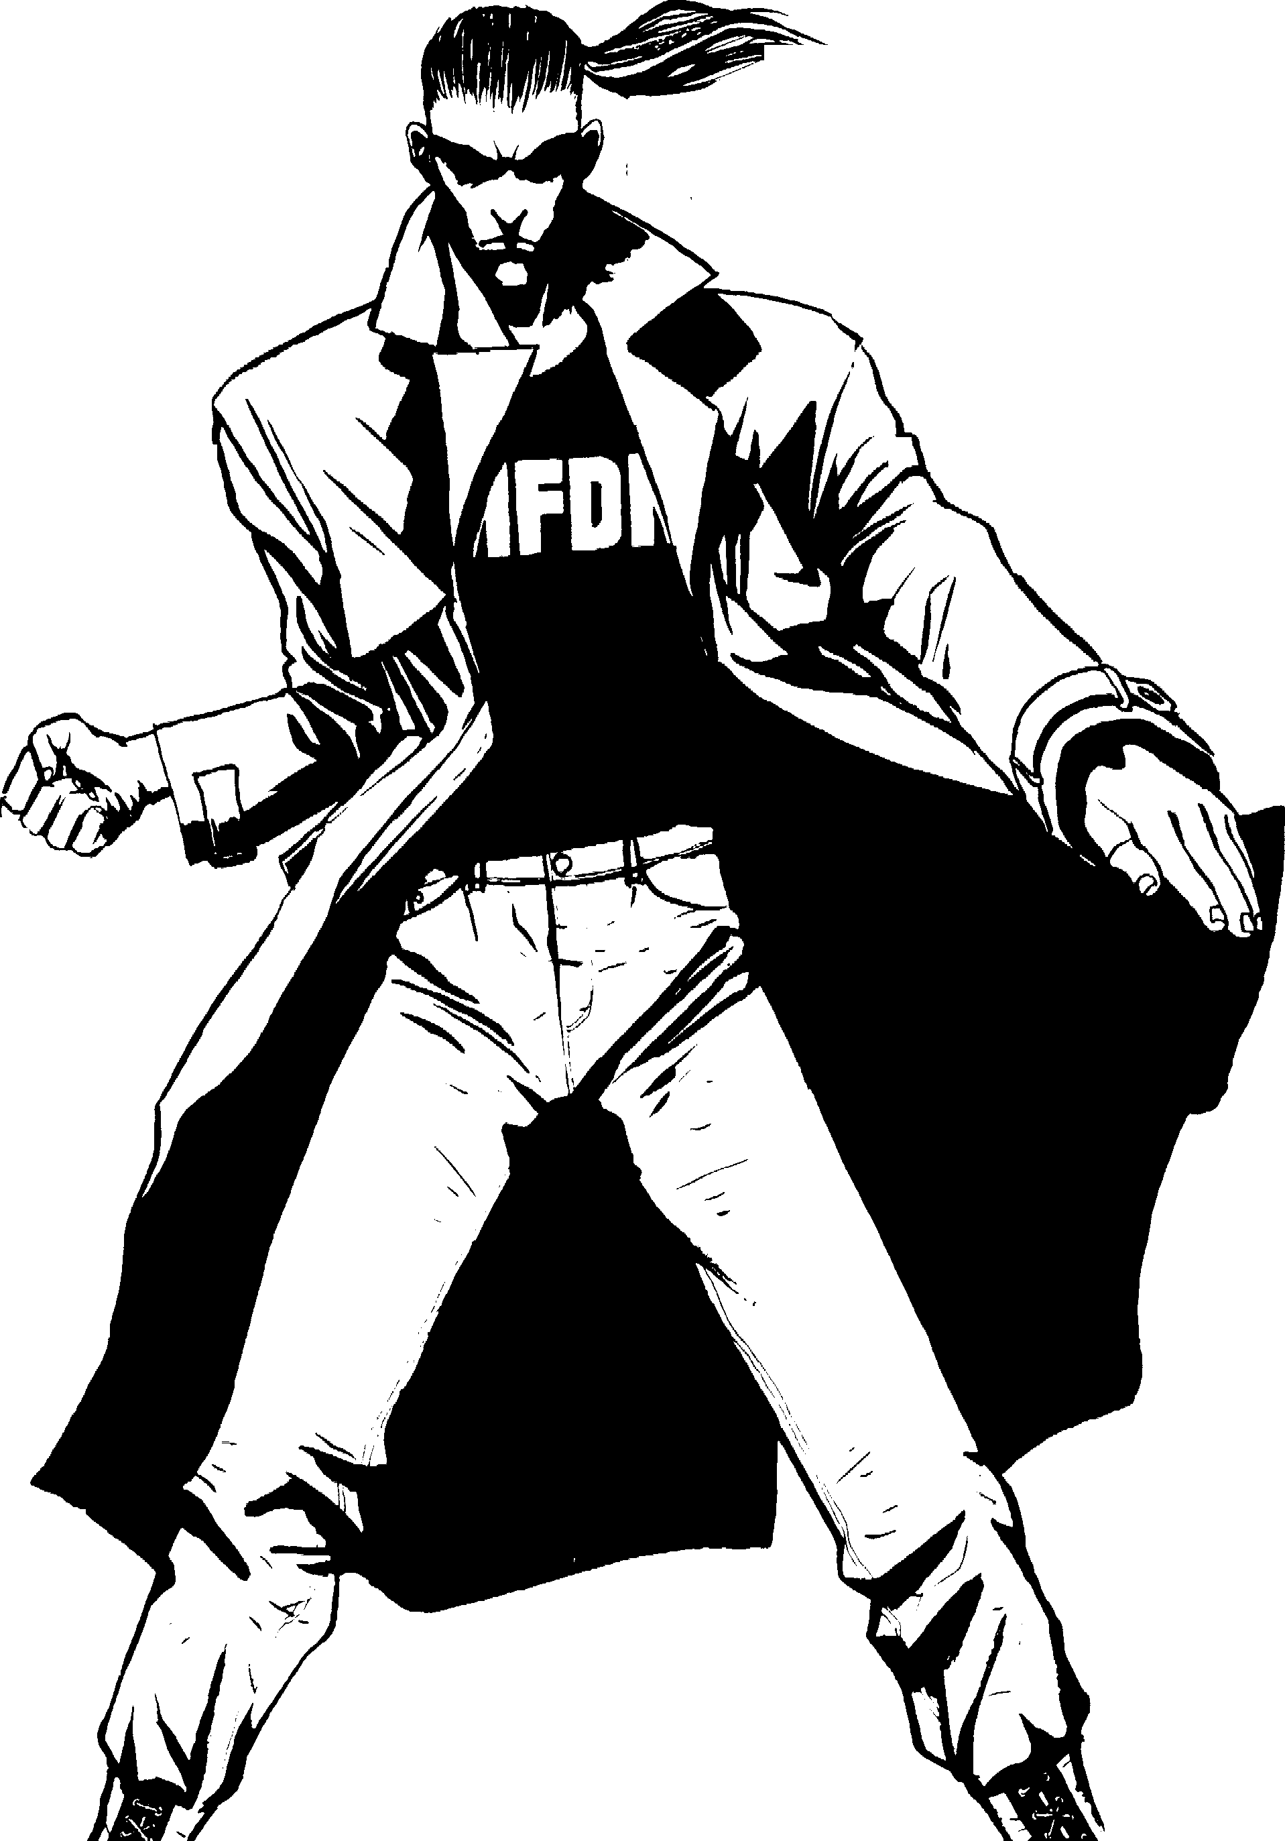
The combat deepens. On, ye brave, Who rush to glory, or the grave!
- Thomas Campbell, "Hohenlinden"
Quote: Hear the wind upon the water. It fiows like the churning in my soul.
Prelude: You spent much of your childhood in Hong Kong, the son of an American business­ man. Your parents returned to America when you were 12, but they allowed you to remain in Hong Kong with your uncle, who ran a
martial arts school. You had the potential to one day become a superior martial artist, and your parents decided to a\low you to pursue your gift.
When you were 15, however, your uncle died in a car wreck, and you returned to America to live with your parents. You had some trouble fitting in at school, but you continued your training, and it
occupied your time. After winning a
number o tournaments, you attracted
the attention of a Toreador who recognized your talent and dedi­ cation. She decided to provide you with all eternity to per­
fect your arts.
Concept: You are an artist. Your unattainable goal is the ultimate and perfect union of mind, body and spirit through the martial arts. The Toreador recognize you as an Artiste, but
you have little to do with them.
You develop your talents not for others, but for yourself.
You have had some difficulty since your Em­ brace. The fact that you do not breathe bothers you and occasionally
interferes with your studies. Recently, you have come to the conclusion that you must achieve some degree of power among the other Kindred, just so they will leave you alone and quit using you as their pawn because of your physical prowe,:is.
Roleplaying Tips: You are quiet most of the time. However, much of
- - what you say is enigmatic, vague and useless. You carry yourself in a very hum-ble
manner, but when you are presented with danger, you take a bold stance and glare at your enemy. When presented with a chance to fight, you move with unnatural
beauty and mechanical precision.
Equipment: Jeans, black heavy metal T-shirt, trench coa2 combat boots and. a concealed martial arts wea­
pcm of some ort.

54

ii
JO[{EADOll

The MasqueradeM

<J
VAMPIRE:

Name: Nature: Perfectionist
Player: Demeanor: Loner
Chronicle: Concept: Martial Artist
Sire: Oeneration: 9th Ha,-en:

•.-.,-v ===============Attrihutes================ •• •p=::e =
Physical Social Mental

Strength eeeooooo Charisma eeo 00000
Dexterity • • • • 00 00 Manipulation •• 0 0 0 0 0 0
Stamina •••00000 Appearance eeoooooo
Perception eeoooooo Intelligence eeoooooo Wits ••••oooo

-<==e-===4 N.....,-v o ============ Abilities==============:::::::::! 4 0 ••=>
Talents Skills owledge...

Actin _
Alertness. _
Athletics _
Brawl _
Dodge. _
Empathy _ Intimidation.
00000000 Animal Ken •0000000
·••00000 Drive 0000000
·••00000 Etiquette •0000000
•••••ooo Firearms 00000000
·••00000 Melee ·••00000
•0000000 Music 0000000
00000000 Repair 0000000
Bureaucracy oooooooo
Computer oooooooo Finance oooooooo lnvestigation oooooooo Law oooooooo
Linguistics ••000000
Medicine eooooooo

Leadership _ 00000000 Security •0000000
Streetwise. _ 00000000 Stealth ·••00000
Subterfuge. _ 00000000 Survival 00000000
Occult ••000000 Politics 00000000 Science 00000000

-<=== • • ==============AdYantages============== a • ==->
Disciplines Backgrounds Virtues
Au,;ex;=----- 00000000 | Allies | eooooooo | Conscience. ••••o
Celaity eeeooooo | Generation | ••••oooo
- 00000000 | Mentor | eooooooo
00000000 | 00000000 |  | Self.-Control. | •••••
00000000 | 00000000
00000000 | 00000000
00000000 | 00000000 |  | - ••••o
 |  |  | OD O:>-

Other Traits--­
00000000
00000000
00000000
00000000
00000000
00000000
- 00000000
00000000
00000000
00000000
00000000
Humanity --­
- •••••••• 0

==• e•i-- Willpower --­
□• □• □• □• □• □• □• □•o□o□
=--Blood Pool
□□□□□□□□□□
□□□□□□□□□□
=•- ·-- Health--
Bruised □
Hurt -1 □
Injured -1 □
Wounded -2 □
Mauled --2 □
Crippled -5 □
lncaJRitated □
-- Weakness -=
ENRAPTURED B\' BEAU1Y. WILLPOWER ROLL REQUIRED TO BREAK FREE.


Attributes:7/5/3 Abilities:13/9/5 Disciplines:3 Backgrounds:5 Virtues:7 Freebie Points:15 (7/5/2/1)

TheOufeast
Equipment: Needles, inks and all other tattooing paraphernalia,

Better to die on your feet than live on your knees.
- Dolores Ibarruri, speech in Paris
Quote: Piss off. Unless you came here to have some work done,
  - e e p ,
it h
xera <.._
be It ·,• ,
Desert Eagle laser sigh and ammunition, holster and sil-

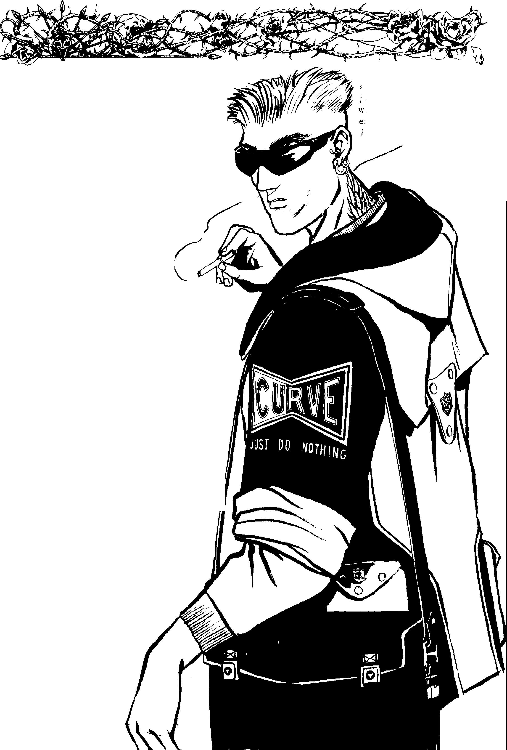
you might as well walk outta here before I throw you out ...Oh,you want a tattoo, huh? You seem a little too scared for that. You sure?
... Wel[, okay then. Have a seat and I'll be right with you ... What do you mean, do I throw away the inks when I'm done? Of course l do. I'm a professional. A real artiste.
Prelude: As a kid, you were a juvenile delinquent. After you graduated high school, you went into the Marines. They threw you out after one enlistment,
so you began working as an apprentice to a tattoo artist. Soon your work was better than his. You left town and started your own busi­ ness.
A Toreador came into your shop one night and r e - quested a tattoo of a phoenix on her back. You did the work, and she was so impressed by it that she Embraced you in payment. However, you quickly found out that you did not fit in among the other Toreador. Your sire had Embraced you only on a dare, and you came to hate her.
One night, you led a group of anarchs to her haven and they destroyed her. They alsoforced you to commit diablerie on her. Afterwards, they told you that you were one of them, and you could never be accepted within your clan as an Artiste.
They threatened to tell others how you betrayed your sire, so you were forced to join them. While hunting one night, a pack of werewolves spotted you. The Lupines were going to destroy you, but you promised to lead them to your anarch gang if they would spare you. They agreed. You led the Lupines to their haven and ran away as the Kindred were torn apart. You have remained an outcast ever since.
Concept: You are an independent. You enjoy unlife on your own terms. You can be cruel and deadly in protecting your freedom, but you prefer to be friendly. However, since your Embrace, you have become more and more distrustful of Kindred and kine alike. Now you focus on your work, and you plan to close your shop so you can travel the world to train with the real masters of your craft.
Roleplaying Tips: You hate raking orders from others. While you would like to be accepted back into your clan or the anarchs as an equal,
you will not let others control you. You are loud-mouthed and mean when neces­ sary, but if a person shows an interest
in you or your work, you can really open up. If someone gave you the chance, you would be a loyal friend, but so far you have only met Kin­ dred who want to use you.
56 4, Clt\nbook:
/ ver dagger.


VAMPIRE: The Masquerade™ D
JOREADOll

Name: Nature: Rebel
Player: Demeanor: Survivor
Chronicle: Concept: Outcast
Sire: Oeneration: 11th
Ha,-en:

=== •• • ===============Attrihutes================:! • ◄• =>-
Physical Social Mental

Strength. eeeooooo
Dexterity •••00000
Stamina eeoooooo
Charisma. eooooooo Manipulation •• 0 00 000 Appearance eeeooooo
Perception. eeeooooo
Intelligence • • • OOOO0
Wits ••••oooo

=-====:::4•.,o:!:-==================Abilities================== • •• -e==►-
Talents Skills Knowledge--
Acting 00000000 Animal Km 00000000 Bureaucracy oooooooo
Alertness •0000000 Drive eooooooo Computer 00000000 Athletics 00000000 Etiquette 00000000 Finance 00000000
Brawl | ••000000 | Fireanns
Dodge | ••000000 | Melee
Empathy | 00000000 | Music
Intimidation | eooooooo | Repair
Leadership | 00000000 | Security
Streetwise | ·••00000 | Stealth
Subterfuge | eooooooo | Survival

·••00000 lnvestigation e0000000
•0000000 Law •0000000
0000000 Linguistics eooooooo "1
•0000000 Medicine 00000000
••000000 Occult eooooooo
••000000 Politics 00000000
eooooooo Science eooooooo
- Oat Ad-vantages J.!J•=
Disciplines Backgrounds Virtues
eooooooo Allies eooooooo Conscience •••oo
Celerity eooooooo Contacts eooooooo
••000000 Generation ••000000
00000000 Resources eooooooo Self-Control ••••o
00000000 00000000
00000000 00000000

---=-
00000000 00000000 •••oo

00 •• - ==
- Other Traits --- Humanity Health
Artistic Ex ression •••00000 e e e e e e e O O 0 Bruised □
00000000 □
Hurt | ..1
Injured | ..1
Wounded | ..2
Mauled | ..2
Crippled | ..5

00000000 =-9::,!s Willpower □
00000000 e e e e e e e O O 0 □

00000000
00000000
00000000
□□□□□□□□□□ □
□

00000000 Blood Pool Incapacitated □

00000000
□□□□□□□□□□ 111\94.':,'!
Weakness

J:C...



00000000 ENRAPTURED BY BEAUll'.

<J
□□□□□□□□□□
00000000 WILLPOWER ROLL REQUIRED
TO BREAK FREE.

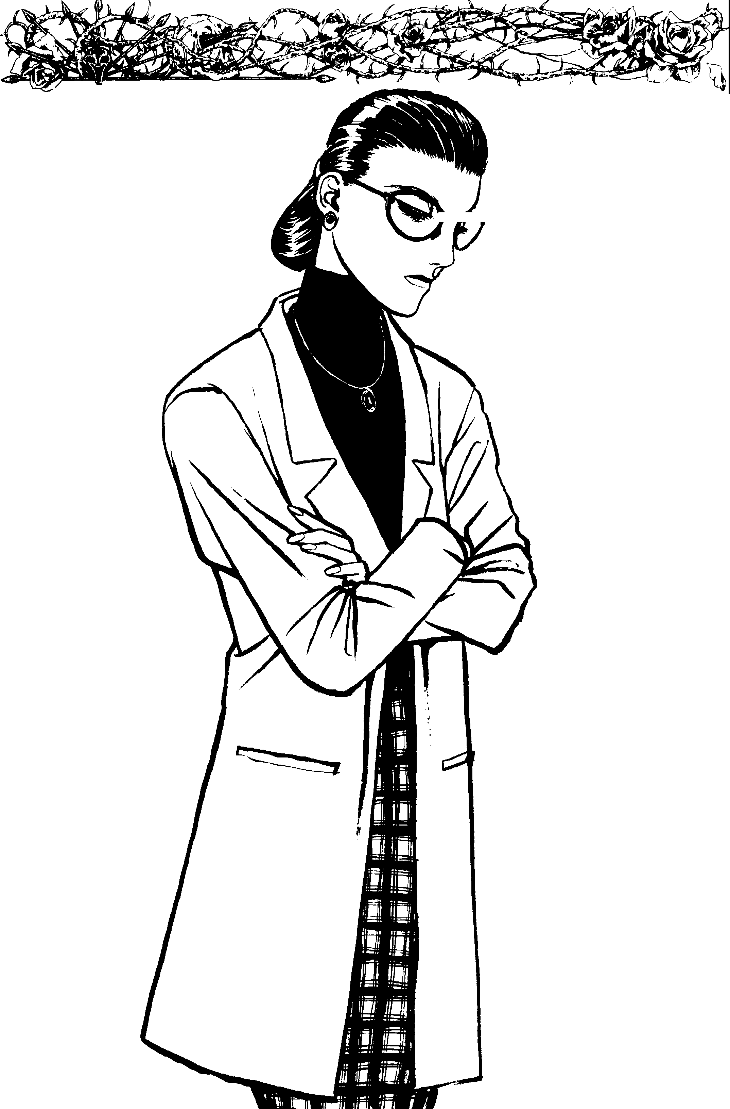
The Plastic Sur eon
I often say a great doctor kills more people than a great general.
- Baron Gottfried Wilhelm von Leibnitz, Bulletin of the New York Academy of Medicine, vol. V
Quote: You are very beautiful, but yes, I can improve upon your nose. After all, no one
is perfect, youknow. Icould also thicken your lips to enhance that new nme.
Would yoube interested? Please sit by the computer and let me show you some of the various looks you could pick from. I can work wonders with the flesh, my dear.
Prelude: You were born in Burbank to a wealthy fam­ ily and have never wanted for
anything. In high school and college, you graduated near the top of your class.You went to one
of the finer medical schools. Even­ tually, you opened your own practice, specializing in cosmetic surgery. It did not take long for you to build up a large clientele of rich, well-known peopl .
You received a call one night from a woman who claimed to have a rare skin condition that would allow her to see you only at night. When you met her at your office, she Embraced you. You had done some work on her ghouls, and she loved it. In her eyes, there is no question about your talent.

58
Concept: You are an excellent plastic surgeon and continue to practice your craft, operating only at night. You claim this is to protect your clients from paparazzi. You wish to attain respect an<l status among the Toreador as an Artiste, an<l it annoys
, .,..,. you that most of them consider you a Poseur. Still, if they were aging mortals with money, they would come to you for help. This gives you the strength to resist their criticisms with a smile. You have heard of
something called Vicissitude, a power to shape and mold living tissue. Now you have dedicated yourself to discovering a vampire who possesses this power.
You'd give just about anything to learn it.
Rolcplaying Tips: You are sophisticated, wealthy, educated and talented, and many important mortals fawn over you. You hate being treated as inferior to anyone else, which is how many of the Toreador elders and critics have treated you. You would like to see them put in their place, but you are too afraid to do it yourself. You are something of a con­
niver and manipulator, but most consider you too cowardly to serve as an actual threat.
Equipment: New, black BMW, cellular phone, beeper and a bag of operating tools-scalpels,
sutures, latex gloves, a mask and other goodies.

JOl{EADOil
ii
rJ VAMPIRE: The Masquerade™

Name: Nature: Autocrat
Player: Demeanor: Perfectionist
Chronicle: Concept: Plastic Surgeon
Sire: Oeneration: 12th HaYen:

..:::::e:=::4• o -4 ===============Attributes=============== 0 • oe:::::--
Physical Social Mental

Strength eeoooooo Charisma ••o00000 Dexterity ••••oooo Manipulation •••00000 Stamina eeoooooo Appearance eeoooooo
Perception ••• 000 O O Intelligence ••••oooo Wits eeeooooo

==•...o.,-v
Abilities

Talents Skills
Acting eooooooo Animal Km 00000000
Alertness eooooooo Drive ••000000
Athletics •0000000 Etiquette D0000000
Brawl 00000000 Firearms 00000000
Dodge •0000000 Melee ••000000
Empathy •0000000 Music 0000000 Intimidation ••000000 Repair •0000000 Leadership •0000000 Security 00000000
Streetwise 00000000 Stealth 00000000
Subterfuge ·••00000 Survival 00000000
Knowledge...
Bureaucracy eooooooo
Computer eeoooooo
Finance eeeooooo lnvestigation oooooooo Law oooooooo Linguistics oooooooo Medicine •••••ooo c t oooooooo
Politics 00000000
& ore 00000000

I'/

==== • ....,-,v • • ===============Adl'antages============== • • ===
Disciplines Backgrounds Virtues AUS(X!X;=--------••000000 Allies eooooooo Conscience eeooo Celerity oooooooo Fame eooooooo
Presence eooooooo Generation eooooooo

00000000 Resouroes ••••oooo
00000000 Status eooooooo
00000000 09000000
00000000 00000000
Self..COntrol. •••••

' •••oo
·· •==

_, ..Other Traits--._,,...
Artistic Expression ••000000
00000000
00000000
00000000
00000000
00000000
00000000
00000000
00000000
00000000
00000000
- Humanity --­
- • • • • • •o o o
-=--"!.!!:I!:! - Willpower--, ­

□•□•□•□•□•□•□0 □0 □0 □0
.

.:.:.v.::;t3 Blood Pool
□□□□□□□□□□
□□□□□□□□□□
-, ,--Health-----
Bruised □
Hurt ..1 □
Injured ..1 □
Wounded ..2 □
Mauled ..2 □
Crippled ..5 □
lncapritat:ed □
Weakness
ENRAPTURED Bl' BEAU1Y. WILLPOWER ROLL REQUIRED TO BREAK FREE.






Attributes:7/5/3 Abilities:13/9/5 Disciplines:3 Backgrounds:5 Virtues:7 Freebie Points:15 (7/5/2/1)

The Speed Metal Guitarist
And I ain't in it for the power And I ain't in it for my health
I ain't in it for the glory of anything at all And I sure ain't in it for the wealth
But I'm in it 'ti! it's over and I just can't stop If you wanna get ir done
You gotta fi?,ht for yourself
And I like my music like I like my life E1,eryrhing louder than everything else!
- Meatloaf, "Everything Louder than Everything Else"
Quote: I'm not a musician. I'm an anarchist and a mental terrorist. l practice what I preach, and l teach the youth to open their eyes and see heyond the intellectual prisons in
which their parents force them to live. The kids who listen to my music understand where l'm coming from. It's something they already feel - something primal. l just show them how to express it.
Prelude: You grew up in a nice suburban neighborhood. You had good friends, though you were never really popular in school. You were neither a geek nor a trouble­ maker; you were just one of those kids who never got noticed. You went to college at your parents' behest, where you met the guys in the band. Together you formed a group called Hecate's Fiasco and began playing where you could find work. You quit college a year before graduation and moved to Los Angeles with your band. You played in clubs, and eventually a minor label signed you.
You did okay for yourself for a few years, but your band eventually broke up over petty squabbling. While visiting some old friends, you were recognized by a Toreador who adored your work. She Embraced you, and you have continued to make records.
Concept: You are an Artiste ( though some would claim otherwise) who lives
60
•

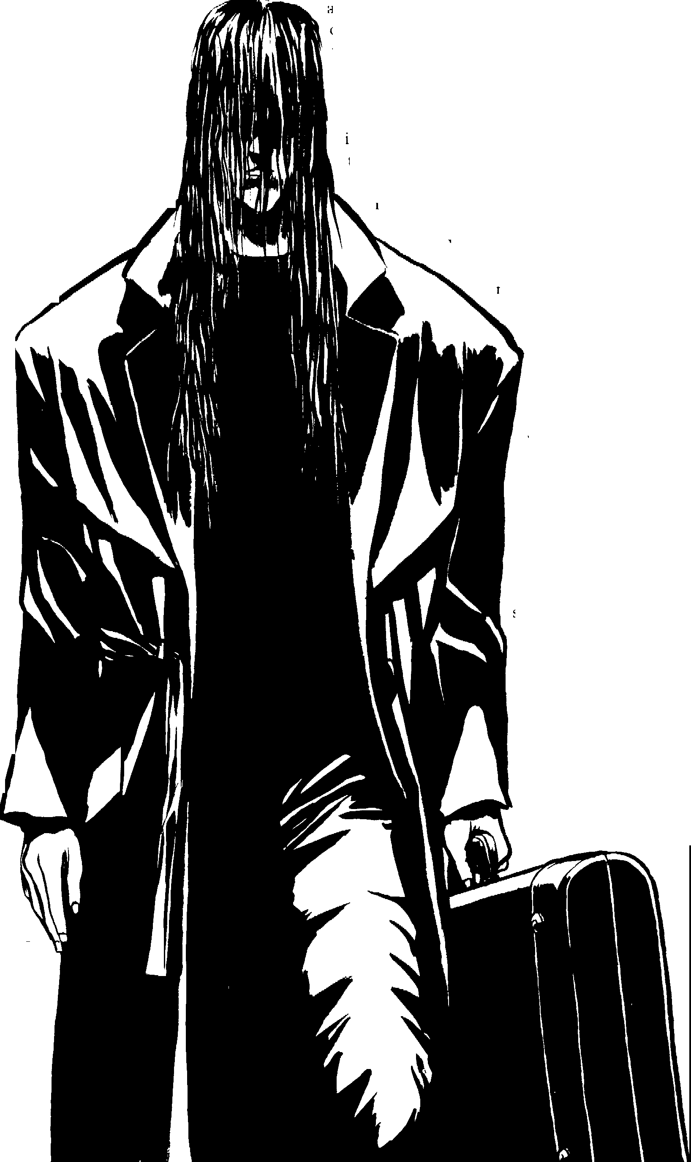
for his work. You see your music as merely a vehicle for expression.You would make a wonderful anarch, but you have yet to give them your full attention. Turning to them now would limit your ability to influence others qf cre­
ative ability. Right now, you are trying tl> figure out what your fellow Toreador are like. You hope to convince them of your way of seeing things. In fact, some of them have developed an apprecia­ tion for your work.
Roleplaying Tips: You believe the message in your words and music. Though you are some­ thing of an anarch, the Toreador do not recognize you ris one. They n,;gard you a, an mtellectual rebel with a message to spread.
You do not seek power for its own sake. You seek power for the purpuse of breaking the honds of stag­ nation, so you and everyone who listen:-,
to you can re,dly live. You are loyal to your clan ,ind your coterie, hut you still do not fit in very well, since you refuse to conform to the
thoughts, appearances and actions of others. Equipment: Femler
Stratocaster, hl,1ck
leather pants, black trench coat, black T­ shirt, shades, silver jewelry, Case knife, Ithaca M37 pump-ac­ tion shotgun, two pockets full of shells, Harley-Davidson mo­ torcycle and whatever sound equipment you
need.

ar,

VAMPIRE: The Masquerade™
JOREADOll
(6

\.J

Name: Player:
Nature: Visionary
Demeanor: Rebel
Sire: Oeneration: 12th

Chronicle: Concept: Speed Metal Guitarist Ha,-en:

=== •• 4• ◄ ===============Attributes================ • 4• ===--
Pbysical Social Mental

Strength eeoooooo Charisma. eeeooooo Dexterity •• • • • 0 0 0 Manipulation •• 0 0 0 0 0 0 Stamina •••00000 Appearance •••00000
Perception eeoooooo Intelligence eeoooooo Wits eeoooooo

=====:::4••• 4•!:!!:::==============Abilities================ v--v•, ••t:==>--
Talents Skills Knowledge...

Actin •0000000 Alertness 00000000 Athletics ·••00000
Brawl ••000000 Dodge •0000000 Empathy 00000000 Intimidation-- •0000000
Leadership 00000000
Streetwise •0000000
Subterfuge 00000000
Animal Km 00000000
Drive ·••00000
Etiquette •0000000
Firearms ••000000
Melee •0000000
Music ••••oooo
Repair •0000000
Security •0000000
Stealth •0000000
Survival 00000000
Bureaucracy oooooooo Computer oooooooo Finance eooooooo Investigation • 0 0 0 0 0 00
Law oooooooo
Linguistics 00000000
Medicine 00000000
Occult ••000000 Politics •0000000 Science 00000000

I'!

--<==41<==4• • • ===============AdYantages============== • • ===--
Disciplines Backgrounds Virtues
:....._ 00000000 Contacts •0000000 Conscience. ••••o
Cderity eeeooooo Fame ••000000
Preseoce eooooooo Generation eooooooo

00000000 Resou es •0000000
00000000 00000000
00000000 00000000 00000000 00000000
Self-Control. eeeoo

- •••oo
•=--
00



Other Traits--.;:,c­
(./
00000000
00000000
00000000
00000000
00000000
00000000
00000000
00000000
00000000
00000000
00000000
=-- Humanity ·"'
••••••••oo
=•$!! Willpower
•□•□•□•□•□•□•□□0 □0 □0

-- Blood Pool
□□□□□□□□□□
□□□□□□□□□□
--Health--
Bruised □
Hurt ..1 □
Injured ..1 □
Wounded ..2 □
Mauled ..2 □
Crippled ..5 □
lncatm-tated □
=• Weakness J• •=
ENRAPTURED BY BEAU1Y. WILLPOWER ROLL REQUIRED TO BREAK FREE.

•

The Televangelist
Television has proved that people will look at anythini rather than each other.
- Ann Landers
Quote: (Change the channel to the religious station and pick one.)
Prelude: You never really took your faith seriously. You went to church, but it never meant anything to you. After graduating high school, you began preaching with a travelling revival. Eventually, you weeded out the other preachers who took their work seriously. They were costing you money with their honesty and good works.
Over a 10-year period, you built a mas­ sive following (and bankroll). Then you began airing your messages on a local television station in the wee hours of
the night. Still, you were not satisfied. Through sheer cunning and charisma, you pushed your "ministry" into a full television station. You now broadcast 24 hours a day. You have put a small fraction of the money you have re­ ceived to actual good use, but the majority lies in your personal Swiss bank account. About a year ago, a Toreador Embraced you, but you
continue your "work" just as before. (i
Concept: You are a spiritual leech who has grown financially fat off
the poor, the old and the naive. (i
Many social security checks are signed over to you each month.
Roleplaying Tips: You have an explosively emotional personality. To many, you are an obvious fake, but your ability to tell people what they want to hear has provided you with quite afollowing. You are
not the least bit religious in real life, but you can tum on your piety like flipping a light switch.
Equip ent: Micro­ phone, white suit, make-up, jewelry
and a Bible.

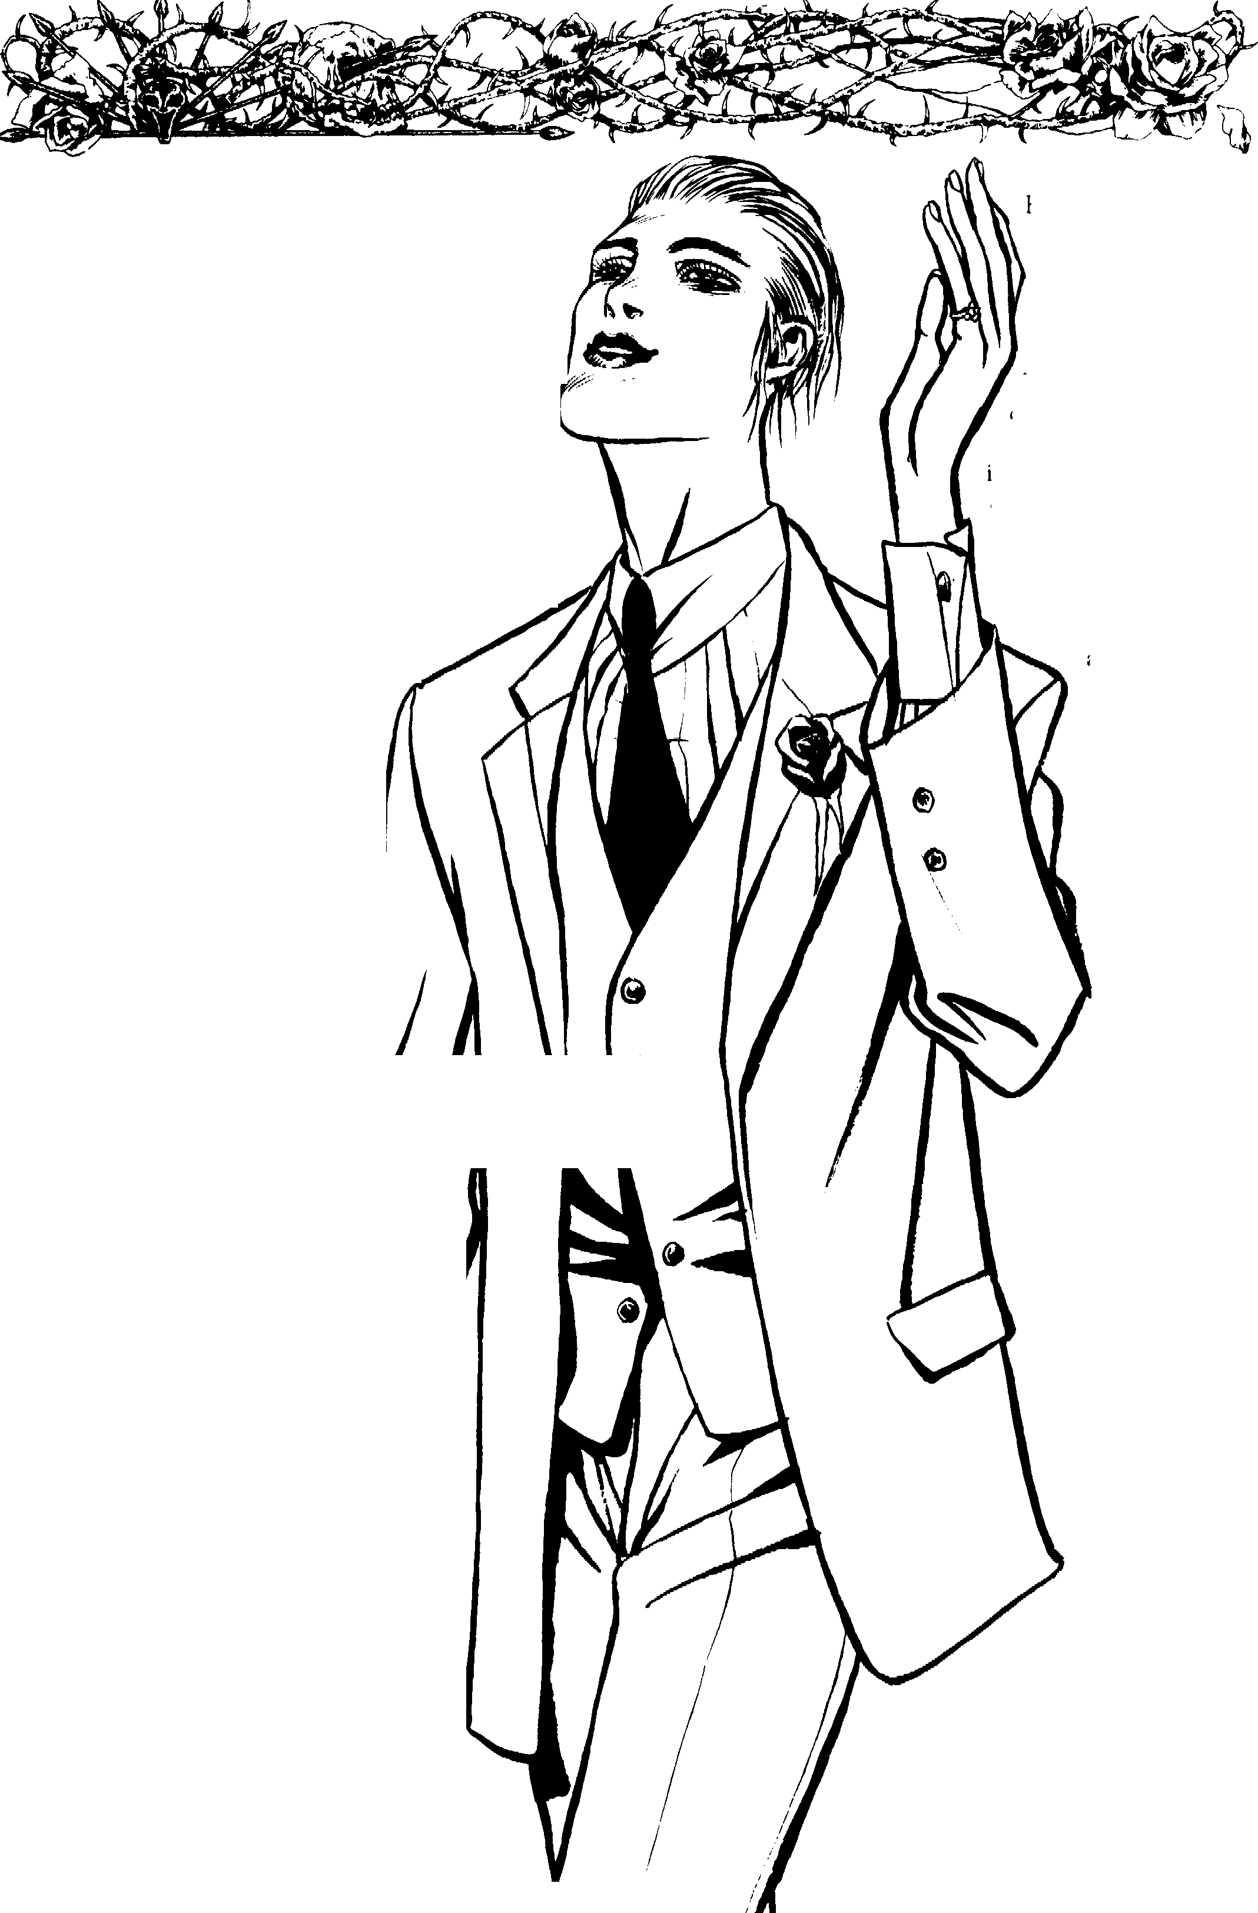

You enjoy your work immensely. Despite the fact that you are Kin- dred, you have no problem with your work. Fortunately, there is not a single individual in your "ministry" who has real Faith. You know very little about the World of Darkness and are a prime target for those who would use you as you have
used other people.

62
,,/,-

cJ VAMPIRE: The Masquerade™
JO EADOll
ii

Name: Nature: Conniver
Player: Demeanor: Fanatic
Chronicle: Concept: Televangelist
Sire: (ieneration: 13th HaYen:

<e=:=:4• • o ===============Attributes================ • • =:=>►
Physical Social Mental

Strength eeoooooo Charisma. eeeeoooo Dexterity eeoooooo Manipulation eeeeoooo Stamina ••000000 Appearance. eeoooooo
Perr tion eeeooooo
Intelligence • • • 0 0 0 00
Wits eeoooooo

-==...•.,,...,..·,.
Abilides

Talents Skills
Actin ·••00000 Animal Ken 00000000
Alertness 00000000 Drive eooooooo
Athletics | 00000000 | Etiquette ••000000 Finance e•oooooo
Brawl | 00000000 | Firearms •0000000 lnvestigation eoo oo o00
Dodge 00000000 |  | Melee | 0000000 | Law .0000000
Empathy ••000000 |  | Music | 0000000 | Linguistics •• O 00 00 O
Intimidation-- ••000000 |  | Repair | 0000000 | Medicine 00000000

owledge'"'
Bureaucracy e0000000
Computer oooooooo

Leadership ·••00000 Security •0000000
Streetwise 00000000 Stealth 00000000 Subterfuge ••000000 Survival 00000000
o uh eeoooooo
Politics eooooooo
Science 00000000

-<c::;:::t• • o =============AdYaotages============== • •• = =-
Disciplines Backgrounds Virtues
---••000000 Allies ••000000 Conscience'--- eoooo Celerity oooooooo Contacts eooooooo
Presen=e; eeoooooo Fame ••000000

00000000 Influence eooooooo
00000000 Resou es ••••oooo
00000000 00000000
00000000 00000000
....,,...,..,.
Self-Control'" • ••••

- ••••o
•=






·=----Other Traits
Maseiluerade eooooooo
•
00000000
- 00000000
00000000
00000000
00000000
- 00000000
00000000
00000000
00000000
00000000
Humanity --­
- • • • • •o o o o
-.- Willpower
e e e e e e e O O 0
□□□□□□□□□□
-==• !,'!=-Blood Pool- -
□□□□□□□□□□
□□□□□□□□□□
=• ---Health----
Bruised □
Hurt -1 □
Injured -1 □
Wounded -2 □
Mauled -2 □
Crippled ..5 □
tated □
-:;,, Weakness ---
ENRAPTURED B\' BEAU1Y. WILLPOWER ROLL REQUIRED TO BREAK FREE.

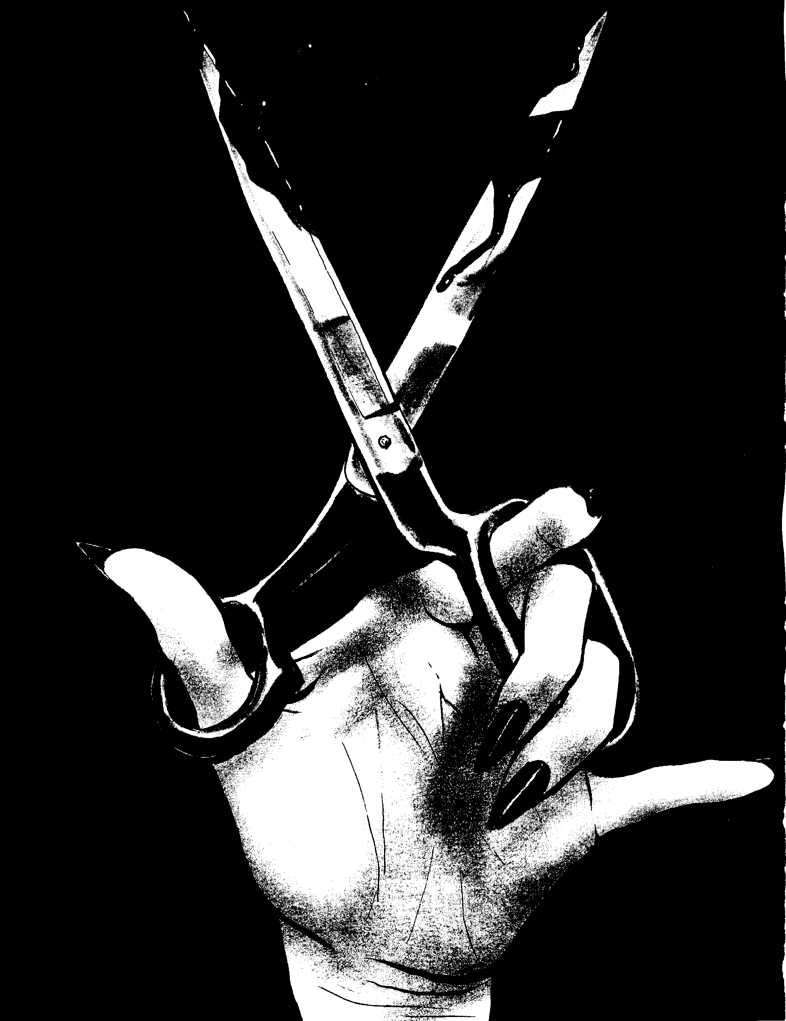

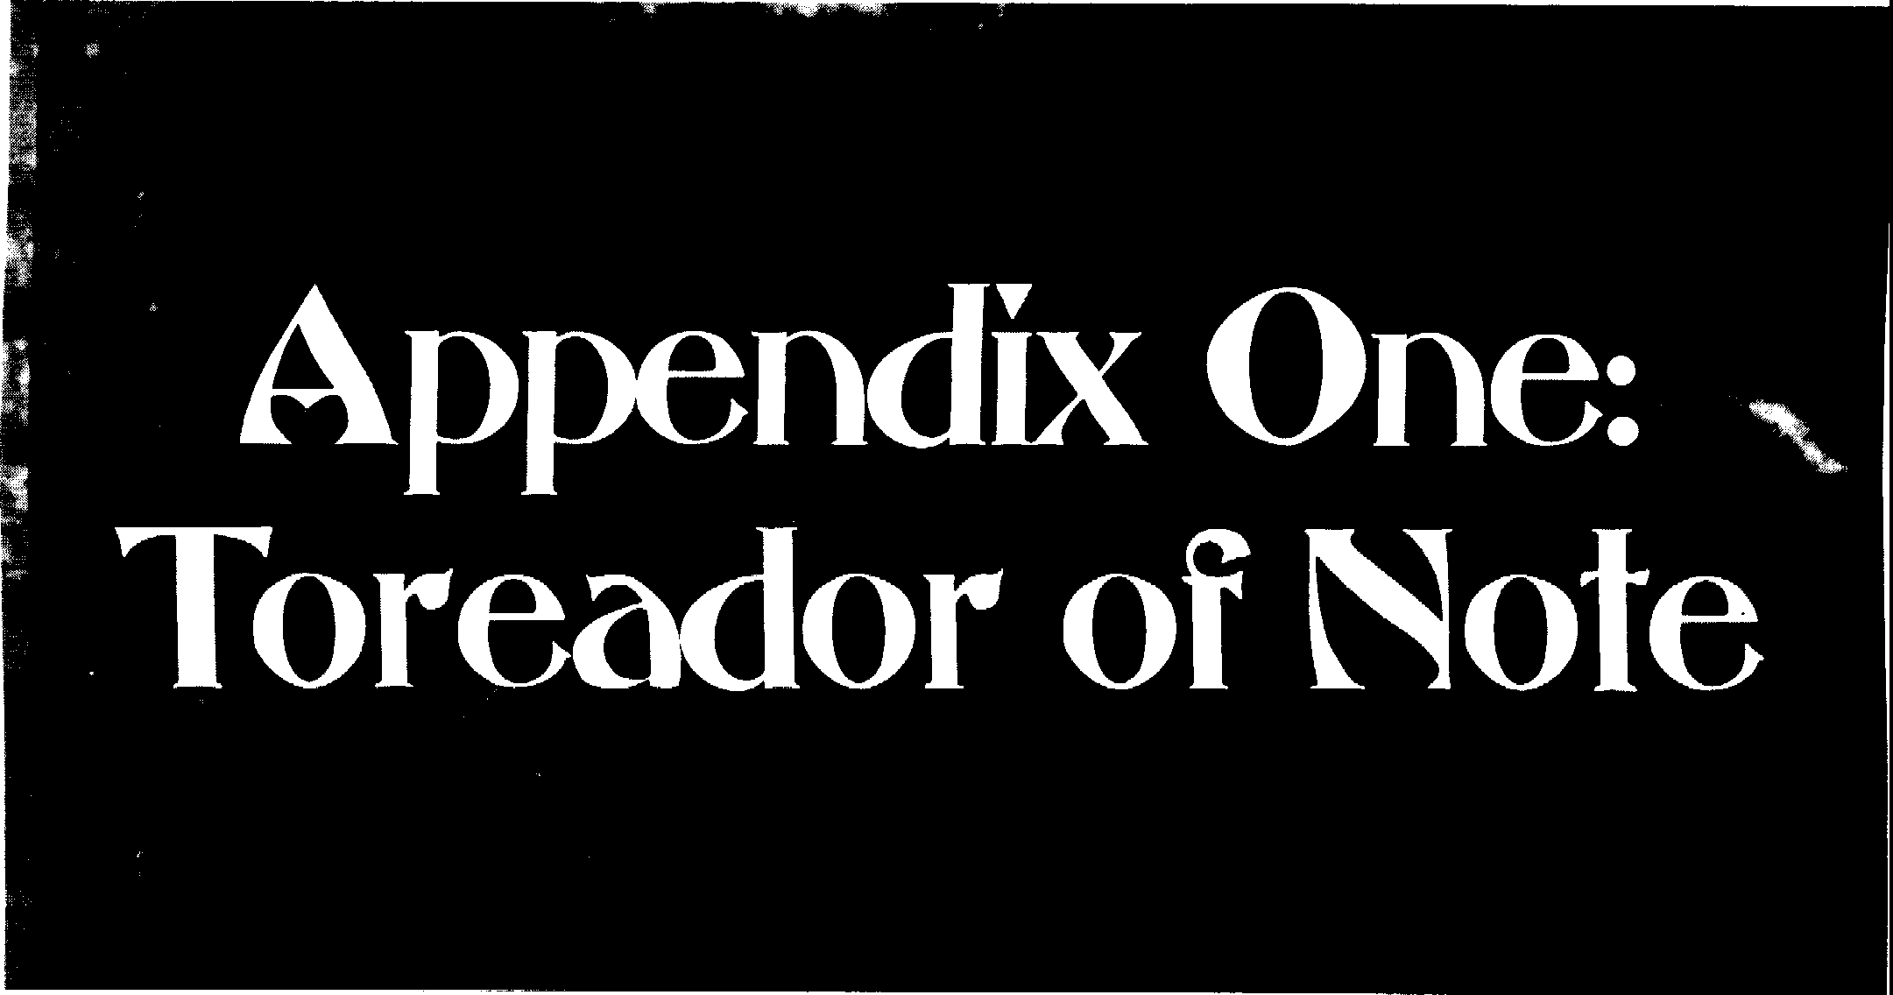

I!
Make way for your betters.
- Latin proverb

While there can be any number of famous individuals among the Toreador, none of them are listed here. One of the considerations a Storyteller must make is deciding which artists, movie stars, rock stars and other celebrities are now
immortal. Be careful not to overpopulate the World of Dark­ ness with well-known figures. Using them sparingly, and making them believable, can spice up the game.



65

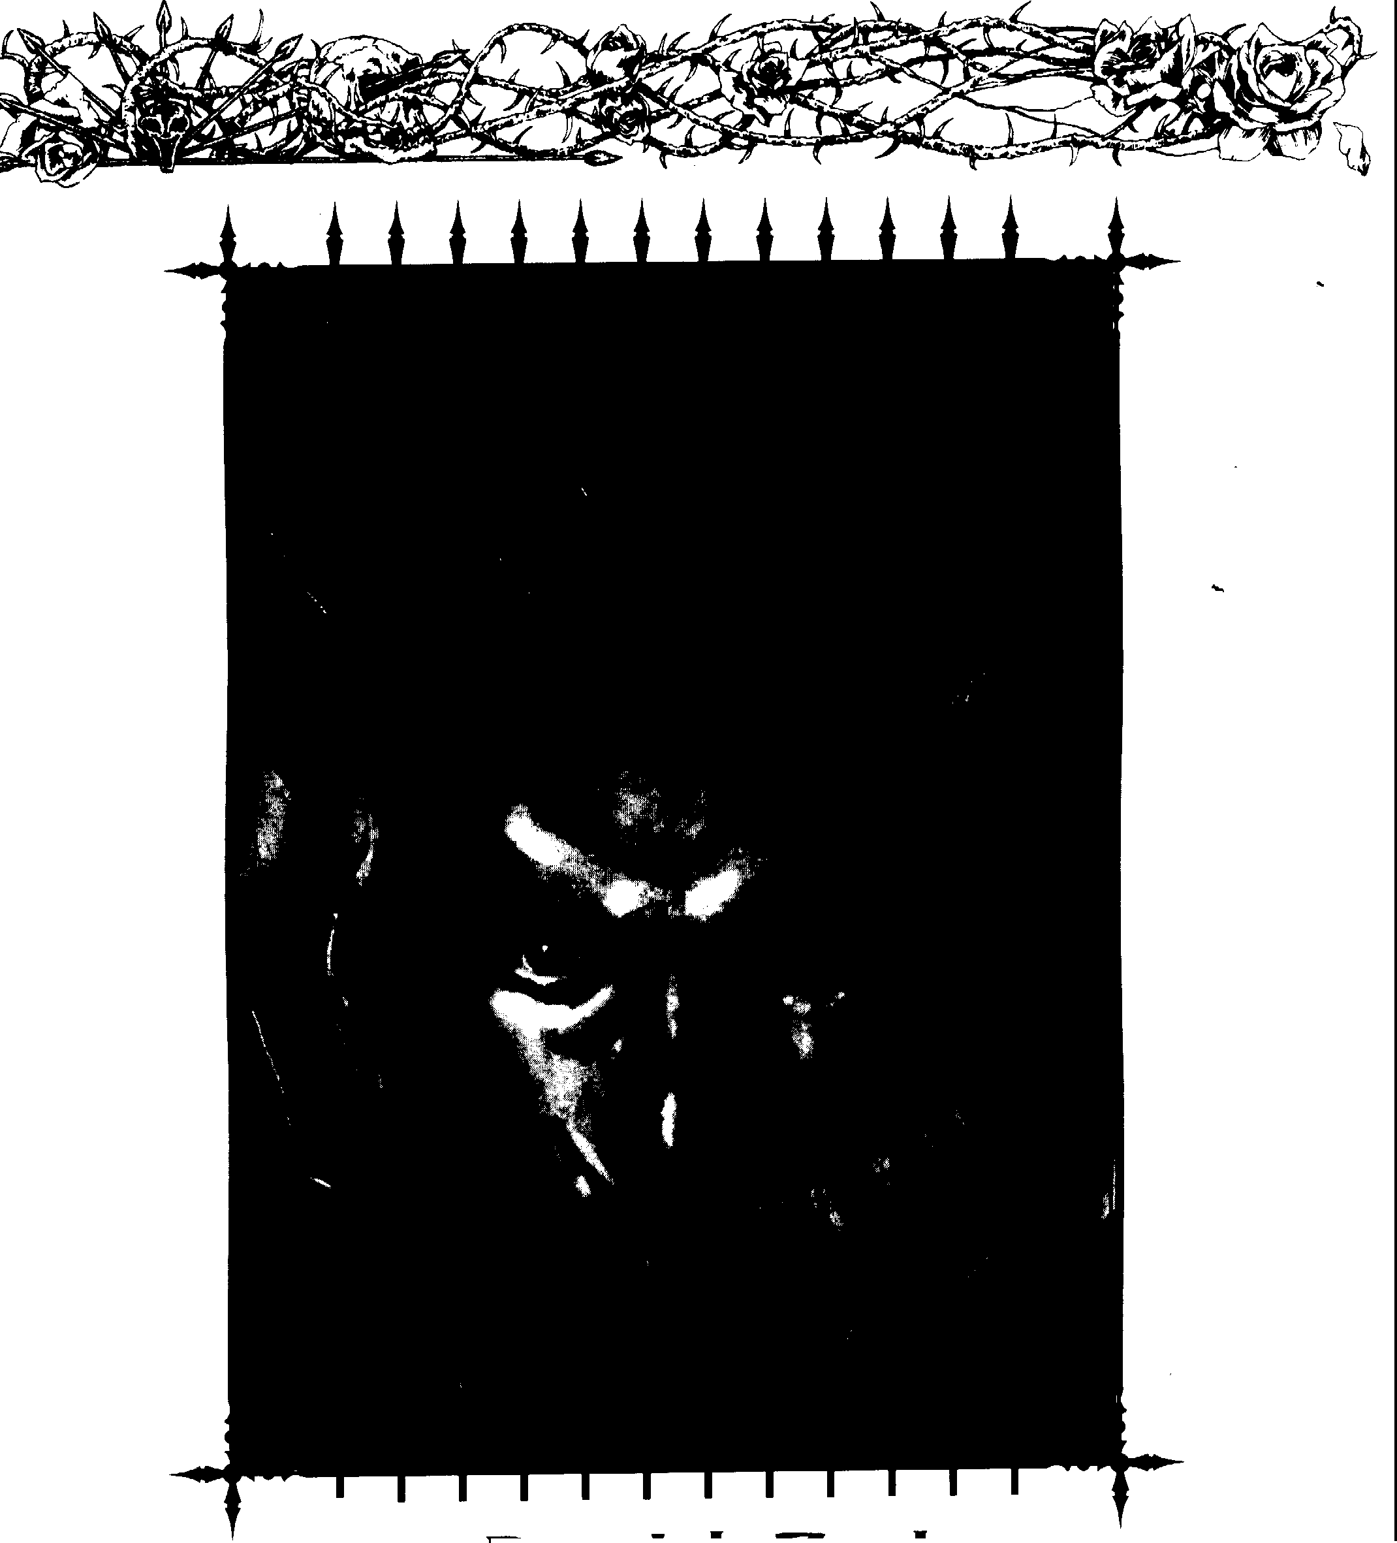
Derrick Zeel

The Kindred known as Derrick Zee! is a porn star. He owns the video production company that makes his films. Zee! is a major figure in the slave trade, and some claim he has cults dedicated to him in every corner of the world. Gangs of powerful anarchs surround him and keep other Kindred from bothering him.
No one knows Zeel's real identity. Many believe he is an incredibly ancient Toreador, but few have actually seen him in person. One Thaumaturgist claims Zee! is a Fourth-Genera­ tion Toreador. Legends tell of a Toreador named lontius who
66 CIBnbook: Toreooor
was Embraced in ancient Greece. lontius somehow gained the ability to feed off his victims through sex rather than by normal vampiric means. Some claim the sexual undertones of vampiric myths originated with him. lontius supposedly never used his real name, but he has been spotted throughout history. He has kept a Giovanni lover for centuries, acted as a major leader in the fight against the Inquisition, and infiltrated and betrayed the Sabbat.
If the Sabbat ever finds evidence that Zee! is Iontius, a War Party will be called for him immediately.

....
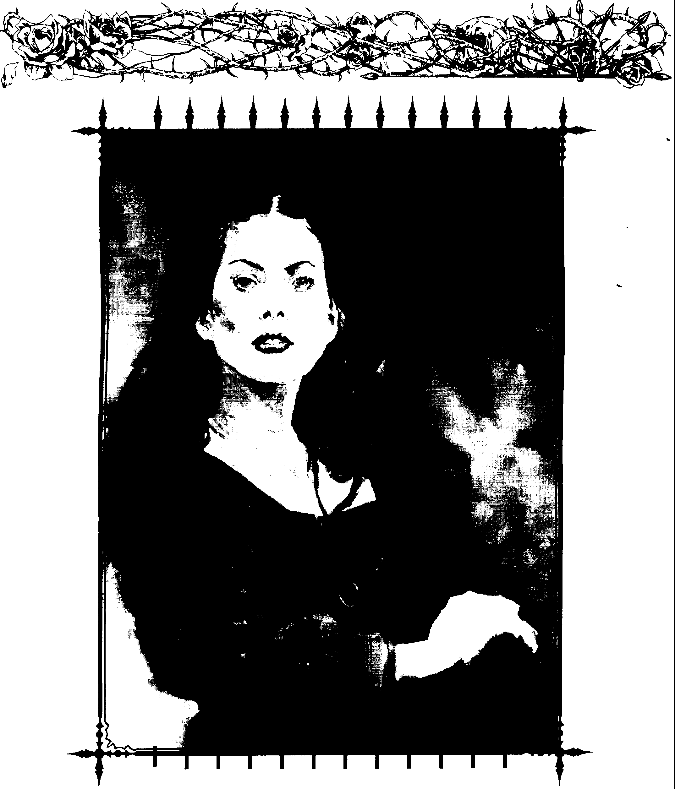
..

I)

Geneveve Orseau

Orseau was Embraced at least 800 years ago and made her reputation as an important and respected art critic. While she is a Poseur, she has demonstrated her abilities as an Artiste in the past. Orseau controls one of the largest Toreador art schools in existence and has students around the world. She is incredibly wealthy and has several childer.
What truly makes her unique is her past. Orseau is believed to be one of the few faerie changelings to survive vampiric Embrace. She has demonstrated odd powers in the past to support this outrageous claim. In addition, she was a major
leader in a Jyhad between the Toreador and the Followers of
Set throughout the 11th and 12th centuries. Some whisper that she is an agent of the lnconnu, but this is only rumor.
Appendix,.> 67

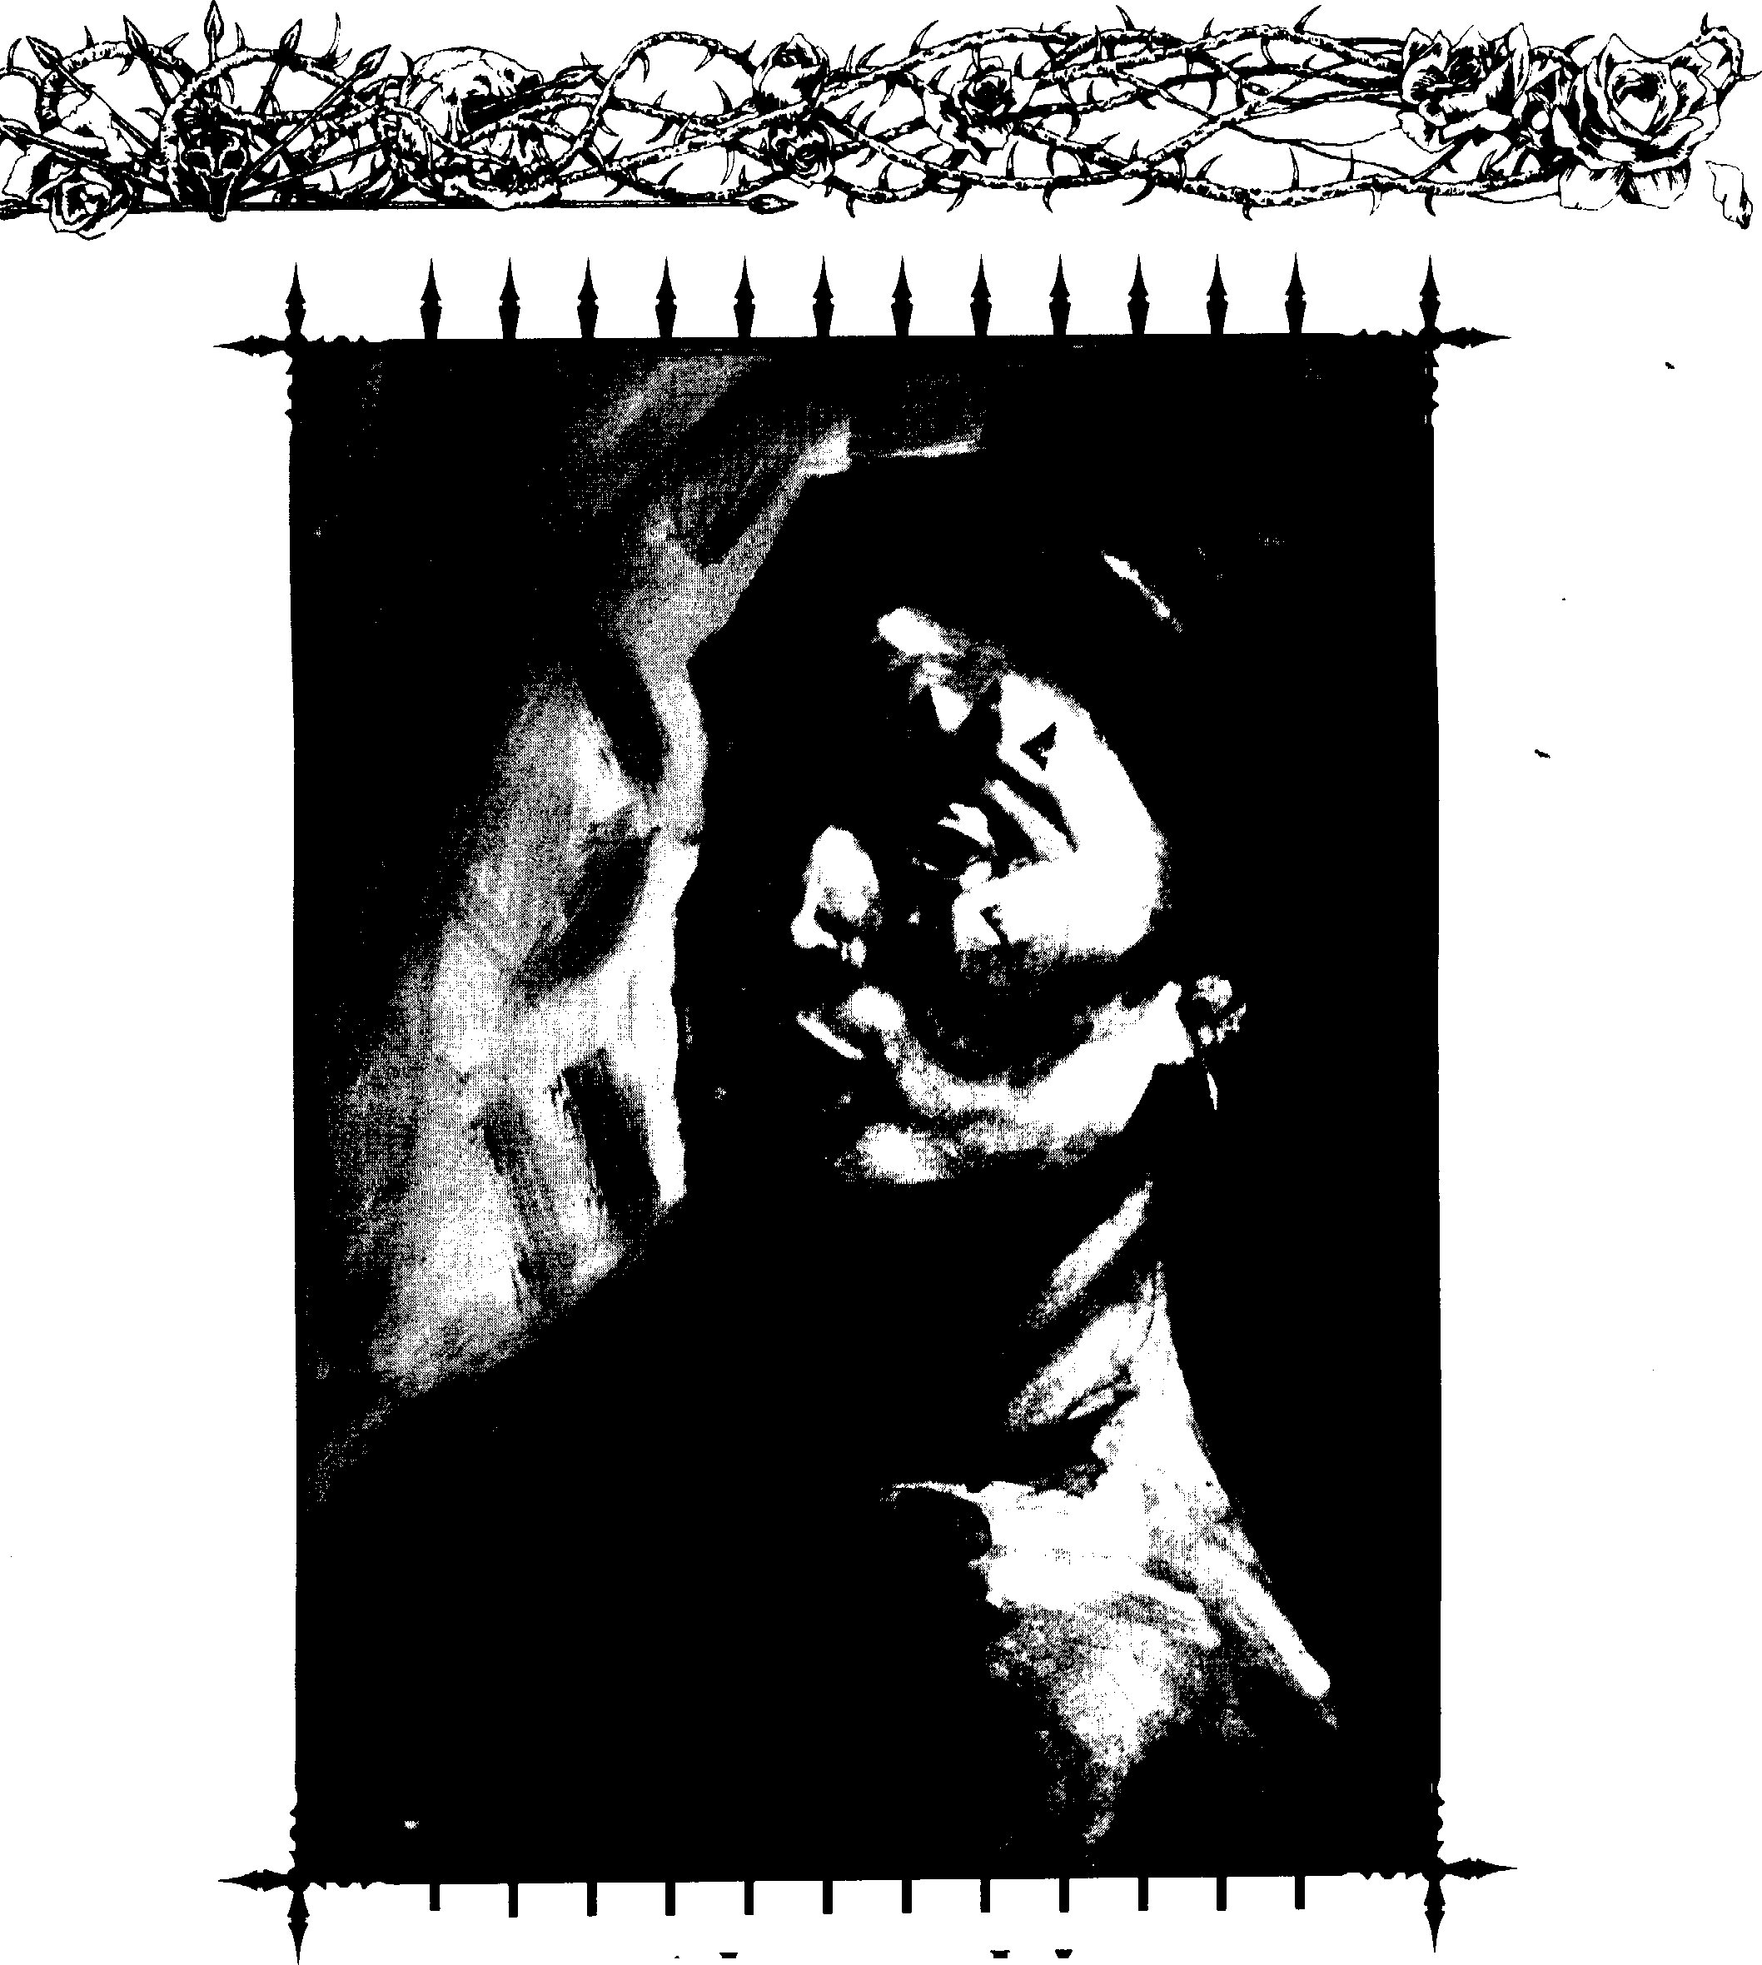
-

I)

Alexandria

Alexandria is believed to be a Fifth-Generation Toreador who controls a number of casinos in Chile and Argentina. She is also the Prince of Buenos Aires. An extremely beautiful vampire, she controls most of the Camarilla's activities in Argentina. Alexandria travelled to the New World with Francisco Pizarro's expedition. She is known to have feuded with Helena, another ancient Toreador who came to the New World around the same time. Some older Toreador claim Alexandria is actually Callisti y Castillo.

68 Clanbook: Toreador
Alexandria is not your typical Toreador. In addition to her already busy schedule, she is possibly the greatest art thief to ever exist. She has stolen many of the greatest masterpieces in existence, replacing them with undetectable fakes. Other princes have placed her on their most-wanted lists under the identity of "Red Ludwig." She is the owner of one of the largest private collections of museum-quality works.
In the room, the women come and go, Talking of Michelangelo.
- T.S. Eliot, "The Love Song of J. Alfred Prufrock"

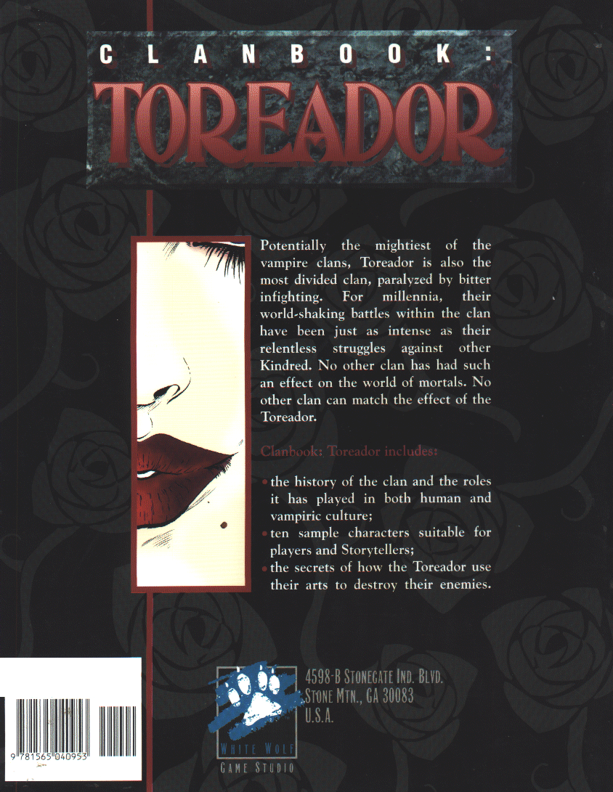

ISllN 1,56504,095-1
WW 2056 $10.00U$ >14.50CAN
51000

